TRIM 8.3 – Saved Searches
TRIM allows you to save searches you might like to use regularly.
Instructions | Picture demonstration
Using ‘Ctrl F’ keys, open the ‘Search for Records’ window as shown.

‘Ctrl F’ is the best one to use so that you can filter out record types and sort the results how you want to see them.
Choose the ‘Search By’ category you would like to search and save. In this example I am going to save 3. I want to search for Records created by Ben Martin (Records team) that are scanned/digitised record types he performs monthly.  Open the folder & change ‘Search By’ to ‘Creator’  ‘Creator’ is found under ‘Contacts, People and Places’ as shown | 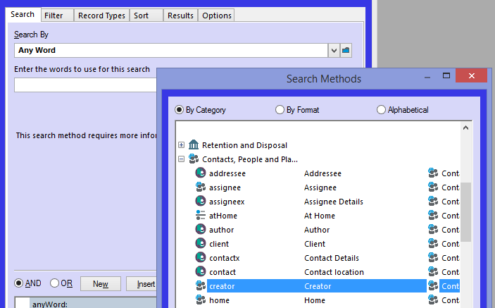
Find the ‘Creator’ by opening the Blue Folder next to the field you want to populate with the persons name | 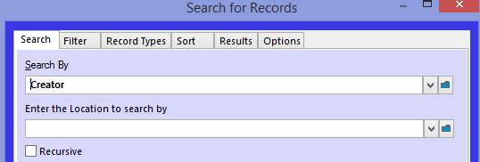
When the names list window appears, just start typing the surname of the person and press ‘OK’ | 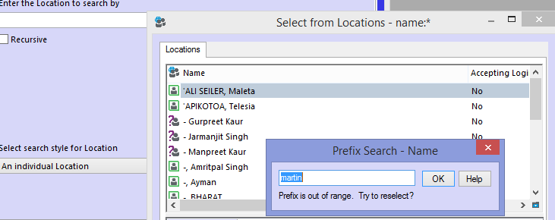
Find the person from the list and press ok | 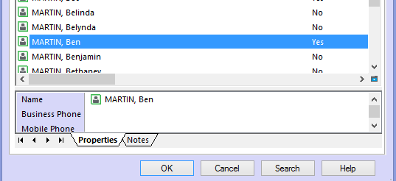
Now that the first layer of my search is complete, I need to add a new layer for the dates I want TRIM to search each time I select this favourite search  New layer | 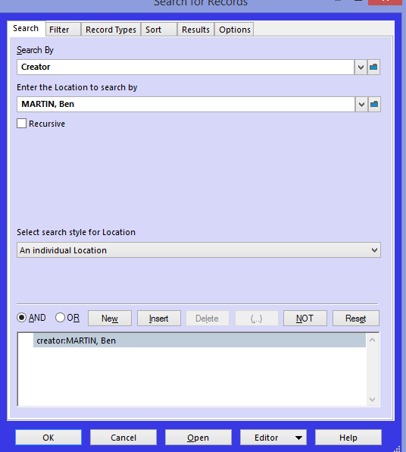
When New Is selected, a new layer will appear so that a new search can be added | 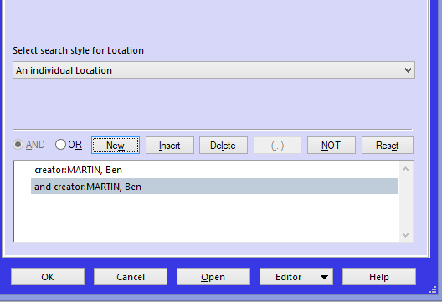
At the top of the ‘Search for Records’ box, you can now change to the next search layer. In this example, I want to see the records Ben has scanned in a specific period every month. Hence I need to add ‘Date Registered’  ‘Date Registered’ falls under the heading ‘Dates and Times’ | 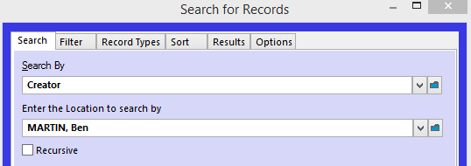  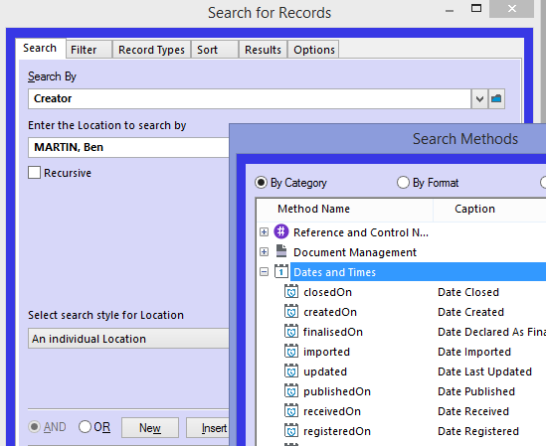
Because I want to check what Ben is scanning each month, the value in ‘More Search Options’ is changed so that I can choose a “floating” range of ‘This Month’…every month I use the saved search | 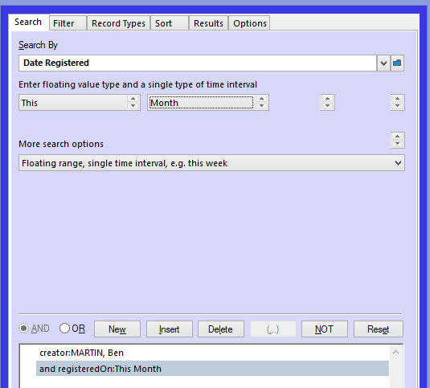
The final step in building the search is narrowing the records type down.  Because I only want to see the records he is scanning, I need to change ‘Records types’ folder | 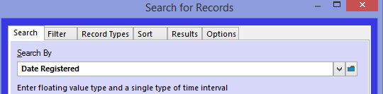
The only record type I want to see is the ‘Digitised Physical Record’  - Right click  - Untag all  - Tag the only record type I want to appear in my search results | 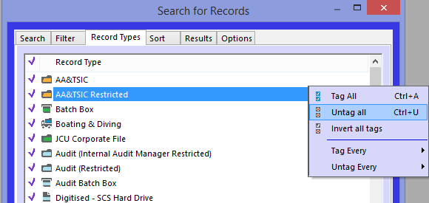  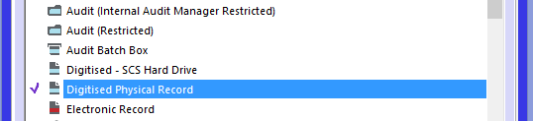
Now to complete the Search | Press OK 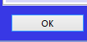
The search is now complete and shows me the results I asked TRIM to search  - Records scanned  - By Ben Martin  - Each Month  To check the numbers he has completed, I would press the 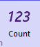  On the Global Bar | 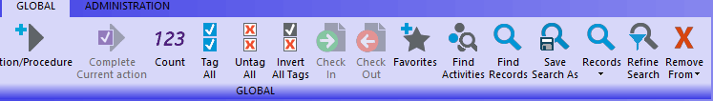
Saving the Search

In the Global setting, choose Save Search As

Complete the fields in the Form:  Name – Choose a name for your search that will stand out from any others you decide to save.  Description – Leave this field, as this is the one populated by TRIM, based on your search  Icon – you can choose an icon so that yours stands out from any others  Owner – you can leave this as yourself, or if you want to share it, add others or teams  Add to favorties – tick the box so that these appear in the favourites ribbon on the left of the TRIM display (see Below)  OK – press OK  Note: where the ‘Add to Favorites’ box is greyed out, refer to the following step | 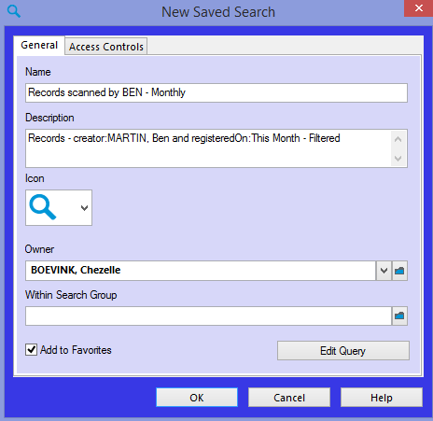
‘Add to Favorites’ when the box is greyed out, hence you are unable to choose the ‘Add to Favorites’ option. | Once you have pressed ‘OK’ go to the 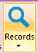 icon in your ‘Global’ Ribbon. Go to ‘Saved Record Searches’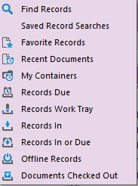  The list of saved searches will appear in a separate window.  - Click on the saved search you want to save to favorites (this one I chose with the ‘heart’ icon.  - Press the ‘F4’ key
Finding and using the saved search.  The search will now be located in your ‘Favorites’ tab  Choose ‘Saved Searches’ for the window to open displaying all the saved searches you have saved for future use | 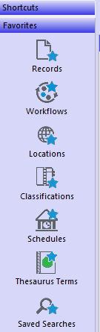
Saved search window and searches  Using the saved search is as easy as double clicking the one you want to use and the results will appear | 