A problem-solving and modelling task suitable for students working with area (Focus: parallelograms, trapeziums, rhombuses and kites)
Modelling Northern Qld

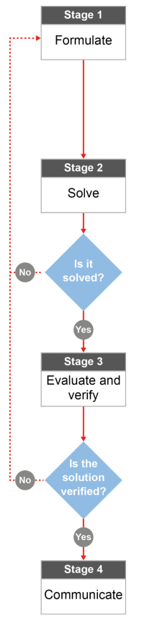

QCAA approach to problem solving and mathematical modelling
(https://www.qcaa.qld.edu.au/downloads/portal/syllabuses/snr_maths_methods_19_syll.pdf)

How big is the Charter Towers Region?

Australian curriculum content descriptors:
Year 8
Find perimeters and areas of parallelograms, trapeziums, rhombuses
and kites (ACMMG196)
L
How big is the Charter Towers Region?
Modelling Northern Qld

1. Which of the following towns do you think is smaller than the Charters Towers Region?

- Townsville
- Mackay
- Cairns
- Brisbane
- Atherton Tablelands
- Rockhampton
- Burdekin Shire
- Whitsundays Region
- Canberra

Research & Formulate

Brittany goes to the Charter Towers Region every year for Christmas with her family. Her friend Jessie thought she meant the town Charters Towers. However, Brittany meant one of the many of smaller regions that make up the Charters Towers Region. Because Jessie has never been to the Charters Towers Region, Brittany is trying to explain how big it really is.
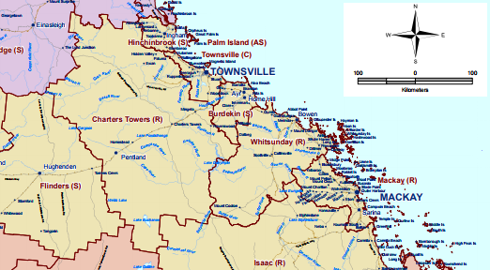
Reference:
Region Map -https://www.communities.qld.gov.au/resources/corporate/regional-boundaries.pdf
2. What single 2D shape could you use to ‘model’ or represent the general shape of the Charters Towers? You’re looking for the shape that fits the closest (no single shape will be perfect).
_______________________________________________________________________________________
- What type of measurement would be the best to describe how big Charters Towers is?
Perimeter Area Volume

- What formula will be useful in your calculations?
_______________________________________________________________________________________________
_______________________________________________________________________________________________
- What information do you need to be able to use the formula? Do you have it already or could you figure it out?
_______________________________________________________________________________________________
_______________________________________________________________________________________________
_______________________________________________________________________________________________

- The picture is a scaled diagram. How will you get the real size of the Charters Towers? [Hint” It is usually easier to do your conversions before using any measurement formula.]
_______________________________________________________________________________________________
_______________________________________________________________________________________________
_______________________________________________________________________________________________
- Looking at the shapes you are using to calculate the size of Charters Towers, would you say that your calculations will be too big or too small? How can you tell?
____________________________________________________________________________________________
____________________________________________________________________________________________
Now that you have a plan…
Solve

- Using your answers from Q2-6, calculate the area of Charters Towers (approximately).

Evaluate & Verify

- The actual area for the Charters Towers Region is 68,366 km². Compare this with your approximation of the area. How could you improve your approximation?
_______________________________________________________________________________________________
______________________________________________________________________________________________
______________________________________________________________________________________________
______________________________________________________________________________________________
______________________________________________________________________________________________
- Google the areas of the towns and regions from question 1. Compare these areas to the area of the Charters Towers Region – are there any that you weren’t expecting? If so, what key factors influenced your decision making?

- Townsville _______
- Mackay _______
- Cairns _______
- Brisbane ______
- Atherton Tablelands ______
- Rockhampton ______
- Burdekin Shire ______
- Whitsundays Region ______
- Canberra ______
______________________________________________________________________________________________
______________________________________________________________________________________________
______________________________________________________________________________________________
______________________________________________________________________________________________
______________________________________________________________________________________________
Communicate

- If someone else was like Jessie and didn’t realise how big the Charters Towers Region is, how would you explain it to them. Justify your answer using your calculations and your research of other areas in Australia.
_______________________________________________________________________________________________
_______________________________________________________________________________________________
_______________________________________________________________________________________________
_______________________________________________________________________________________________
_______________________________________________________________________________________________
_______________________________________________________________________________________________

