A problem-solving and modelling task suitable for students working with trigonometry (Focus: Pythagoras’ Theorem)
Modelling Northern Qld

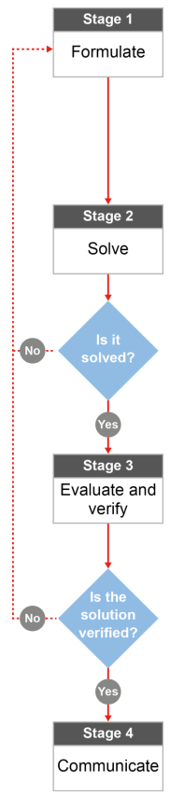

QCAA approach to problem solving and mathematical modelling
(https://www.qcaa.qld.edu.au/downloads/portal/syllabuses/snr_maths_methods_19_syll.pdf)

How much steel is used for the Burdekin bridge?

Australian curriculum content descriptors:
Year 9
Investigate Pythagoras’ Theorem and its application to solving simple problems involving right angled triangles (ACMMG222)

L
How much steel is used for the Burdekin bridge?

Modelling Northern Qld

- Do you live near any bridges? If so, have you considered the materials and designs chosen to build it? What are the bridges that you live near made of and what do they look like?

________________________________________________________________________________________________________________________________________________________________________________

Research & Formulate

Let’s investigate the structure and size of one of our very own bridges The Burdekin Bridge (Silver Link) is longer than Brisbane’s Story Bridge with a total length of 1,097 metres. It is a truss bridge, which means that it is composed of trusses; a structure of connected elements forming triangular units. The truss structures are made up of steel. How much steel would be used along both sides of the entire bridge?
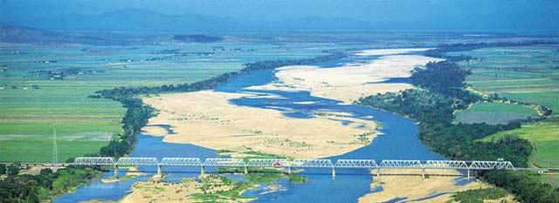
Below is a diagram of the truss structure used to create spans. In total, there are 10 main truss spans and 22 approach spans. For this investigation, we will be focusing on just the 10 main truss spans. Here is one:
60.8 m
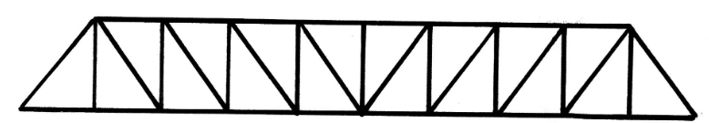
10 m
76 m

- What other information do you need to work out the total amount of steel (as a length) that is needed to make this truss for one side of the bridge? [Hint: not all information you need is there yet.] __________________________________________________________________________________________________________________________________________________________________

- What formula could you use to help you work out the total amount of steel used along the side of the bridge? How can you get the dimensions needed to be able to use this formula? __________________________________________________________________________________________________________________________________________________________________

Now that you have a plan…
- Calculate the amount of steel that is used along the total length of BOTH sides of the Burdekin bridge. Use the diagram and your suggested formula above.
Solve

Evaluate & verify

- Would this solution represent the total length of steel used along the entire length of the bridge? Why/why not?

________________________________________________________________________________________________________________________________________________________________________________________________________________________________________________________________________
________________________________________________________________________________________
- If you were in charge of purchasing the steel to build a bridge like this, would the length of steel that you’ve calculated be enough information? What else would you need to know?
________________________________________________________________________________________________________________________________________________________________________________________________________________________________________________________________________
Communicate

- The maintenance and rehabilitation project for this bridge is estimated to take 5 years to complete. Using your solution and mathematical reasoning, explain why bridge maintenance takes so long.

________________________________________________________________________________________________________________________________________________________________________________
________________________________________________________________________________________
References:
Image Burdekin bridge
http://www.newspapers.com.au/ayr.html

