Chemistry Refresher Workbook

This workbook is used in conjunction with the Chemistry Refresher course. It covers concepts such as:

Part 1
- Matter and Atomic Structure
- The Periodic Table of Elements
- Chemical notation
- Introduction to ionic bonding
- Chemical Reactions
- Simple covalent compounds
Part 2
- The mole and Molar mass
- Stoichiometry
- Periodic trends
- Basic electron configuration
- Introduction to covalent bonding

www.jcu.edu.au/students/learning-centre

Chemistry Refresher – Work booklet.
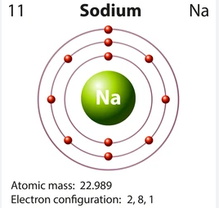
Diagram of a sodium ion. (Lose one electron) [Slide 6]

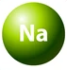

What neutral atom’s electron configuration does this ion now have?
Click or tap here to enter text.
Complete the table. (Slide 8)
Name of element | Element symbol | Mass number | Atomic number | Protons | Neutrons | Electrons
Calcium | Click or tap here to enter text. | Click or tap here to enter text. | Click or tap here to enter text. | Click or tap here to enter text. | Click or tap here to enter text. | Click or tap here to enter text.
Iron | Click or tap here to enter text. | Click or tap here to enter text. | Click or tap here to enter text. | Click or tap here to enter text. | Click or tap here to enter text. | Click or tap here to enter text.
Lead | Click or tap here to enter text. | Click or tap here to enter text. | Click or tap here to enter text. | Click or tap here to enter text. | Click or tap here to enter text. | Click or tap here to enter text.

(Slide 11) Formula for ionic compounds.
Name | Formula (show working)
Calcium chloride
Sodium oxide
Click or tap here to enter text.
Click or tap here to enter text.
Click or tap here to enter text.
Click or tap here to enter text.
Click or tap here to enter text.
Click or tap here to enter text.
Click or tap here to enter text.

(Slide 11) Naming ionic compounds.
Formula | Name of compound
BaCl₂ | Click or tap here to enter text.
MgCO₃ | Click or tap here to enter text.
SrI₂ | Click or tap here to enter text.
LiOH | Click or tap here to enter text.
ZnSO₃ | Click or tap here to enter text.

(Slide 12) Writing balanced chemical equations.
Observations that indicate a chemical reaction has occurred.
Click or tap here to enter text.
Click or tap here to enter text.
Click or tap here to enter text.
Click or tap here to enter text.
What does the equation tell us?

Click or tap here to enter text.
Balance the following equations. (Slide 12)

N_{2(g)} + H_{2(g)} NH_{3(g)}

CH_{4(g)} + O_{2(g)} CO_{2(g)} + H₂O_{(l)}

Pb(NO₃)_{2(aq)} + KI_{(aq)} PbI_{2(s)} + KNO_{3(aq)}

Ca(OH)_{2(aq)} + HNO_{3(aq)} Ca(NO₃)_{2(aq)} + H₂O_{(aq)}

Write full balanced equations for each reaction description. (Slide 13)
Formula | Balanced equation
Zinc – Zn_{(s)}
Hydrochloric acid – HCl_{(aq)}
Hydrogen gas – H_{2(g)}
Zinc chloride
Zn²⁺ Cl⁻¹

ZnCl₂
(Don’t need the “1”)

Click or tap here to enter text.

Click or tap here to enter text.

Click or tap here to enter text.

Click or tap here to enter text.

(Slide 14) Naming and writing formula for covalent compounds.
Name | Formula
Nitrogen trichloride
Click or tap here to enter text.

Click or tap here to enter text.

Click or tap here to enter text.

Click or tap here to enter text.

Formula | Name of compound
H₂S | Click or tap here to enter text.
NH₃ | Click or tap here to enter text.
P₂O₅ | Click or tap here to enter text.
SiBr₄ | Click or tap here to enter text.

PART 2
(Slide 18) Atomic mass/weight. Mole calculations.
Element | Atomic weight | 0.5 mol - mass (working) | 0.0025 mol - mass (working)
Sodium | Click or tap here to enter text.
Lead | Click or tap here to enter text.
Carbon | Click or tap here to enter text.
Uranium | Click or tap here to enter text.
Neon | Click or tap here to enter text.
Iron | Click or tap here to enter text.
(Slide 19)
Compound | Formula weight (working)
Magnesium oxide
MgO

Click or tap here to enter text.
Click or tap here to enter text.
Click or tap here to enter text.
Click or tap here to enter text.

Click or tap here to enter text.

(Slide 21) Stoichiometric calculations.
N_{A} = 6.02 x 10²³
$$n=\frac{m}{MM}$$

- 2Mg_{(s)} + O_{2(g)} 2MgO_{(s)}
- 2H_{2 (g)} + O_{2 (g)} 2H₂O _{(g)}
- H_{2 (g)} + ½O_{2 (g)} H₂O _{(g)}

What does the following equation tell us in terms of quantities reacted and formed?
Equation (a): Click or tap here to enter text.
Equation (b): Click or tap here to enter text.
Equation (c): Click or tap here to enter text.
(Slide 22/23) – Calculations involving mass, volume, concentration, and Avogadro’s number.
1. | 2.
3. | 4.
5. | 6.
7. | 8.
9.

Periodic Trends (Slide 25)
- Click or tap here to enter text.
- Click or tap here to enter text.
- Click or tap here to enter text.
- Click or tap here to enter text.
- Click or tap here to enter text.
- Click or tap here to enter text.
- Click or tap here to enter text.

- Circle or highlight the atom in each row with the larger atomic radius.
Al | B
Na | Al
S | O
O | F
Br | Cl
Mg | Ca

Electron configurations for: (slide 26)
B | Neon
P | Scandium
Ca | Zinc

(Slide 27) Lewis diagrams.
- How many valence electrons does oxygen have? Click or tap here to enter text.

How many electrons are needed to fill this level? Click or tap here to enter text.

2. | 3.

(Slide 28) Lewis structure and molecule shape.
HCl | AlCl₃
CH₄ | CCl₄
CO₂ | O₂

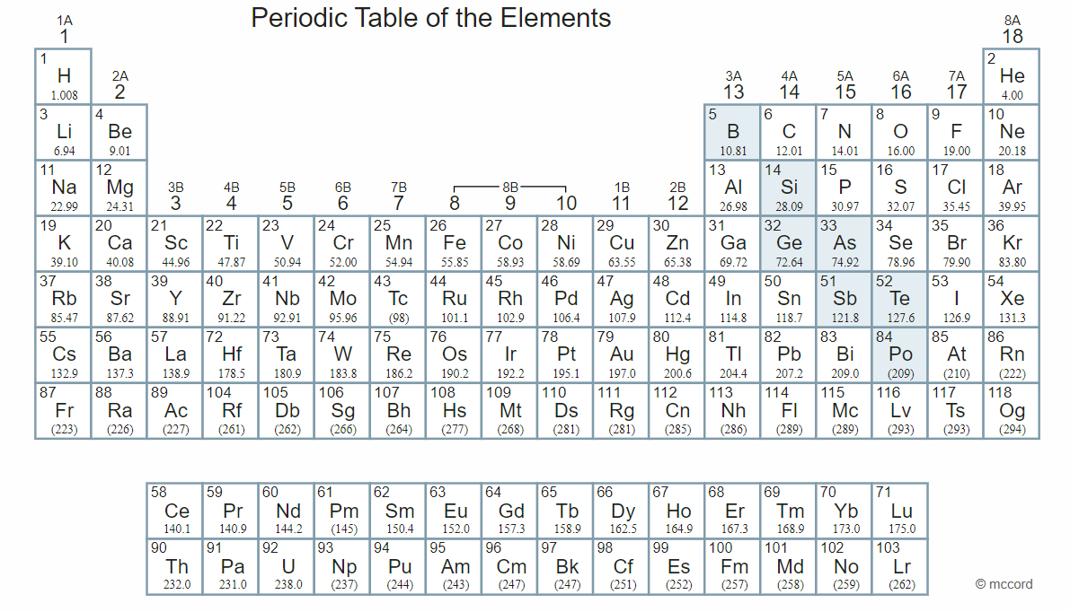

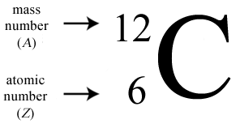
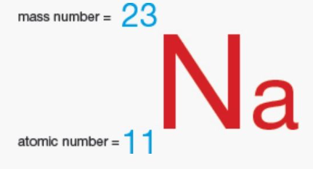
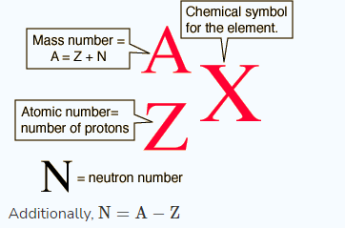

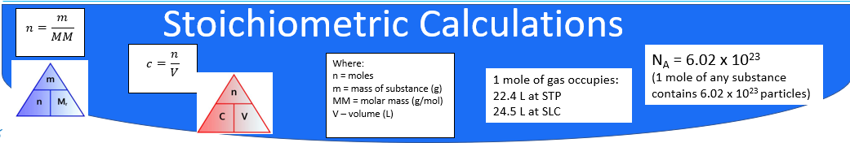

*22.7 L

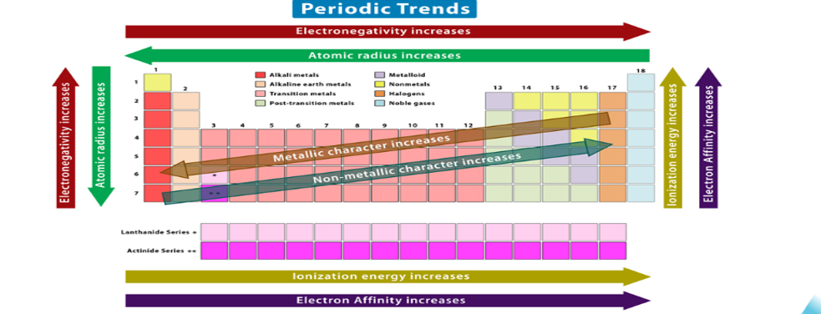
Ionisation energy: is the energy required to remove the highest-energy electron from a neutral atom.
Electronegativity: is the measure of the ability of an atom in a bond to attract electrons to itself.
Atomic radius: is the distance from the atom’s nucleus to the outer edge of the electron cloud.
Electron affinity: a neutral atom’s likelihood of gaining an electron. (change in energy when electron added)
Metallic character: refers to the level of reactivity of a metal (metals tend to lose electrons in chemical reactions)
Non-metallic character: relates to the tendency to accept electrons during chemical reactions

