Planning
JCU Blended Learning Design Tool

At JCU Blended learning refers to the purposeful combination of face-to-face and online activities designed to optimise student engagement and the achievement of learning outcomes. The design of the blend will vary according to intended outcomes, student needs, context, discipline, mode of delivery and whole-of-course considerations. Blended subjects may be offered in internal, limited, block or placement/work experience modes. Subjects may also be offered fully online in external mode.
The JCU Blended Learning Design Tool is a companion to Blended Learning @ JCU: a guide for staff and will assist you to work through the phases of the design cycle. The guiding questions are mapped to the JCU Standards for Blended and Online Subject Design. Work through the questions in this document either individually, as a teaching team or with facilitation from an Educational Designer.
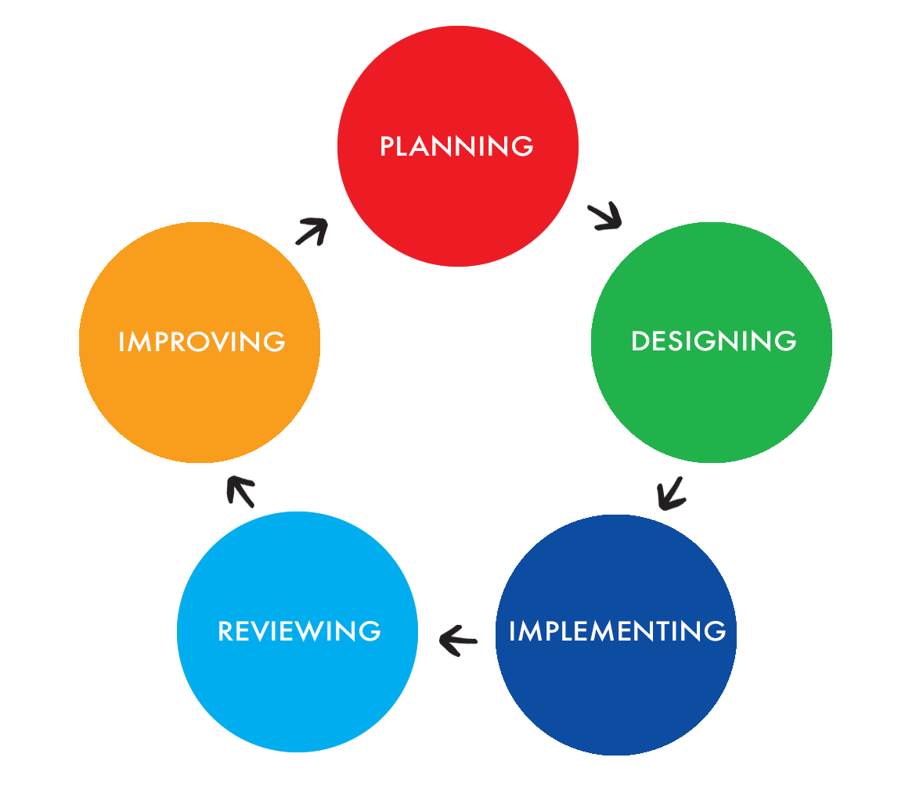

Understanding the big picture and identifying what you want to preserve and transform in your subject redesign.

Guiding Questions | Blended Learning Standards
Profile my learners  What are the characteristics of my students? What can I draw from COGNOS to help me understand these characteristics?  What are the historical success rates of students in this subject and similar year and disciplines cohorts? Are there any previous differences in the student experience by campus of mode of delivery?  Do they comprise a large or small cohort?  What is their digital literacy? What is their access to information and communication technology (ICT)?  Are there students with disabilities? How can I adapt materials for them?  My thoughts | Standard 1 Threshold  - Select content to support different learning styles.  Standard 5 Threshold  - Explicitly include academic skill development and assurance in core subjects.  Standard 6 Threshold  - Recognise disparities in students’ access to internet services.  Standard 6 Desirable  - Provide links to institutional policies and contacts for supporting learners with disabilities.  - Include design factors such as colour, text size manipulations, audio and video controls to reflect accessibility considerations.  Standard 6 Key First Year Indicators  - Use survey or readiness tools to diagnose learning technology access and familiarity with use of core technologies.  Standard 8 Threshold  - Implement reasonable adjustments for students with a disability.
Review the subject learning outcomes  What do I want my students to know when they have completed my subject? Review key learning outcomes – knowledge, skills and attitudes.  How do my subject learning outcomes relate to course learning outcomes and professional accreditation standards?  My thoughts | Standard 1 Desirable  - Use the Six principles of JCU model to support distinctive JCU experience.
How will students demonstrate these outcomes?  What assessments will my students complete to demonstrate their learning in my subject? Are there formative assessment opportunities? Are assessment types authentic?  How well aligned are these assessments to my learning outcomes?  How can technologies enable equivalence of my assessment across different modes of study?  My thoughts | Standard 2 Threshold  - Ensure clear alignment of assessment tasks to learning outcomes and make this alignment explicit for students.  - Provide assessment for learning opportunities in all subjects including the use of diagnostic tools, peer assessment, multiple attempt quizzes etc.  - Provide peer assessment opportunities in the face-to-face and or/online environment within a course.  - Use a variety of assessment types that ensure academic integrity according to JCU Learning, Teaching and Assessment Policy core principle 5.  - Provide explicit assessment criteria and exemplars when assessing Communication Skills and Numeracy.  - Use Gradebook to promote self-tracking of progress and staff monitoring of submission and progress.  - For block or limited mode subjects, schedule assessment to be submitted close to the face-to-face component and in a time that reflects availability of students.  Standard 2 Desirable  - Develop eAssessment options.  Standard 2 First Year Indicators  - Provide clear statements of how assessment activities align with learning and teaching activities.  - Include compulsory completion of an academic integrity module as part of assessment tasks.  - Schedule formative quizzes to promote confidence.  - Provide opportunities to complete assessment tasks in stages with explicit feedback at each stage that supports completion of subsequent stage(s).  - Include advice on support that is available to assist students to complete tasks.
What do I want to preserve from my existing subject?

Do I have quality teaching and learning outcomes in a particular area? Assessments that work well for my students? Do I already have high-quality media, readings, activities or other LearnJCU resources? Are there high-impact learning experiences that I want to retain?

My thoughts

What is the current feedback about this subject?  What is my JCU Course Performance Report telling me regarding internal and external student survey data and success outcomes for this subject?  What are my JCU Subject Learning Analytics reports telling me?  My thoughts | Standard 4 Key First Year Indicators  - Utilise Learning Analytics to proactively identify students in need of support to enable resources to be provided as appropriate.  Standard 6 Threshold  - Use LearnJCU Retention Centre and Analytics to monitor student engagement.  Standard 8 Threshold  - Use Learning Analytics to monitor student engagement.
What would I like to transform?  Do I have elements of my subject that are particularly confusing, boring or fundamental?  How can I transform my outcomes, assessments, activities or resources to make a real difference to my student learning?  My thoughts | Standard 1 Threshold  - Select content that is aligned to learning outcomes.  - Ensure subject design includes guidance for learners to work with content in meaningful ways.  - Use a variety of LearnJCU tools to engage students with course content.  - Use JCU Library licensed content and/or open source content or to support relevant key concepts (high value discipline websites/ resources/videos/streaming material)  - Include teacher-created video to identify key points/focus areas or highlight threshold concepts (maximum 10 minutes).  Standard 1 Desirable  - Present materials in a clear sequence based on the disciplines preferred learning design e.g. inquiry frameworks such as 5Es; project/problem based learning; or scenario based learning.  - Support students’ independent learning by providing carefully selected content that encourages them to investigate subject content beyond threshold concepts especially into research orientations where appropriate.  - Provide mixed face-to-face and online delivery of threshold concepts in middle/final year of courses.  - Schedule regular LearnJCU Collaborate sessions to provide students with support around content and provide opportunity for collaboration.
What support or professional development do I need?  Do my teaching team or I need specific skills, educational design advice or support to help achieve the blended learning goals for the subject?  My thoughts | Refer to all 8 Blended Learning Standards:  - Enabling Learning Technologies @ JCU links  - More Information/Examples links

Designing
Identifying learning & teaching activities, assessment, key topics, and online components for your subject.

Guiding Questions | Blended Learning Standards
What framework supports blended learning in my context?  Crucial to student success in blended learning is active engagement with the teacher, their peers and the learning materials. Is my subject suited to the 5 E’s approach? What other frameworks are used in my discipline area?  My thoughts | Standard 1 Desirable  - Present materials in a clear sequence based on the disciplines preferred learning design e.g. inquiry frameworks such as 5Es; project/problem based learning; or scenario based learning  - Use the Six principles of JCU model to support distinctive JCU experience  Standard 4 Desirable  - Engage and support online interaction using Salmon’s 5 stage model for external and block mode subjects
What types of learning activities will I design?  Teaching involves developing challenging and engaging learning activities. Is the use of case-based, problem-based, scenario-based or project-based learning a valid option for my subject?  Can I use Bloom’s Digital Taxonomy to match learning activities to the level of learning expected?  My thoughts | Standard 1 Threshold  - Use a variety of LearnJCU tools to engage students with course content  - Use adaptive release feature of LearnJCU to support students’ access and engagement  Standard 1 Desirable  - Use Learning Analytics to review and improve use of content and learning activities  - Provide options for students to generate and share own content  Standard 3 Threshold  - Ensure face-to-face teaching provides opportunities for students to collaborate and develop a sense of belonging through active learning and group activities  - Provide clear expectations and/or exemplars of what constitutes a ‘good’ response or posting  - Support online collaboration using tools such as wikis, especially where group work is part of assessment requirements  - Use online discussion tools in a purposeful manner  Standard 3 Desirable  - Integrate scenario/problem-based/case based group work using authentic examples inherent to discipline  - Provide opportunities to discuss content and professional orientations using online discussion tools  - Support the adoption of professional networking approaches by using online tools such as LinkedIn, ResearchGate and similar applications
What will count as evidence of learning?  What assessment tasks will allow students to demonstrate and apply knowledge and skills in authentic and novel contexts?  How do my assessment methods align with learning outcomes? How and when will I provide feedback to students?  Do my assessments have clear and well-developed rubrics? Do I have exemplars of previous student work? Are my assessments described with clear, detailed, step-by-step supporting documents?  My thoughts | Standard 2 Threshold  - Ensure clear alignment of assessment tasks to learning outcomes and make this alignment explicit for students  - Provide assessment for learning opportunities in all subjects including the use of diagnostic tools, peer assessment, multiple attempt quizzes etc.  - Provide peer assessment opportunities in the face to face and or/online environment within a course  - Use a variety of assessment types that ensure academic integrity according to JCU Learning, Teaching and Assessment Policy core principle 5  - Provide explicit assessment criteria and exemplars when assessing Communication Skills and Numeracy  - Use Gradebook to promote self-tracking of progress and staff monitoring of submission and progress  - For external subjects, schedule timely online workshops to explicitly discuss assessment expectations task and requirements  - For block or limited mode subjects, schedule assessment to be submitted close to the face to face component and in a time that reflects availability of students  Standard 2 Desirable  - Develop eAssessment options  Standard 2 First Year Indicators  - Provide clear statements of how assessment activities align with learning and teaching activities  - Provide exemplars of completed assessment tasks at varying achievement standards  - Include compulsory completion of an academic integrity module as part of assessment tasks  - Schedule formative quizzes to promote confidence  - Provide opportunities to complete assessment tasks in stages with explicit feedback at each stage that supports completion of subsequent stage(s)  - Include advice and model how to submit assessment using SafeAssign  - Include advice on support that is available to assist students complete tasks
What are my expectations for student participation in a blended environment?  How will I create a purposeful flow between online and physically based learning experiences? How will I monitor student participation? Can I develop efficiencies through my subject design for internal and external students? What impact will my changes make on student workload?  My thoughts | Standard 1 Threshold  - Sequence content so it flows in a logical progression that students can navigate  - Ensure content is made available or ‘chunked’ in manageable segments (i.e. weekly topics/modules)  - Provide preliminary content prior to block teaching periods to promote engagement  - Ensure any online content supplements and reinforces face-to-face delivery for internal subjects  - Include teacher-created video to identify key points/focus areas or highlight threshold concepts (maximum 10 minutes)  - Use internally recorded lectures for internal mode subjects only (revision purposes)  Standard 1 Desirable  - Provide options for students to generate and share own content  - Support students’ independent learning by providing carefully selected content that encourages them to investigate subject content beyond threshold concepts especially into research orientations where appropriate  - Provide mixed face-to-face and online delivery of threshold concepts in middle/final year of courses  - Schedule regular LearnJCU Collaborate sessions to provide students with support around content and provide opportunity for collaboration  Standard 4 Threshold  - Provide explicit guidance about the purpose and nature of various face-to-face learning experiences  - Ensure provision for face-to-face contact in all internal subjects (equivalent 2-3 hours per week across a regular study period)  - Clearly indicate staff support options (both academic and professional) throughout the subject, and action using just in time† approaches  - Provide synchronous support options of up to 2 hours per week for external students  Standard 4 Key First Year Indicators  - Utilise Learning Analytics to proactively identify students in need of support to enable resources to be provided as appropriate  Standard 6 Threshold  - Use LearnJCU Retention Centre and Analytics to monitor student engagement  Standard 8 Threshold  - Use Learning Analytics to monitor student engagement
What enabling tools will I use?  Review the Teaching with Technology @ JCU diagram. What tools in LearnJCU can I use to enable interaction, collaboration and reflection? Will I make use of threaded discussions, quizzes, journals, blogs, wikis, web conferencing or e-portfolios?  My thoughts | Standard 1 Threshold  - Use a variety of LearnJCU tools to engage students with course content  - Use adaptive release feature of LearnJCU to support students’ access and engagement  - Sequence content so it flows in a logical progression that students can navigate  Standard 2 Threshold  - Provide assessment for learning opportunities in all subjects including the use of diagnostic tools, peer assessment, multiple attempt quizzes etc.  Standard 2 Desirable  - Develop eAssessment options  - Use online tools such as audio or video feedback options available on LearnJCU to provide high quality and timely feedback  Standard 3 Threshold  - Support online collaboration using tools such as wikis, especially where group work is part of assessment requirements  - Use online discussion tools in a purposeful manner  Standard 6 Threshold  - Communicate clear expectations for interactions in the online learning environment  - Model learning technology use in face-to-face delivery in internal subjects  - Introduce varied technologies gradually  - Explicitly teach use of core learning technologies  Standard 6 Key First Year Indicators  - Use survey or readiness tools to diagnose learning technology access and familiarity with use of core technologies
What resources and supports will I need to provide in the LearnJCU site to enable students to successfully access learning resources and participate in learning activities?  My thoughts | Standard 1 Threshold  - Ensure subject design includes guidance for learners to work with content in meaningful ways  - Use adaptive release feature of LearnJCU to support students’ access and engagement  Standard 1 Desirable  - Schedule regular LearnJCU Collaborate sessions to provide students with support around content and provide opportunity for collaboration  Standard 1 Key First Year Indicators  - Provide explicit guidance on to how to use learning resources within LearnJCU (site map, location of assessment, learning activities, collaboration tools)  Standard 4 Threshold  - Provide explicit guidance about the purpose and nature of various face-to-face learning experiences  - Clearly indicate staff support options (both academic and professional) throughout the subject, and action using just in time approaches  - Provide synchronous support options of up to 2 hours per week for external students  Standard 5 Threshold  - Provide links in LearnJCU to information literacy guides relevant to the subject  - Provide real-time support using synchronous sessions e.g.: LearnJCU Collaborate for external and block mode subjects  Standard 5 Desirable  - Direct students to online learning skills options  Standard 5 First Year Indicators  - Include detailed advice on information literacy resources relevant to the subject  - For external subjects, ensure synchronous support is provided for up to 2 hours per week at key times (e.g.: LearnJCU Collaborate for Learning Advisors, library staff)  Standard 6 Threshold  - Describe hardware, software, connectivity requirements to support full engagement with external subjects  - Provide links to key web-based discipline resources including learning applications (apps)  - Provide explicit advice on how to navigate the subject LearnJCU site and access relevant policy and support materials  - Explicitly teach use of core learning technologies  - Actively refer to self – help resources e.g.: Lynda.com  - Direct to appropriate online, up-to-date and reliable technological guides and resources  - Ensure appropriate, timely and reliable asynchronous technological support if available for external subjects  Standard 6 Desirable  - Direct students to self-service supports  - Provide links to institutional policies and contacts for supporting learners with disabilities  Standard 8 Threshold  - Ensure up-to-date links to self-help options are available e.g.: The Desk  - Provide links and integrate key library resources such as Info Skills Road Trip and Libguides on LearnJCU  - Provide dedicated links to off-campus library services for external subjects
Have I planned the structure of my LearnJCU site to ensure ease-of-use for students?  Do I need to use a common template or design endorsed by my College or discipline?  Am I aware of good practice in the use of folders, documents and links?  My thoughts | Standard 1 Threshold  - Ensure subject design includes guidance for learners to work with content in meaningful ways  - Sequence content so it flows in a logical progression that students can navigate  - Ensure content is made available or ‘chunked’ in manageable segments (i.e. weekly topics/modules)  Standard 1 Desirable  - Present materials in a clear sequence based on the disciplines preferred learning design e.g. inquiry frameworks such as 5Es; project/problem based learning; or scenario based learning
How will I communicate the learning design and overall subject expectations to my students?  Is my subject outline easily found? How can I ensure students have read and understood key elements of the subject outline?  Have I explicitly linked the subject learning outcomes to any module or weekly learning outcomes?  Have I supplied learning guides? Have I planned for in-class explanations?  My thoughts | Standard 1 Threshold  - Select content that is aligned to learning outcomes  - Ensure subject design includes guidance for learners to work with content in meaningful ways  - Provide key readings with rationale for inclusion and introduction to each  Standard 1 Key First Year Indicators  - Provide explicit instructions about time required for study:  - Ensure provision for face to face contact in all internal subjects (equivalent 2-3 hours per week across a regular study period)  - Independent study (6 – 8 hours per week for each subject)  Standard 2 Threshold  - Ensure clear alignment of assessment tasks to learning outcomes and make this alignment explicit for students  Standard 2 Key First Year indicators  - Provide clear statements of how assessment activities align with learning and teaching activities  Standard 4 Threshold  - Provide explicit guidance about the purpose and nature of various face-to-face learning experiences

Implementing
The actual subject delivery. Where the rubber hits the road.

Guiding Questions | Blended Learning Standards
What new learning activities and/or content and/or assessment do I need to develop for my subject?  Do I have the time, resources and capability to develop these elements? Are there existing JCU resources I could adapt? Are there Open Educational Resources I could adapt and re-use?  My thoughts | Standard 1 Threshold  - Select content that is aligned to learning outcomes  - Provide key readings with rationale for inclusion and introduction to each  - Select content to support different learning styles  - Provide preliminary content prior to block teaching periods to promote engagement  - Use JCU Library licensed content and/or open source content or to support relevant key concepts (high value discipline websites/ resources/videos/streaming material)  - Ensure any online content supplements and reinforces face-to-face delivery for internal subjects  - Include teacher-created video to identify key points/focus areas or highlight threshold concepts (maximum 10 minutes)  - Use internally recorded lectures for internal mode subjects only (revision purposes)  Standard 1 Desirable  - Provide options for students to generate and share own content  - Support students’ independent learning by providing carefully selected content that encourages them to investigate subject content beyond threshold concepts especially into research orientations where appropriate  Standard 2 Threshold  - Provide assessment for learning opportunities in all subjects including the use of diagnostic tools, peer assessment, multiple attempt quizzes etc.  - Provide peer assessment opportunities in the face to face and or/online environment within a course  - Use a variety of assessment types that ensure academic integrity according to JCU Learning, Teaching and Assessment Policy core principle 5  Standard 2 Desirable  - Develop eAssessment options  Standard 2 Key First Year Indicators  - Provide clear statements of how assessment activities align with learning and teaching activities  - Provide exemplars of completed assessment tasks at varying achievement standards  - Include compulsory completion of an academic integrity module as part of assessment tasks  - Provide assessment for learning opportunities in all subjects including the use of diagnostic tools, peer assessment, multiple attempt quizzes etc.  - Provide opportunities to complete assessment tasks in stages with explicit feedback at each stage that supports completion of subsequent stage(s)  - Include advice and model how to submit assessment using SafeAssign  - Include advice on support that is available to assist students complete tasks  Standard 3 Threshold  - Ensure face-to-face teaching provides opportunities for students to collaborate and develop a sense of belonging through active learning and group activities  - Support online collaboration using tools such as wikis, especially where group work is part of assessment requirements  - Use online discussion tools in a purposeful manner  Standard 6 Threshold  - Explicitly teach use of core learning technologies  Standard 6 Desirable  - Provide opportunities to demonstrate digital literacies in assessment pieces
How will I track learner activity and provide feedback?  How are my students engaging with the subject materials? Is there an increase in content access? Are my students participating more in active learning? Are there more or less queries regarding assessment and other learning content? Have I made use of Learning Analytics to access reports, such as ‘Subject at a Glance’?  My thoughts | Standard 1 Desirable  - Use Learning Analytics to review and improve use of content and learning activities  - Schedule regular LearnJCU Collaborate sessions to provide students with support around content and provide opportunity for collaboration  Standard 4 Key First Year Indicators  - Utilise Learning Analytics to proactively identify students in need of support to enable resources to be provided as appropriate  Standard 6 Threshold  - Use LearnJCU Retention Centre and Analytics to monitor student engagement  Standard 8 Threshold  - Use Learning Analytics to monitor student engagement
What plans/support do I have in place to help students address scheduling their work and managing their time?  My thoughts | Standard 1 Key First Year Indicators  - Provide explicit instructions about time required for study:  - Ensure provision for face to face contact in all internal subjects (equivalent 2-3 hours per week across a regular study period)  - Independent study (6 – 8 hours per week for each subject)  Standard 5 Threshold  - Explicitly include academic skill development and assurance in core subjects  Standard 5 Desirable  - Direct students to online learning skills options  Standard 5 First Year Indicators  - For external subjects, ensure synchronous support is provided for up to 2 hours per week at key times (e.g.: LearnJCU Collaborate for Learning Advisors, library staff)
Have I checked the settings and availability dates of any quizzes, assignment submissions or other content items?

My thoughts

Reviewing
Determining the effectiveness of the subject and disseminating the results.

Guiding Questions | Blended Learning Standards
What kind of evaluation processes am I planning in order to assess the effectiveness of my subject redesign and inform continuing improvement?

Am I using the extra question personalisation available in the YourJCU Subject and Teaching Surveys to access student learning and experience of my blended initiatives?

Have I considered a peer review of materials used in LearnJCU?

Could I use assistance from a more experience blended learning mentor via the Peer Assisted Teaching Scheme (PATS)?

My thoughts

How will I share what I learn with others in my College?

What mechanisms exist currently in my College to share my experiences with others?

Can I present my blended learning initiatives to my external peers at discipline specific or general Learning and Teaching forums / conferences?

My thoughts

Improving
Making informed changes for yourself and your students.

Guiding Questions | Blended Learning Standards
What changes to the learning experience will I make? What support or professional development do I need to make the improvements I identify?

What aspects from the 4Q model of Learning and Teaching evaluation will inform any changes? Have I closed the feedback loop and ensured students are informed in the next iteration of the subject via the Subject Outline?

Have I kept clear evidence of my blended learning changes and student learning to inform my professional development, PMP process and promotions?

My thoughts

The JCU Standards for Blended and Online Subject Design have been significantly modelled on the Standards of Online Education developed by Mitch Parsell.

The JCU Blended Learning Design Tool is adapted from Designing your Unit for Blended Learning, Developed by the Blended Learning Team, Learning and Teaching Unit | www.uws.edu.au/qilt

