Modelling Northern Qld
A problem-solving and modelling task suitable for students working with data (Focus: investigating numerical data)

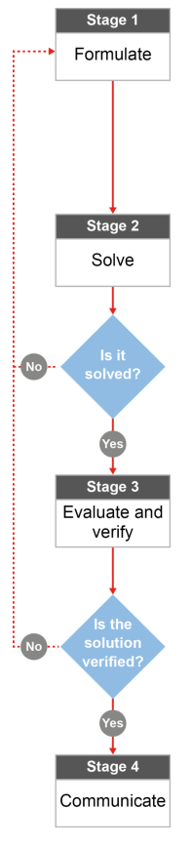

QCAA approach to problem solving and mathematical modelling
(https://www.qcaa.qld.edu.au/downloads/portal/syllabuses/snr_maths_methods_19_syll.pdf)

Is your favourite NRL footballer also the best?

Australian curriculum content descriptors:
Year 7
Identify and investigate issues involving numerical data collected from primary and secondary sources (ACMSP169)

L
Is your favourite NRL footballer also the best?
Modelling Northern Qld

- If you follow the national NRL competition, then you are likely to have a favourite team and a favourite player. If you don’t have a favourite player then pick one player from your team who you can then compare with players from other teams. Unfortunately, Johnathan Thurston can’t be considered as he played so few games this year. Who is your choice? (You could choose Cameron Smith, the Queensland captain if you don’t have a preference).
How does your choice compare with players who played in the same on-field position with other clubs in the competition? Is he better than most of them or much the same in ability in your opinion?
__________________________________________________________________________________________________________________________________________________________________
Research & Formulate

Let’s look at finding a list of the players who play the same position (number) as your player and collect some of their game statistics for the season, so we can work out whether our player is the best in this position.
We can compare many areas where statistics are recorded during matches but we will focus on points scored, tries (getting the ball over the line to score points), try assists (helping a team mate score a try), goals (kicks for extra points), tackles (stopping someone else who has the ball), runs (how many times you get the ball and run forward with it) and run distance (how far you move the ball forward before being tackled). Areas not covered include penalties, errors, send-offs, missed tackles, etc., as we are more interested in their good points rather than the bad.
- Do you feel these are a good measure of a player’s ability or should something be added or removed to give a better picture of your player’s real ability?
__________________________________________________________________________________________________________________________________________________________________
- Get the stats for your favourite player. Go to NRL Player Stats www.nrl.com/stats/telstrapremiership/playerstatistics/tabid/10877/default.aspx and type your player’s name in the Player Search box. Make sure the page shown indicates Telstra Premiership for 2017
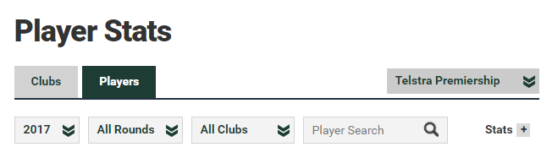

Record his below. The Stats + button tells you what all the green box headings are.
Now fill in row number 1 of the table below for your player, using the 2017 total statistics on the website (not the 2017 average). An example with Johnathon Thurston’s statistics is provided below. NOTE: You won’t need all of the information from the website so look carefully at what information you need. Please leave the “Points” column in your table blank for now.
No. | Player | Club | Tries | Goals | Field Goals | Points | Try assists | All runs | All run metres | Tackles
e.g. | Thurston | Cowboys | 2 | 26 | 1 |  | 7 | 87 | 585 | 97

1

2

3

4

5

6

- To work out points, you need to allow 4 points for a try, 2 points for a goal and 1 point for a field goal. If P represents the number of points in total, t represents the number of tries scored, g represents the number of goals scored and f represents the number of field goals scored…
- What formula could you use to calculate the points scored by a player? P = _
- Use your formula to work out the total points scored by your player and add it in to your table.
- Now get the stats on similar players in the NRL competition so that you can compare with your favourite player. Go to www.nrl.com/news/weeklyfeatures/teamlists/tabid/11656/roundid/1455/default.aspx to find the Team lists for the last game (round 26) before the finals.

Select the SHOW button if necessary to see all the players in a team (do that as you scroll down to other teams). From any five teams, find the player who plays in the same position as your player

For example: Johnathan Thurston is a halfback and other halfbacks from other teams include:

Cooper Cronk (Storm) Cherry-Evans (Eagles) Nikorima (Broncos) Mason Lino (Warriors)
To get the statistics of any player, simply click on the player’s name in the team list to get their stats. Record the stats of each player under the categories in your table. You may prefer to set up a spreadsheet to record your data.
- Now you have a lot of data!! With all this data how do you expect to be able to tell that your chosen player is better than those playing the same position for other teams? __________________________________________________________________________________________________________________________________________________________________
Now you can show your player is best!
Solve

- With all your Player Stats collected, complete a bar graph for all 6 – 8 players including your player to compare the number of points scored by each player.
Draw a labelled bar graph (like the one shown for JT but don’t include him in your comparison!) – one bar or column for each player chosen.

Does this bar graph give you enough information to suggest your player is the best of this group? Why/why not?
___________________________________________________________________________________________________________________________________________________________________________________________________________________________________________________

- Repeat the process for number of tries and try assists.

What can you say about how your player stacks up against his competitors now? ________________________________________________________________________________________________________________________________________________________________________________________________________________________________________________________________________

- Repeat the process for the total number of runs and total distance covered.

How does your player compare with his competitors in this area? ________________________________________________________________________________________________________________________________________________________________________________________________________________________________________________________________________
- Finally, consider the number of tackles to complete the stats.

As a defender, how does your player compare in his ability to tackle players? ________________________________________________________________________________________________________________________________________________________________________________________________________________________________________________________________________
Evaluate & verify

- Overall, by consider his ranking in the graphs you created, how does your favourite player compare with equivalent players from other clubs? Which statistics (if any) could you use to argue that your player is the best?
________________________________________________________________________________________________________________________________________________________________________________________________________________________________________________________________________________________________________________________________________________________________
- Apart from the award for Player of the Year, there is also an award for the best player in each position.
Fullback | Billy Slater (Storm) | – number 1
Winger | Jordan Rapana (Raiders) | – number 2 or 5
Centre | Dylan Walker (Eagles) | – number 3 or 4
Five-eighth | Gareth Widdop (Dragons) | – number 6
Halfback | Michael Morgan (Cowboys) | – number 7
Prop | Aaron Woods (Tigers) | – number 8 or 10
Hooker | Cameron Smith (Storm) | – number 9
Second-rower | Matt Gillett (Broncos) | – number 11 or 12
Lock | Paul Gallen (Sharks) | – number 13
Dally M Player of the Year | Cameron Smith (Storm)‌

Was your player fortunate enough to win one of the position awards?
Do you feel your player was good enough to win his position or was he possibly overlooked by the judges? In which areas did he excel and where might he have been less successful? ________________________________________________________________________________________________________________________________________________________________________________________________________________________________________________________________________________________________________________________________________________________________
Communicate

- We know there is more to a player’s ability in any football code to simply scoring. Run metres, tackle breaks, line-breaks, tackles made, tackles missed and errors are all actions that are easily recorded, and are what most people will also look at to judge the players ability and effort in a match.
But the expert commentators often see things differently and pick their best players for reasons that are not always clear to the fans. They refer to things called “one percenters” as being important. What do you think this term means when picking best players? Google the term to find out more if you need to.

________________________________________________________________________________________________________________________________________________________________________________________________________________________________________________________________________

