A problem-solving and modelling task suitable for students working with Rates (Focus: dollars/second analysis)
Modelling Northern Qld

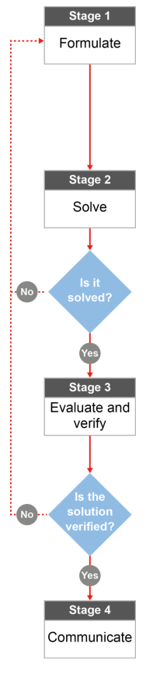

QCAA approach to problem solving and mathematical modelling
(https://www.qcaa.qld.edu.au/downloads/portal/syllabuses/snr_maths_methods_19_syll.pdf)

Does it cost more to be a North Queensland thrill seeker?
This task forms part of a set of tasks that link to an excursion to your local show.
Our thanks to the Cairns State High School maths staff for sharing these ideas.

Australian curriculum content descriptors:
Year 8
Solve a range of problems involving rates and ratios, with and without digital technologies (ACMNA188)

L
Does it cost more to be a North Queensland thrill seeker?

Modelling Northern Qld

- Is there a connection between the cost of thrill rides and ride time or the thrill factor? Would you expect the cost of a ride to increase with increasing ride length or for scarier rides? Or are these factors entirely unrelated? State your opinion based on what you know about show rides.

________________________________________________________________________________________________________________________________________________________________________________

Research & Formulate

Let’s gather some information by (1) researching more about the cost of local show rides, the time a ride takes and the thrill factor and (2) using our knowledge of statistics to find out if your prediction in Question 1 is accurate.

Research the situation: Costs of rides
Ride operators have a lot to consider when they determine an appropriate ticket price for their rides. Too much and they won’t have many participants; too little and they won’t make much profit. Decisions about such matters fall under the mathematical concept termed ‘optimisation’. But firstly, you need to determine if there is a relationship between these aspects of rides.
Research the Maths needed to investigate:
When we compare quantities involving different units, we can describe one quantity in terms of another (e.g. speed is a measure of distance covered compared to the time it takes).
- Plan out how you could get some information on the variables involved in this situation: cost, length of ride and thrill factor.
- What would be an appropriate unit to measure the length of a ride? __________________________
- What tool could you use to measure the length of a ride? ___________________________________
- What would be an appropriate unit to measure the cost of a ride? ____________________________
- How would you go about finding out the cost of each ride? __________________________________
- How will you categorise the rides according to “thrill factor”? You will need to make a decision about the kinds of categories you will use (choose at least two levels of “thrill” – perhaps more). You can refine your categories once you begin collecting your data.
Solve

- Collect some data on ride time, ticket price, and thrill factor as you move around the show. Use the table on the next page to record your data.
  - First, record the thrill category using your categories from question 1. You can modify your categories as you move around the show. Mathematicians often modify their models as they work.
  - Record the cost of a ride before the ride starts in Column 3 of the table.
  - Record the ride time (time from the start of the ride to the finish) in column 4.
  - Collect data on at least 10 different rides. Make sure you choose different types of rides (include rides for little kids, “family” type rides like the dodgems and thrill seeker rides (mild, medium, extreme or whatever categories you are using).
Ride | Thrill factor category | Cost ($) | Time (seconds) | Time/cost (sec/$) (How long do you get for each dollar you spend?) | Cost/time ($/sec) (How much do you pay for each second you ride?)
(e.g. The Claw) | High thrill (upside down) | (4) | (115) | 115 sec for $4 or 29 seconds/dollar | $4/115 sec or $2.09/min
1
2
3
4
5
6
7
8
9
10

- Next, write the cost and time for each ride as two different rates.
- In column 5, write the time compared to the cost, then simplify your rate so that the ride time is described in terms of one dollar.
- In column 6, write the cost of the ride compared to the time, then simplify your ratio so that the cost of the ride is described in terms of one minute. You may find it easier to work in cents and seconds and to describe the cost of the ride for 60 seconds (and then it converts easily to cost per minute).

Evaluate & verify

- Do you notice a trend across all of the rides? ___________________________________________
- If so, describe the relationship between ride cost and ride time.
_________________________________________________________________________________________________________________________________________________________________________________________________________________________________________________________________________________

- Now look at rides in the same “thrill category”. Do you notice any trends for different thrill categories? ___________________________________________
- If so, describe the relationship between ride cost and ride time for different thrill categories.
_________________________________________________________________________________________________________________________________________________________________________________________________________________________________________________________________________________

- Can you think of any other variables you might collect data on that would show a definite relationship with Ride Cost? ___________________________________________________

Communicate

- What if someone you knew decided to join the show and to run an extreme thrill seeker ride. What advice would you give to that person about ticket prices and ride time? Justify your advice with specific examples from your data.
____________________________________________________________________________________________________________________________________________________________________________________________________________________________________________________________________________________________________________________________________________________________________________________________________________________________________________________________________________

