A problem-solving and modelling task suitable for students working with trigonometry (Focus: Pythagoras’ Theorem)
Modelling Northern Qld

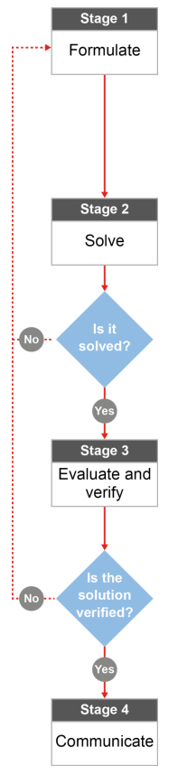

QCAA approach to problem solving and mathematical modelling
(https://www.qcaa.qld.edu.au/downloads/portal/syllabuses/snr_maths_methods_19_syll.pdf)

How much steel is used for the Burdekin bridge?

Australian curriculum content descriptors:
Year 10
Solve right-angled triangle problems including those involving direction and angles of elevation and depression (ACMMG245)

L
How much steel is used for the Burdekin bridge?

Modelling Northern Qld

- Do you live near any bridges? If so, have you considered the materials and designs chosen to build it? What are the bridges that you live near made of and what do they look like?

________________________________________________________________________________________________________________________________________________________________________________

Research & Formulate

Let’s investigate the structure and size of one of our very own bridges The Burdekin Bridge (Silver Link) is longer than Brisbane’s Story Bridge with a total length of 1,097 metres. It is a truss bridge, which means that it is composed of trusses; a structure of connected elements forming triangular units. The truss structures are made up of steel. How much steel would be used along both sides of the entire bridge?
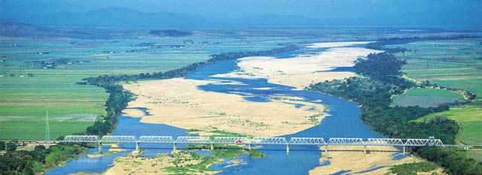
Below is a diagram of the truss structure used to create spans. In total, there are 10 main truss spans and 22 approach spans. For this investigation, we will be focusing on just the 10 main truss spans.
60.8 m
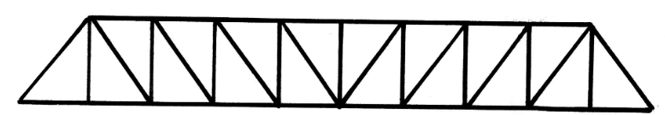
10 m
76 m

- What other information do you need to work out the total amount of steel (as a length) that runs along the side of the bridge? [Hint: not all information you need is there yet.]
__________________________________________________________________________________________________________________________________________________________________

- What formula could you use to help you work out the total amount of steel used along the side of the bridge? How can you get the dimensions needed to be able to use this formula? __________________________________________________________________________________________________________________________________________________________________

Below is a diagram of a similar truss structure that is used along the top of each span on the bridge, above the cars that drive on the bridge. Assume that every diagonal length starts exactly in the middle of the space between the vertical beams, and finishes in the middle of the next space.

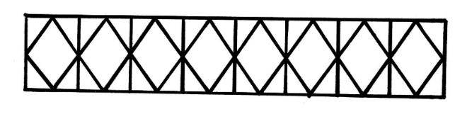
60.8 m
10 m

- What other information do you need to work out the total amount of steel to make this section of the bridge?
__________________________________________________________________________________________________________________________________________________________________

- Write someone else a plan of how they could calculate all of the steel (as a length) needed. You’ll need to include formulae and operations (e.g., multiplication, addition) and the right order for all of these to be done in your plan. __________________________________________________________________________________________________________________________________________________________________

Now that you have a plan…
Solve

- Calculate the amount of steel that is used along the total length of BOTH sides and the top of the Burdekin bridge. Use the diagrams and your suggested plan above.

Evaluate & verify

- Would this solution represent the total length of steel used along the entire length of the bridge? Why/why not?

________________________________________________________________________________________________________________________________________________________________________________________________________________________________________________________________________
________________________________________________________________________________________
- If you were in charge of purchasing the steel to build a bridge like this, would the length of steel that you’ve calculated be enough information? What else would you need to know?
________________________________________________________________________________________________________________________________________________________________________________________________________________________________________________________________________
Communicate

- The maintenance and rehabilitation project is estimated to take 5 years to complete. Using your solution and mathematical reasoning, explain why bridge maintenance has taken so long.

________________________________________________________________________________________________________________________________________________________________________________________________________________________________________________________________________
________________________________________________________________________________________

References:
Image Burdekin bridge
http://www.newspapers.com.au/ayr.html

