TRIM – Saving documents from shared drives to TRIM
TRIM allows you to save documents to TRIM. You can either undertake the process one document by one document, or you can save multiple documents to the one file in TRIM.
Single document save to TRIM
Process Steps | Instructions | Picture demonstration
1 | Using TRIM search, locate the container record/file in TRIM the documents from the shared drive will be going in to.  This example I am using a student record, hence the student ID number is used in the search. | 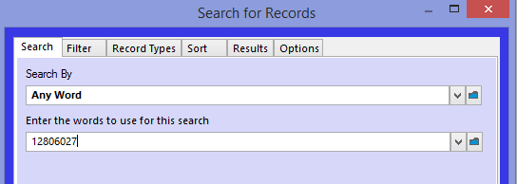
2 | Once the record is found, take note of the ‘Record Number’ or copy the container record number from the bottom pane. | 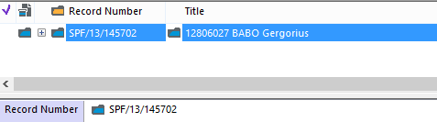
3 | Open the drive or desktop where the electronic files are located to be transferred to TRIM  Highlight the file to be transferred to the container record in TRIM | 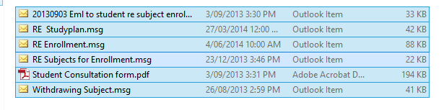
4 | You can either  Right click and choose, send to, then TRIM  Or drag and drop all the files to the Folder in TRIM  Note: If there are more than one record being moved across, there is an extra step.
 | When multiple records are moved to the one container, a separate window will appear in TRIM.  - Tick all records in the List  - Right click and choose ‘Check In’  If you have elected TRIM to check in the records without completing the ‘Check in’ form & Assuming the Record type for each has been selected, then all will disappear from this window and go to the file without any further user details required.  IF not, go to the next step | 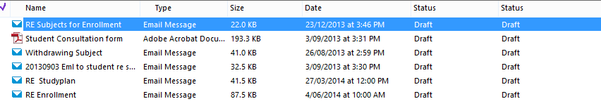  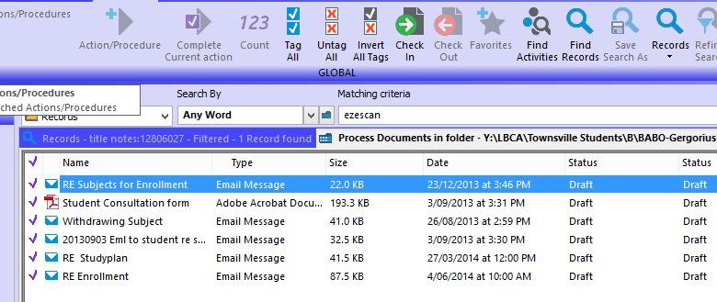
5 | The first screen to appear and will appear for each document, is the ‘Record type’ screen. From here, select the record type for each as TRIM checks each in.  Note. You can turn this function off. What this means is, TRIM will put all the selected records in TRIM without asking the Record Type it will show as in the folder and will assume the current title is the one to be saved as.  See Taskcard:  ‘TRIM Set up options’ | 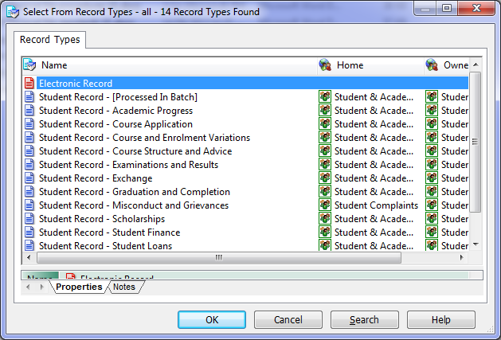
6  7 | Now that TRIM knows the type of document you are saving, the next step is to title the document.  ‘Title (Free Text Part).  If you are happy with the current title you can go to the ‘Container’ field and type in or paste the ‘Record number’ associated to the Folder/File in TRIM you want to save the documents/Records in to.  Tip: you can ‘right click’ and ‘copy’ the record number from the bottom pane of the record in TRIM. Unless you have dragged and dropped the records, in which case this field will be prepopulated.  Complete both fields and select ‘OK’ | 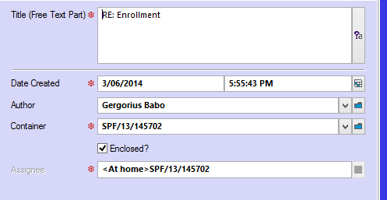
8 | The document has now been renamed and appears in the TRIM container of choice | 