A problem-solving and modelling task suitable for students working with area (Focus: parallelograms, trapeziums, rhombuses & kites)
Modelling Northern Qld

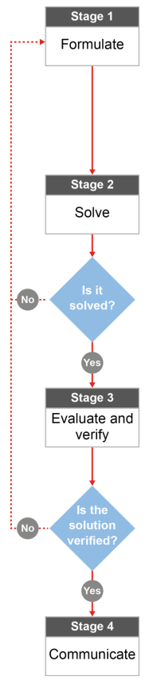

QCAA approach to problem solving and mathematical modelling
(https://www.qcaa.qld.edu.au/downloads/portal/syllabuses/snr_maths_methods_19_syll.pdf)

How big is the Tablelands Region?

Australian curriculum content descriptors:
Year 8
Find perimeters and areas of parallelograms, trapeziums, rhombuses and kites (ACMMG196)
L
How big is the Tablelands Region?
Modelling Northern Qld

1. Which of the following towns/regions do you think is smaller than the Tablelands Region?

- Townsville
- Mackay
- Cairns
- Brisbane
- Burdekin Shire
- Rockhampton
- Charters Towers Region
- Whitsundays Region
- Canberra

Research & Formulate

Brittany goes to the Tablelands Region every year for Christmas with her family. Her friend Jessie thought she meant the town, Atherton which she called Atherton Tablelands. However, the Tablelands region is made up of many smaller towns such as Julatten, Tinaroo and Walkamin. Because Jessie has never been to the Tablelands Region, Brittany is trying to explain how big it really is.
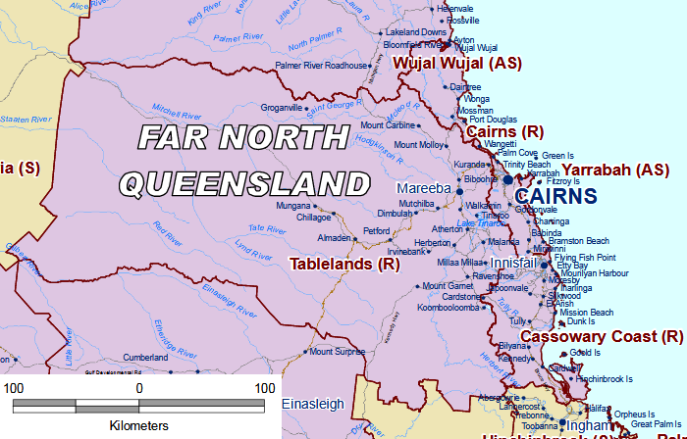
Reference:
Region Map -https://www.communities.qld.gov.au/resources/corporate/regional-boundaries.pdf
2. What single 2D shape could you use to ‘model’ or represent the general shape of the Tablelands? You’re looking for the shape that fits the closest (no single shape will be perfect).
_______________________________________________________________________________________
- What type of measurement would be the best to describe how big the Tablelands is?
Perimeter Area Volume

- What formula will be useful in your calculations?
_______________________________________________________________________________________________
_______________________________________________________________________________________________
- What information do you need to be able to use the formula? Do you have it already or could you figure it out?
_______________________________________________________________________________________________
_______________________________________________________________________________________________
_______________________________________________________________________________________________

- The picture is a scaled diagram. How will you get the real size of the Tablelands? [Hint” It is usually easier to do your conversions before using any measurement formula.]
_______________________________________________________________________________________________
_______________________________________________________________________________________________
_______________________________________________________________________________________________
- Looking at the shapes you are using to calculate the size of the Tablelands, would you say that your calculations will be too big or too small? How can you tell?
____________________________________________________________________________________________
____________________________________________________________________________________________
Now that you have a plan…
Solve

- Using your answers from Q2-6, calculate the area of the Tablelands (approximately).

Evaluate & Verify

- The actual area for the Tablelands Region is 64,999 km². Compare this with your approximation of the area. How could you improve your approximation?
_______________________________________________________________________________________________
______________________________________________________________________________________________
______________________________________________________________________________________________
______________________________________________________________________________________________
______________________________________________________________________________________________
- Google the areas of the towns and regions from question 1. Compare these areas to the area of the Tablelands – are there any that you weren’t expecting? If so, what key factors influenced your decision making?

- Townsville _______
- Mackay _______
- Cairns _______
- Brisbane ______
- Burdekin Shire ______
- Rockhampton ______
- Charters Towers ______
- Whitsundays Region ______
- Canberra ______
______________________________________________________________________________________________
______________________________________________________________________________________________
______________________________________________________________________________________________
______________________________________________________________________________________________
______________________________________________________________________________________________
Communicate

- If someone else was like Jessie and didn’t realise how big the Tablelands Region is, how would you explain it to them. Justify your answer using your calculations and your research of other areas in Australia.
_______________________________________________________________________________________________
_______________________________________________________________________________________________
_______________________________________________________________________________________________
_______________________________________________________________________________________________
_______________________________________________________________________________________________
_______________________________________________________________________________________________

