Learning Glass Lesson plan

Topic:  What are you teaching in this session? | Weekly Learning Sequence
Student outcome:  What do you want the students to be able do with your topic? | Students to design their own weekly learning sequence for Assessment 2.
Visually map your topic:  Break down your topic into concepts. On a piece of paper design how you want to visually represent each concept in your topic.  Tips:  - One glass one concept.  - Clean glass before starting a new concept. | 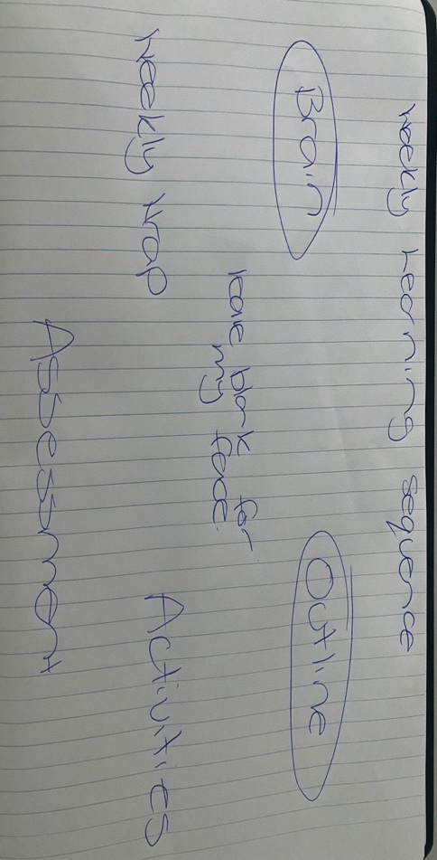  This will be my overview glass. I will have subsequent glasses explaining each concept.
Mode of delivery:  Are you creating a digital object (Panopto)?  - Live teaching (collaborate or zoom)?  - Recording live teaching?  - Using OBS (coming soon) | Live teach in collaborate to my third years.
Planning:  Will you be using complimentary materials when using the LG? i.e., will you be switching between PowerPoint and the LG to teach your topic? | I will be using PP, YouTube and LG.
Attire:  Dark colour attire, devoid of patterns.  No watches or bangles as they scratch the LG. | I will be wearing a black sleeveless dress; I will remove my watch and bangles.
Teaching Tips: | Look at the camera not the TV.  Map out a neutral space where you will not draw so you can move there and your face will not be obscured.  Do not overload the glass as this will cognitively overload your students (remember 1 glass, 1 concept).  Do not write too big or small. Test out your writing first and see how it looks on camera.  If you are live teaching and ask your students a question, give them time to answer.  Only use the pens provided.  Use different colour pens to highlight different points.  If live teaching it is better to get your students to verbally ask question rather than use the chat box.

