Mid Placement and Final Evaluation process:

- A grading of SATISFACTORY means that progress so far is satisfactory and the learning goals are being achieved. (Obviously, further work will be expected during the remainder of the placement).

- A grading of DEVELOPING serves to remind both field educator and student to give attention to these aspects over the remaining weeks. Contact with the University liaison person may be of value.

- A grading of UNSATISFACTORY indicates need to contact with the University liaison person immediately to review the current Learning Plan and the student’s learning needs.

NB The Field Educator/Task Supervisor is able to select the appropriate grading on the form by a drop down box selection by clicking on ‘choose an item’.

The James Cook University Field Education Team expects:
- Students initiate preparation of the Mid Placement and Final Evaluation. Ideally it is an interactive process between Field Educator/Task supervisor and student developing naturally from the reflection and feedback which has occurred during supervision throughout the placement
- Students to self-assess in Learning Plan document to provide a basis for discussion and encourage the professional skill of being a reflective practitioner
- The Field Educator/Task Supervisor should use this template to provide a written assessment of students learning performance for both Mid placement and Final Evaluation.
- Comments should relate to the student’s performance against:
  - the specific learning goals for this placement as outlined in the student’s learning plan,
  - the key aspects and concepts of the AASW Practice Standard
- The Mid Placement and Final Evaluation report should be completed prior to meeting with the Liaison
- The student and the liaison person should be provided with a copy of the assessment as mid-placement and end of placement meeting

Mid Placement Review prepared by ………………………………………….. (field educator/task supervisor name) for……………………………………………(student name)
 | Evaluation  (Satisfactory, Developing or Unsatisfactory) | Field Educator/Task Supervisors Comments
Values & Ethics | Choose an item.
Culturally Responsive Practice | Choose an item.
Knowledge | Choose an item.
Skills | Choose an item.
Methods & Processes | Choose an item.
Awareness of Self | Choose an item.
Mid Placement Evaluation Recommended Grade Choose an item.
Signed……………………………………………………………………………

Final assessment
In order to assess the student’s performance on placement the field educator (and task supervisor where applicable) is asked to assess the student’s performance at the end of placement based on the Australian Social Work Education Assessment Standards- ASWEAS (AASW 2012, p.11):
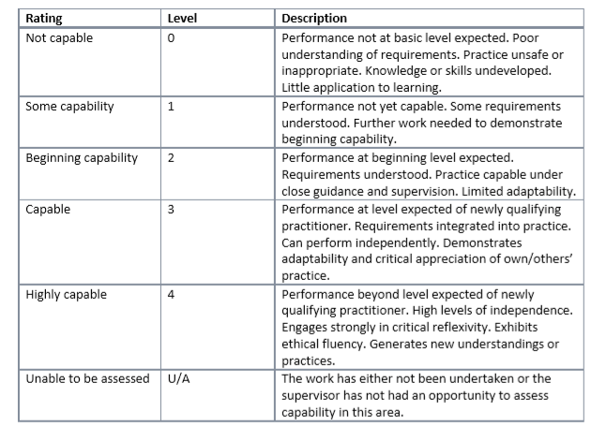
“To pass the first placement, students must at least reach a level of ‘beginning capability’ (2) for all learning outcome areas appropriate to the setting by the end of the placement.
To pass the final field education placement, students must at least reach a level of ‘capable’ (3) across all learning outcome areas, relevant to placement setting, by the end of the placement.”
Final Evaluation prepared by …………………………………………………………(Field educator/Task supervisor) for ……………………………………………………(Student name)
 | Evaluation  (Satisfactory or Unsatisfactory) | Level of Capability  Using the  ASWEAS, 2012 Guideline 1.2, p 11 | Field Educator/Task Supervisors Comments
Values & Ethics | Choose an item. | Choose an item.
Culturally Responsive Practice | Choose an item. | Choose an item.
Knowledge | Choose an item. | Choose an item.
Skills | Choose an item. | Choose an item.
Methods & Processes | Choose an item. | Choose an item.
Awareness of Self | Choose an item. | Choose an item.
Final Evaluation Recommended Grade Choose an item.
Signed……………………………………………………………………..

