A problem-solving and modelling task suitable for students working with simple interest (Focus: comparison)
Modelling Northern Qld

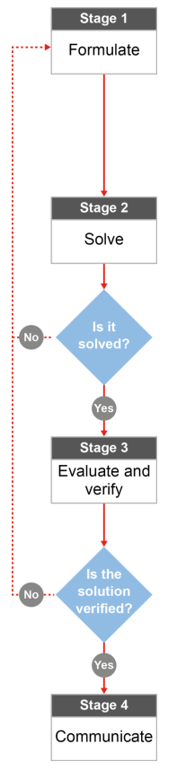

QCAA approach to problem solving and mathematical modelling
(https://www.qcaa.qld.edu.au/downloads/portal/syllabuses/snr_maths_methods_19_syll.pdf)

What’s the best way to
buy a dinghy?

Australian curriculum content descriptors:
Year 9
Solve problems involving simple interest (ACMNA211)
L

What’s the best way to buy a dinghy?

Modelling Northern Qld

- Has someone you know (maybe even your teacher?) ever taken out a loan? What was it for? Did they pay interest on their loan? How much was the money they borrowed and how much was the interest they paid?
_______________________________________________________________________________________
_______________________________________________________________________________________
_______________________________________________________________________________________
Research & Formulate

David has found an aluminium dinghy he wants to buy so it’s easier for him to go fishing. The dinghy costs $600 and David will need to borrow the money from either the bank or the boat shop. The bank’s simple interest rate is 12% p.a. paid off over three years. The boat shop’s simple interest rate is 15% p.a. if you pay it off over two years. Can you help David choose which place he gets his dinghy loan from?
- What will you need to calculate to make a good comparison? Which formula will be useful in these calculations?
_______________________________________________________________________________________
_______________________________________________________________________________________
_______________________________________________________________________________________
- What information do we need to know to use the formula? What information do we have? What might we need to figure out?
_______________________________________________________________________________________
_______________________________________________________________________________________
_______________________________________________________________________________________
- After you do some calculations, how will you know which bank loan is the best one to use? What are you looking for?
_______________________________________________________________________________________
_______________________________________________________________________________________
_______________________________________________________________________________________

Now that you have a plan…

Solve

- Using your plan, calculate the amount of interest David would pay if he got his loan through the bank.

- Using the formula from question 2, calculate the amount of interest David would pay if he got his bank loan through the boat shop.

- Which loan would David end up paying the most interest on?
_______________________________________________________________________________________
_______________________________________________________________________________________
_______________________________________________________________________________________

Evaluate & Verify

- The amount of interest is an important factor to think about when choosing a loan but it’s not the only one. What other factors should David consider when calculating the best loan?
_______________________________________________________________________________________
_______________________________________________________________________________________
_______________________________________________________________________________________
_______________________________________________________________________________________

- If David were to choose the bank option, how much money would he have to pay back each month to buy the boat by the end of the three year loan? Remember to include the cost of the boat ($600) and the interest.
_______________________________________________________________________________________
_______________________________________________________________________________________
_______________________________________________________________________________________
- If David decided to choose the boat shop option, how much money would he have to pay back each month to buy the boat by the end of the two year loan? Include the coast of the boat and the interest. _________________________________________________________________________________
_______________________________________________________________________________________
_______________________________________________________________________________________

Communicate

- Your older brother wants to buy a car when he gets his open license next year. He is thinking about getting a loan out because he doesn’t have much savings. What would you advise him to do, to make sure he gets the best loan?
_______________________________________________________________________________________
_______________________________________________________________________________________
_______________________________________________________________________________________
_______________________________________________________________________________________
_______________________________________________________________________________________

