For most of Maths Methods, you’ll work on one main set of connected ideas: Algebra and Calculus. |  |  |  |  | Statistics and Probability (25% of Maths Methods)
Advanced algebra: Functions  To investigate all kinds of situations in our world, we need to describe those situations using different types of equations,that produce different shaped graphs.  We do take a small peek at some relationships that are not functions (like circles). They are called relations. | When quantities are increasing or decreasing (but not over and over), we can describe how they are rising and falling with…  Polynomial functions  ($x$ is raised to a power in the equation)  like $x^{2}$ (2 directions) or $x^{3}$ (up to 3 directions)  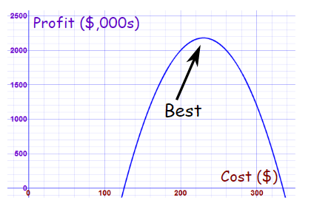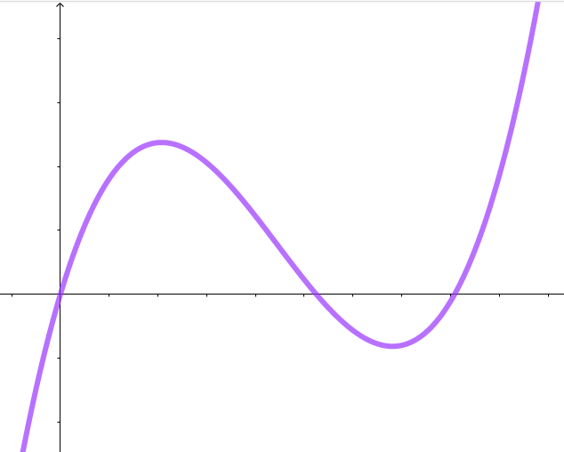  Bike shop: Profit made, This section shows the depending on how much amount of chocolate you you charge for the bikes. can fit in a wrapper of a  Don’t charge too little… set size depending on  or too much! how high or wide you  make the chocolate bar.  or $x^{4}$ (up to 4 directions)  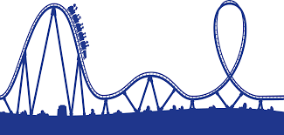  You can replicate (we call it “modelling” in Maths Methods) these four directions on a roller coaster path.  Preparing (early in year 11): Arithmetic Sequences and linear (straight line) functions represent situations where numbers are increasing by the same amount each time (e.g., your pay each hour: 5, 10, 15, 20 and so on). | When a quantity is increasing at a faster and faster rate or decreasing at a slower and slower rate we can use…  Exponential functions  (when x is in the power, like 2^{x} or 0.8^{x})  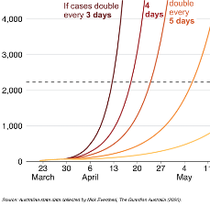  Predicting the spread of COVID-19 is modelled with exponential functions.  Sound level as you move further away from a live concert.  Preparing (early in year 11): Working with indices (index laws) and scientific notation (writing very large and small numbers like speed of light)  &  Geometric Sequences - investigate situations where numbers are increasing/ decreasing by the same rate each time (e.g., city population increasing by 2% every year) | In certain situations when one quantity increases as another decreases (like increasing your speed to decrease the time it takes to get somewhere) use…  Inverse functions  (when x is in the denominator of a fraction, like $\frac{3}{x}$or $\frac{21}{x-2}$ )  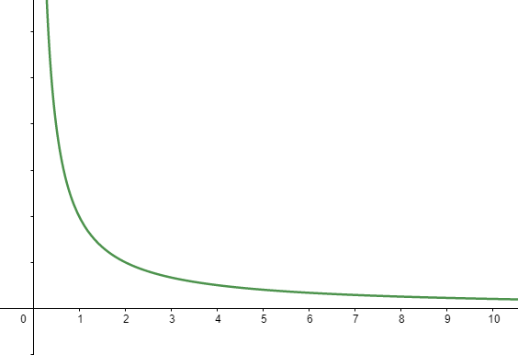  $  Number of people  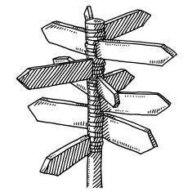  This graph shows how much money each person might contribute to an expensive group gift. As the number of people sharing the cost goes up, the amount each person has to contribute goes down. | For situations that repeat in cycles, you will need these…  Trigonometric functions  (when sin x, cos x or tan x is included)  If you want to track high and low tides or rises/falls in temperatures, these situations can be modelled (approximately) with these graph shapes:  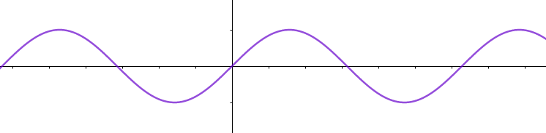  You can even track your height off the ground on a ferris wheel with these kinds of functions (also known as periodic functions because they repeat over a certain ‘period’).  At the end of Year 12, you will revisit trigonometry. This time you will focus more on triangles and ratios, not equations and graphs. The triangles will be found in many 3D situations. | Meet the maths that helps governments and businesses predict how likely complicated events are to happen in the future.  Topic 1 Permutations and combinations  Working out how many options exist when there are lots of possibilities and requirements to include.  For example, in a 20 man squad, how many different combinations of cricket players could form the Australian cricket team for the Boxing day test? What if the team needs at least 5 batsmen and 4 bowlers?  Topic 2: Discrete random variables  Making decisions based on past events that have lots of factors to consider.  For example, businesses can predict the number of defective goods that can be reasonably expected or dentists can predict the number of weekly consultations that can be reasonably expected.  Topic 3: More on discrete random variables (continuing topic 2)  Topic 4: Continuous random variables  Finding the chance of a range of events, not just countable events.  Topic 5: Interval estimates for Proportions  Finding ways to measure confidence or bias in different statistics situations.  For example, how well can polls predict the outcome of an election? What’s a reasonable margin of error?  Governments need to be more confident about the effectiveness of a new vaccine than the effectiveness of new nail polish brand. So how do you measure confidence in statistics?
Calculus intro: Differentiating  When you can represent different situations with graphs and equations, you can learn extra calculus skills to find out more about each situation. h | What’s differentiating?  How steep is a straight line? That’s pretty easy because it’s the same everywhere on the line. But what about curved lines when the steepness keeps changing? To calculate how steep those curved graphs are at any point (and lots of other things), we find the “derivative” and that can be used to tell us a lot of information about a situation. For example in your bike shop, how does your profit change as you increase the cost of your bikes?  You’ll learn introductory skills to differentiate any of the polynomial functions first.  Next, you’ll learn three more rules to differentiate more complex functions. These are called the chain, product and quotient rules. | Let’s tour around Maths Methods The colours indicate if you will learn the topic in Unit 1, Unit 2, Unit 3 or Unit 4.  Introductory skills to differentiate exponential functions.  Next, more complex ones (chain, product and quotient rules).  How fast is a virus spreading?  How quickly is your superannuation building or your mortgage decreasing?  How effectively is a drug being broken down (decaying) in someone’s body? | Introductory skills about differentiating log functions that result in inverse proportion functions.  Next, more complex ones (chain, product and quotient rules).  How fast does a plane travel during take off and how does the speed of the plane change as it reaches maximum altitude? | Introductory skills to differentiate trigonometric functions ($\sin{x}$ and $\cos{x}$).  Next, more complex ones (chain, product and quotient rules, including $\tan{x}$).  How quickly is the tide changing at different parts of the day? Does the tide go in/out more quickly at low tide, high tide or in between?  How does your speed vary as you go around on a ferris wheel?
When you can differentiate, you can learn to repeat or reverse the calculus skills you have.
You can differentiate forwards? If you reverse the same processes, you can find out a whole lot of other information about a situation. That’s called Integration. Reversing the derivative or integrating tells you about the size of the area/s between your graph and the x-axis (known as the area “under the curve”). You’ll also use a “trapezoidal rule” to find the area in a different way.
You can go forwards once? What about differentiating TWICE - that’s known as a double derivative and it tells you more again about the original situation. Repeating the derivative procedures can help you find maximum and minimum amounts (like the maximum speed on that rollercoaster or the acceleration of the rollercoaster or the best bike price to maximise your profit).
FRACTIONS: Fractions have algebraic terms but they still work the same way.
Adding/subtracting - You need the denominators to be the same (common denominators) to add or subtract. Multiply both parts of a fraction by the same amount to find an equivalent fraction.
Multiplying - Multiply the numerators, multiply the denominators AND look for common factors on any numerator and any denominator to cancel.
Dividing - Dividing by a fraction is the same as multiplying by the reciprocal so rewrite and then multiply. The fraction line also means division - sometimes it helps to first rewrite a messy fraction as two separate expressions being divided.

SOLVING two or more, simultaneous equations
Are you trying to solve for more than one unknown with more than one equation?
Substitution method is most common in Methods but you need to adapt it: Find a term or an expression in one equation (x or 2x or more complicated “chunks” like (x² - 11 x) or (3 sin x). Substitute it into the second equation so that you are left with only one unknown to solve.
Graphical method - the intersection point is the only place where the (x, y) values are true for both equations.

SOLVING one equation, with one or more solutions
Look out for ways to solve linear equations, even if they look slightly different: $4=2x+3$ in junior maths becomes: $4=2\sin{x}+3$ but the first steps in solving both equations are the same.
Look out for quadratic equations, even if they look slightly different: $2a^{2}+5a -3=0$ may look like: $2{\cos{θ}}^{2}+5\cos{θ} -3=0$. Be ready to solve them with three different methods from Year 10 (factorise or complete the square or use the quadratic equation). Quadratics will turn up in almost every Maths Methods topic and will be extended with cubic equations - one equation, up to 3 solutions!

Change the equation Change the points Change the graph…
Extending what you know from Years 7-10: You already know how to make a straight line steeper or how to turn a parabola upside down. The same principles apply to the functions in Maths Methods (exponential, polynomial, periodic/trigonometric and inverse).
Change the equation | Change the coordinate points | Change the graph | Examples
$$f\left(x\right)+c$$ | ($x$, $y$) ($x$, $y+c$) | Vertical translation (shift) up $c$ units | Changing $f\left(x\right)= sin⁡(x)$ to $f\left(x\right)=\sin\left(x\right)+8$ moves all points in the first graph up by 8 units
$$f\left(x\right)-c$$ | ($x$, $y$) ($x$, $y-c$) | Vertical translation (shift) down $c$ units | Changing $f\left(x\right)= 2^{x}$ to $f\left(x\right)= 2^{x}-3$ moves all points in the first graph down by 3 units
$$f\left(x+b\right)$$ | ($x$, $y$) ($x-b$, $y$) | Horizontal translation left $b$ units | Changing $f\left(x\right)= x^{3}$ to $f\left(x\right)={(x+4)}^{3}$ moves points in the first graph left by 4 units
$$f\left(x-b\right)$$ | ($x$, $y$) ($x+b$, $y$) | Horizontal translation right $b$ units | Changing $f\left(x\right)=cos⁡(x)$ to $f\left(x\right)=\cos{(x-π)}$ moves points in the first graph right by $π$ units.
$$af\left(x\right)$$ | ($x$, $y$) ($x$, $ay$) | Vertical dilation, stretch if $\left|a\right| >1$ ,  OR  compress (squash) if $0<\left|a\right| <1$ | Changing $f\left(x\right)= sin⁡(x)$ to $f\left(x\right)=2 sin\left(x\right)$ makes all the y coordinates 2 times bigger, stretching the graph vertically (higher, not wider). However, for $f\left(x\right)=0.5 sin\left(x\right)$, the y coordinates are only half as big now, so the graph looks flattened (squashed/lower, vertically compressed).
$$f\left(ax\right)$$ | ($x$, $y$) ( $\frac{x}{a}$ , $y$) | Horizontal dilation, compress (squash) if $\left|a\right| >1$ ,  OR  stretch if $0<\left|a\right| <1$ | Changing $f\left(x\right)= sin⁡(x)$ to $f\left(x\right)=\sin\left(2x\right)$ means that two of your new graph could fit within the original length of the first graph, effect is compressed (squashed in). But $f\left(x\right)=\sin{(\frac{1}{4}x)}$, means that a quarter of your new graph fits in the original length, so the effect is that the graph will be stretched out (horizontally).
$$-f\left(x\right)$$ | ($x$, $y$) ($x$, $- y$) | Reflection over x-axis (upside down or invert) | Changing $f\left(x\right)= 2^{x}$ to $f\left(x\right)= {-2}^{x}$ changes every y coordinate to its opposite (positive or negative), moving each point to the other side of the x-axis (horizontal mirror line).
$$f\left(-x\right)$$ | ($x$, $y$) ($- x$, $y$) | Reflection over y-axis (left/right “flip” effect) | Changing $f\left(x\right)= 2^{x}$ to $f\left(x\right)= 2^{-x}$ changes every x coordinate to its opposite (positive or negative), each point moves to other side of the y-axis (vertical mirror line).
Your Maths Methods Toolkit
Look for these maths ideas that will turn up again and again in Maths Methods. They will look slightly different so pay attention to the overall structure of the expressions and equations that you have.
Look for places when you can use these tools. The more you can spot, the better!
REWRITE ALGEBRA into another (better) form:
In Maths Methods, you need to use all of your Year 7-10 algebra skills to rewrite lines of algebra into easier forms. Practise these skills and be on the lookout for times when you can…
- Rewrite all algebraic terms as additions and multiplications (subtraction and division are harder to work with). For example, you can rewrite (or rethink in your head) subtractions as addition of the opposite number, so $5-x$ is the same as $5+\left(-x\right)$. Division can be rewritten as ‘multiplying by the reciprocal’.
- Simplify, by collecting like terms
- Expand brackets using the distributive law
- Factorise by spotting a common factor to take out the front of a set of brackets. The factor can be more complicated in Maths Methods but the process works the same way. For example, $e^{2x}$ would be the common factor here:
$$8e^{2x}- xe^{2x}= e^{2x} (8-x)$$
- Factorise an expression into two brackets. Look for the special structures below. When you see them, it’s likely that expanding or factorising will be helpful.
Spot these structures OR rearrange into these structures.

ORDER OF OPERATIONS, look out for invisible brackets
The order of operations rules all still apply with large calculations BUT brackets may not always be obvious so you might need to add some in.
$$B I \begin{matrix}M \\ D\end{matrix} \begin{matrix}A \\ S\end{matrix}$$

  - Mark in brackets that aren’t already shown. Look for smaller calculations above/below fraction lines or surd/square root symbols that sit over the top of smaller calculations - these indicate invisible or implied brackets so mark them in.
  - Perform calculations/simplify expressions within those brackets first.
  - Look for any indices/powers (squares, cubes etc) to calculate.
  - Complete multiplications/divisions from left to right as you see them.
  - Finally, complete additions/subtractions from left to right.
Write down what represents (maybe = $x^{2}$ or = $2^{x}$ or = $\frac{-3}{x}$ or even = $\tan{θ}$) and then factorise or expand from there.
PERFECT SQUARES DIFFERENCE BETWEEN TWO SQUARES
( + Δ)² = ( + Δ) ( + Δ) = ² + 2 Δ + Δ ² ² - Δ ² = ( + Δ) ( - Δ)
QUADRATIC EXPRESSION THAT YOU CAN FACTORISE (and solve too if you use the null factor law - let each factor = 0 and solve).
$a$² + $b$ + $c$ = ( $+$)( $+$) (lots of different ways to work out the values in the brackets - refer to your Year 10 notes)

