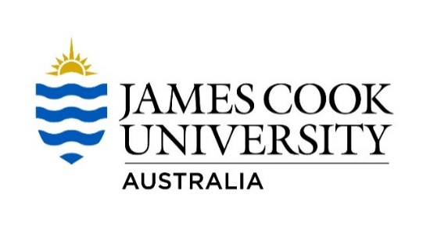

Student scholarship - Sustainability Conference, Sunshine Coast, November 2016!

James Cook University is offering two students the opportunity to attend the 2016 Australasian Campuses Towards Sustainability (ACTS) Conference, being held at the University of the Sunshine Coast, Queensland from the 2 - 4 November.

About the Conference
The 16th International ACTS Conference is being held at the University of the Sunshine Coast from the 2–4 November 2016. This year’s Conference theme is ‘Connect – Innovate – Ignite! Collaborating to spark sustainable solutions for a smart future’, challenging participants with the question – How do we work together to drive the sustainability agenda as the solution to building a smart future?’

About the ACTS
The ACTS is a member based organisation that aims to inspire, promote and support change towards best practice sustainability within the operations, curriculum and research of the Australasian tertiary education sector. James Cook University is a founding member of the ACTS.

About the JCU Scholarship
The scholarship provides an opportunity for JCU students from our Cairns and Townsville campuses to attend the ACTS Conference as representatives of the university. Two scholarships will be awarded, one from each campus, dependent on suitable applications being received.

To apply, please complete the Application Form on page 3. Applications due: 5pm, Friday 16 Sept. 2016.
Value
Each scholarship will provide up to a total value of AU$2,000 (incl. GST) towards the cost of attending the 2016 ACTS Conference. Where the total cost of attending the conference is less than
$2,000, the scholarship will be the actual cost incurred. Where the total cost of attending the conference is more than $2,000, the scholarship awardee must meet and cover all additional costs.

The scholarship will contribute to the following items:
- Return travel from Townsville / Cairns to Sippy Downs, the Sunshine Coast
- Conference registration, including the Conference Dinner and the Green Gown Awards ceremony
- Accommodation at the Sunshine Coast for the duration of the Conference
- Daily main meals (breakfast, lunch and dinner) - all meal costs will be paid for by the scholarship holder during the trip and reimbursed upon return from the conference and receipt of appropriate tax invoices.
Administration
The JCU Sustainability Office will make the necessary travel arrangements for the successful applicants and will administer all scholarship funding.

Eligibility
- Applicants must be currently enrolled students at James Cook University and study at either the Cairns or Townsville campuses.
- One student per campus (Cairns and Townsville) will be awarded a scholarship, dependent on suitable applications being received.
- Applicants must demonstrate how they are proactively seeking experience and/or learning in sustainability (e.g. involvement with environmentally focused student or community groups; volunteering; pursuing other sustainability related extra curricula activities).
- Successful applicants will be required to write a short article on their experience for JCU’s TropEco newsletter.
- Students must be available to travel from Tuesday 1st to Friday 4th November 2016.
NOTE – Lecture recess starts Monday 31st October and exams begin on Saturday 5th November.

Further Information
- For further information about the scholarship, please contact:

Kerryn O’Conor
Sustainability Officer
Division of Global Strategy and Engagement James Cook University
Ph: 07 4232 1084
E: kerryn.oconor@jcu.edu.au

- For further information about the Australasian Campuses Toward Sustainability (ACTS) Conference, visit http://www.actsconference.com.au/

APPLICATION FORM – JCU STUDENT SCHOLARSHIP ACTS CONFERENCE

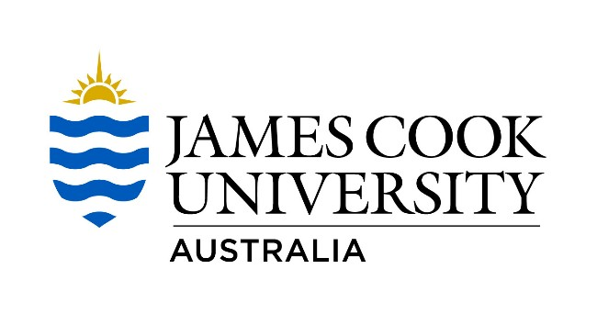

The Application Form
To apply for a JCU scholarship to attend the 2016 ACTS Conference, please complete the application form and send to sustainability@jcu.edu.au by 5pm, Friday 16 September 2016.

Scholarship Application – 2016 ACTS Conference
Name of Applicant
Phone number
Email
Campus (Townsville or Cairns)
Course title, year and major
College
Study load (Full or Part time)
Outline how you will balance your study commitments and attendance at the conference. (100 words max.)
How do you actively support sustainability at JCU and beyond? (150 words max.)
Why do you want to attend the ACTS Conference as a representative of JCU, and what are you hoping to gain from the experience? (150 words max.)
Outline how you intend to share your experience with your peers to promote further involvement in sustainability at JCU. (100 words max.)

