TRIM and outlook Email
Turning on outlook integration
You can save your emails in to TRIM easier by turning on the “Integration” between TRIM and Outlook. Once set up, you can send your emails to TRIM from your inbox in Outlook.

Process Steps | Instructions | Picture demonstration
1 | TRIM and Outlooks link is established by a connection in TRIM. The following ribbon will be presented in Outlook if there is a connection
2 | If it is not there, Open TRIM and go to the icon at the top left corner, use the drop down to find and select ‘Desktop Add-ins’  ‘Desktop Add-ins’ | 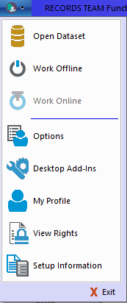
3 | Within the ‘HP TRIM Desktop Add-Inns’ table, tick the box next to ‘Microsoft@Outlook’  And Click ‘OK’.  Note: if you do not want all your documents you save to a shared drive to end up in a holding file for TRIM, ensure there a no ticks next to any of the boxes above. | 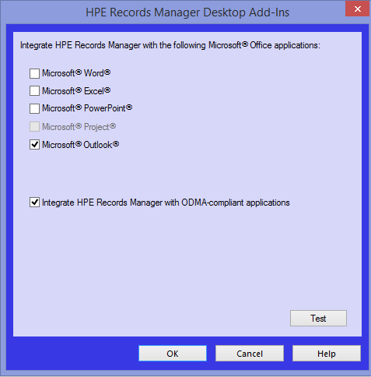

Emailing Records from Outlook
Emailing TRIM records from Outlook is very similar to how you have been emailing shared drive attachments.
Process step | Instructions | Picture demonstration
1 | Open Outlook email – and choose ‘New E-mail’ | 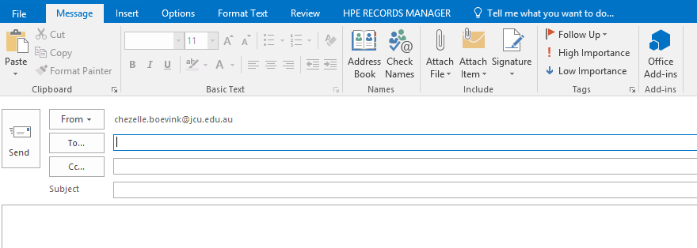
2 | Find the document and associated Record number in TRIM first and copy the Record number as shown  Note… you cannot email entire files/folders out of TRIM | 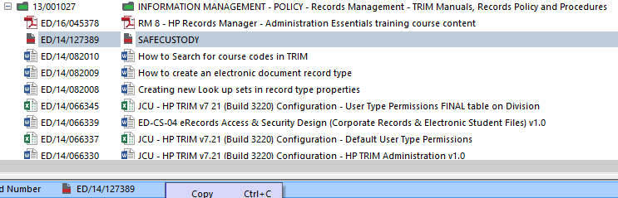
3 | Go back to the email and Click on ‘HPE RECORDS MANAGER’ tab and choose ‘Attach Records’. | 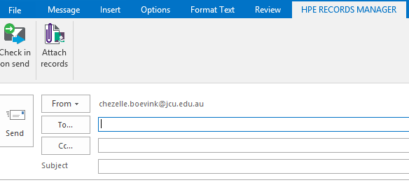
4 | Once you click on ‘Attach Records’. The Search window will open. Change the ‘Search By’ to ‘Record Number’ to attach the correct record. | 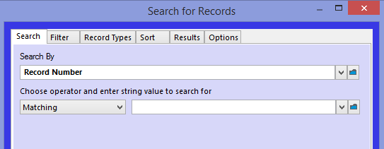
5 | Past the copied record number in to the ‘Matching’ field and click on OK | 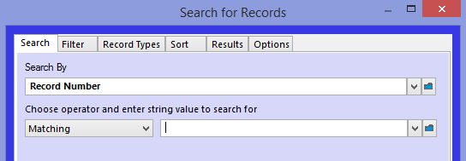  Past the Electronic Document record number as below  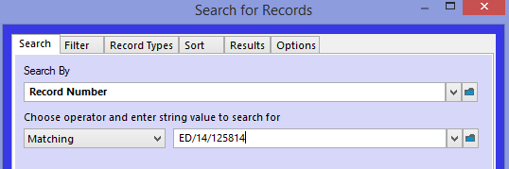
6 | TRIM will confirm the record you are asking to attach. If the record is correct click on OK | 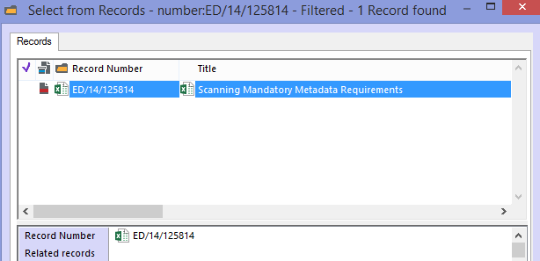
7 | Before you click OK you need to tell TRIM how you would like the record to show in the recipient inbox.  ‘Attach Electronic document’ is the best to choice when attaching an ‘Electronic Document’ to an email. This is because the recipient will receive an attachment rather than a link to TRIM, which is what the other two options mean.  click OK. | 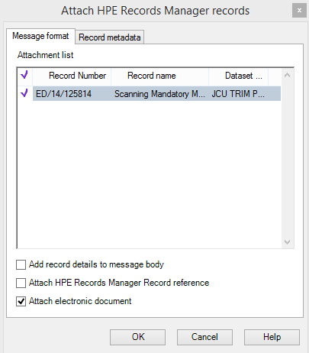
8 | The attachment is now in the email.  Here is where you can now add the Recipients details in the ‘To…’ field  The ‘Subject’ field also has the TRIM record we chose attached in the email.  Complete your message by filling in the body of the email. | 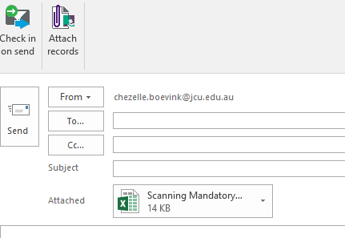

Cataloguing an email into TRIM from a personal Account
Cataloguing is the process of saving a document in TRIM from Outlook. You can do this without having to log in to TRIM and it becomes a new TRIM record.
Process step | Instructions | Picture demonstration
1 | Open the message in your inbox that you would like to send to TRIM. Click on ‘HPE Records Manager’ tab
2 | Click on the first icon ‘HP TRIM: Catalogue’ icon.  If there is only a message and no attachment, TRIM will only allow you to Catalogue the message.  If you choose ‘Check in’ both the body of the email and the attachments will be saved to TRIM | If there was an attachment and that was all that needing saving to TRIM, Both options shown would be available as below  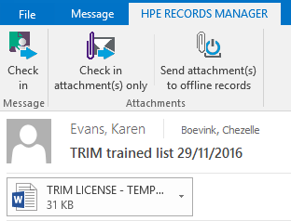
3 | Now to select the type of record you are placing in TRIM. In TRIM the record name should show as ‘Electronic Record’ Whether you are saving an email message or an attachment from email or the shared drive, all these records are ‘Electronic Record’  Click OK | 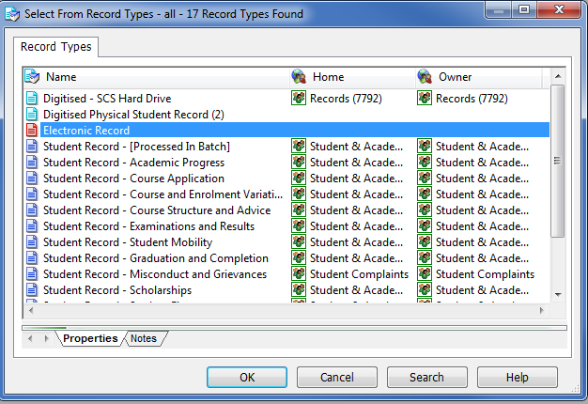  Note: If you are going to use the same ‘Record Type’ each time you place documents in TRIM, you can automate this part of the process so that TRIM always uses that record type and removes this step from the process.
4 | Once you have clicked ‘OK’, the ‘New Record Electronic Record’ box will appear.  As you will see, the title of the document has auto populated. Check and amend if needed.  The only step to complete now is deciding which ‘Container’ in TRIM the document is going in to | 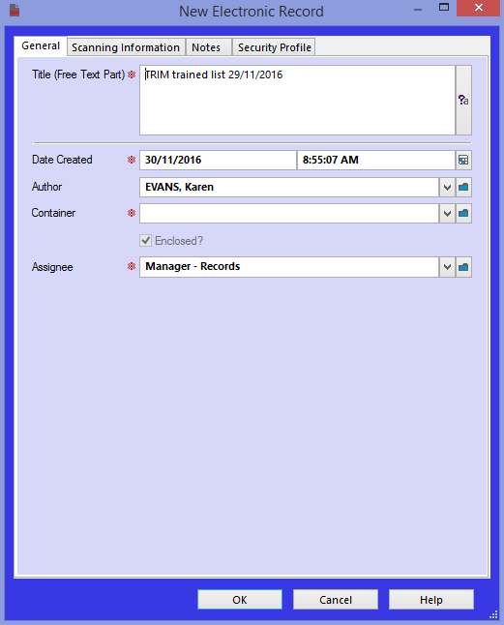
5 | Copy the record number from TRIM and paste it in. This will save you time searching for it here, as shown earlier.  Once the ‘Record Number’ appears in the ‘Container’ field, Check all the other details are correct, then Click OK. | 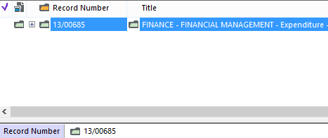  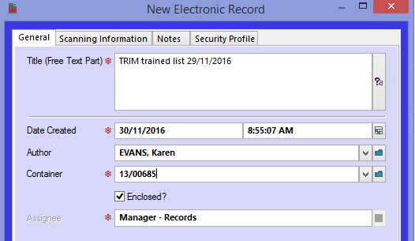
6 | Now the email has been catalogued in TRIM. You will now notice the email has the word ‘HPRM’ added to the subject line, confirming it has been catalogued/added to TRIM. Process ends. | 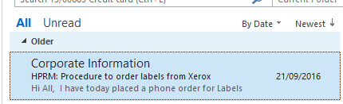

Cataloguing an email attachment
Cataloguing emails attachments is the process of saving an email attachment directly in to TRIM from Outlook.
Process step | Instructions |  | Picture demonstration
1 |  | Open the message in your inbox that you would like to send to TRIM. Click on ‘HPE Records Manager’ tab
2 |  | Click on the first icon ‘HP TRIM: Catalogue’ icon.  If there is only a message and no attachment, TRIM will only allow you to Catalogue the message.  Choose ‘Check in attachments only’ only the attachments will be saved to TRIM | If there was an attachment and that was all that needing saving to TRIM, Both options shown would be available as below
3 |  | Now to select the type of record you are placing in TRIM. In TRIM the record name should show as ‘Electronic Record’ Whether you are saving an email message or an attachment from email or the shared drive, all these records are ‘Electronic Record’  Click OK | Note: If you are going to use the same ‘Record Type’ each time you place documents in TRIM, you can automate this part of the process so that TRIM always uses that record type and removes this step from the process.
4 |  | Once you have clicked ‘OK’, the ‘New Record Electronic Record’ box will appear.  As you will see, the title of the document has auto populated. Check and amend if needed.  The only step to complete now is deciding which ‘Container’ in TRIM the document is going in to
5 |  | Copy the record number from TRIM and paste it in. This will save you time searching for it here, as shown earlier.  Once the ‘Record Number’ appears in the ‘Container’ field, Check all the other details are correct, then Click OK.
6 |  | Now the email has been catalogued in TRIM. You will now notice the email has the word ‘HPRM’ added to the subject line, confirming it has been catalogued/added to TRIM. Process ends.

