A problem-solving and modelling task suitable for students working with linear relationships (Focus: gradients)
Modelling Northern Qld

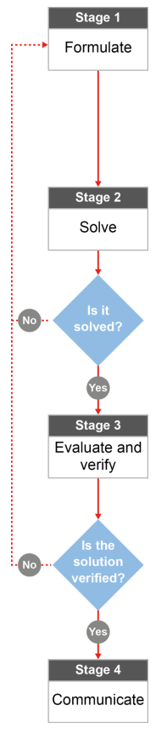

QCAA approach to problem solving and mathematical modelling
(https://www.qcaa.qld.edu.au/downloads/portal/syllabuses/snr_maths_methods_19_syll.pdf)

Do Townsville residents use less water when water restrictions change levels?

Australian curriculum content descriptors:
Year 9
Find the midpoint and gradient of a line segment (interval) on the Cartesian plane using a range of strategies, including graphing software (ACMNA294)

L
Do Townsville residents use less water when water restrictions change levels?

Modelling Northern Qld

- Would you say that Townsville residents change their water usage when different water level restrictions are imposed by the Townsville City Council? State your opinion based on what you’ve heard in the local media or from family and friends.

________________________________________________________________________________________________________________________________________________________________________________

Research & Formulate

Let’s gather some information by researching more about water restrictions and use our knowledge of gradients to find out if what you’ve heard is accurate.
Here’s what we know about water restrictions from the Townsville City council website:

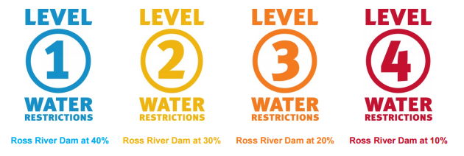

Hmmm… Looks like water restrictions are related to the level of the Ross River dam. That means we’ll need more information.

On the next page is some information about the Ross River Dam levels in Townsville over the past eight years.
NOTE: Ignore the small peaks that look like this: . These are incorrect sensor readings.

2. Answer the following questions to connect the graph with what you already know about North Queensland.
a) What do the numbers represent on the vertical axis? __________________________________________________
b) What happens to each line at the end of each year? Where does it continue? ______________________________
c) Does the Ross River dam level tend to increase in the first or the second half of each year? ___________________
Why is that? (HINT: think about weather in North Qld) ________________________________________________
d) Cyclone Olga crossed the North Queensland Coast early in 2013 and North Queensland had a great deal of rain as a result. Circle the corresponding change on your graph.
e) Water restrictions are enforced according to the dam levels. Take a ruler and rule four horizontal lines to indicate where level 1, 2, 3 and 4 water restrictions should occur. Use the graphic up the top of this page to help you find the percentage that matches each water restriction level.
f) The capacity of the Ross River dam is 233 187 ML (mega litres). Add this value to the vertical axis next to 100% and then use that information to add the capacity of the dam at 75%, 50%, 25%, 20% to the vertical axis.
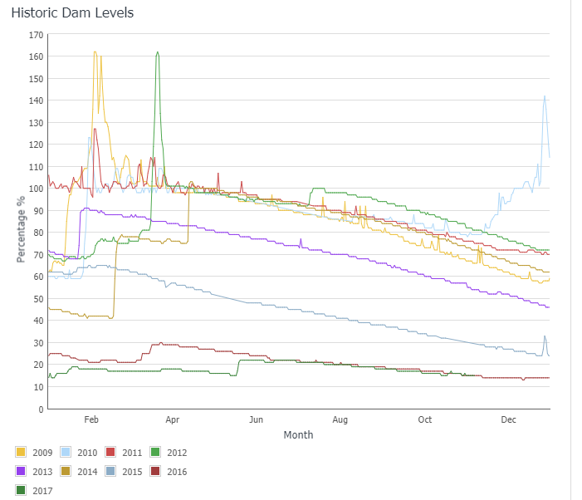

- You can model (represent) what is happening to the Dam levels using gradient calculations because the graph is made up of some straight(ish) lines. Identify the 2013 Dam levels on the graph. Use a ruler to rule in a line of best fit on your graph from February to December 2013. Number the horizontal axis as “Months after the year begins” so that you have numbers to work with on that axis. Now calculate the gradient of your line segment.
Solve

________________________________________________________________________________________________________________________________________________________________________________________________________________________________________________________________________________________________________________________________________________________________________________________________________________________________________________________
- What does the value of the gradient represent in this situation? You’ll need to think carefully about what the vertical and horizontal axis represent. (HINT: Think about the unit of measure that you are using to measure gradient)

________________________________________________________________________________________________________________________________________________________________________________

- How does the value of the gradient vary as different water restriction levels are put in place?
- To find out more, use a ruler and sections of the graph to get a feel for the steepness (gradient) and how the rate of usage decreases or increases within each water restriction level. Next, you will need to find parts of the lines that go from one water restriction level to another. You may find that the gradients of those lines change so you will need to sketch in different lines of best fit for different sections. You will need to calculate the gradient for each of those line segments. Use the capacity measurements from the vertical axis (in ML) and not the percentages in your calculations. Complete the table below to help keep your information organised:

Changes in water restriction level

From… | Line of best fit for which year/month (e.g., 2008 Jan-Aug) | Gradient of the line segment  (ML per month) | To… | Line of best fit for which year/month (e.g., 2008 Aug - Dec) | Gradient of the line segment  (ML per month)
No restriction |  |  | Level 1
Level 1 |  |  | Level 2
Level 2 |  |  | Level 3
Level 3 |  |  | Level 4

- When level 1, 2, 3, or 4 restrictions were imposed by the council, what effect did that have on water usage, according to your calculations in the table? Use gradient calculations to justify your response.

________________________________________________________________________________________________________________________________________________________________________________
________________________________________________________________________________________________________________________________________________________________________________________________________________________________________________________________________

- Late in 2016, the Townsville City Council began to pump water from the Burdekin Dam into the Townsville water supply. How did the rate of water usage (i.e., the gradient) change at that time? Compare the gradient in late 2016 with previous years/months. Do a few calculations to support your answer.

________________________________________________________________________________________________________________________________________________________________________________________________________________________________________________________________________
Evaluate & verify

- Do your findings support your initial thoughts (in Question 1) about what you’ve heard about water restrictions and water usage in Townsville?

________________________________________________________________________________________________________________________________________________________________________________________________________________________________________________________________________
Communicate

- If someone who didn’t live in Queensland asked you about how Townsville residents change their water usage habits when water restriction levels change, what would you say? Include an example using your gradient calculations.

________________________________________________________________________________________________________________________________________________________________________________________________________________________________________________________________________

Sources for local information: https://www.townsville.qld.gov.au/water-waste-and-environment/water-supply-and-dams/dam-levels ; https://www.townsville.qld.gov.au/__data/assets/pdf_file/0012/3270/Water-Restrictions_FAQs.pdf

