A problem-solving and modelling task suitable for students working with graphs (Focus: Interpreting real data)
Modelling Northern Qld

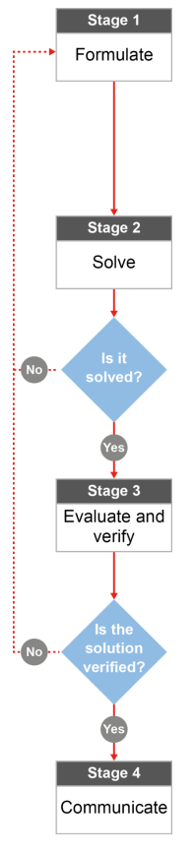

QCAA approach to problem solving and mathematical modelling
(https://www.qcaa.qld.edu.au/downloads/portal/syllabuses/snr_maths_methods_19_syll.pdf)

What’s happened to the amount of water in the Ross River dam?

Australian curriculum content descriptors:
Year 7
Investigate, interpret and analyse graphs from authentic data (ACMNA180)
Identify and investigate issues involving numerical data collected from primary and secondary sources (ACMSP169)

L
What’s happened to the amount of water in the Ross River dam?

Modelling Northern Qld

- What do you know about the water levels of the Ross River dam (how full it is) over the past few years? State your opinion based on what you’ve heard in the local media or from family and friends.

________________________________________________________________________________________________________________________________________________________________________________
- If the Ross River Dam, which provides water to all Townsville residents were to be filled up today, how long do you think it should last Townsville before it runs out (assuming we have no rain)? ___________________

Research & Formulate

Let’s gather some information by researching more about the dam levels and use our knowledge of straight line graphs to find out if what you’ve heard is accurate.
Here’s what we know about the levels of the Ross River dam from the Townsville City council website:
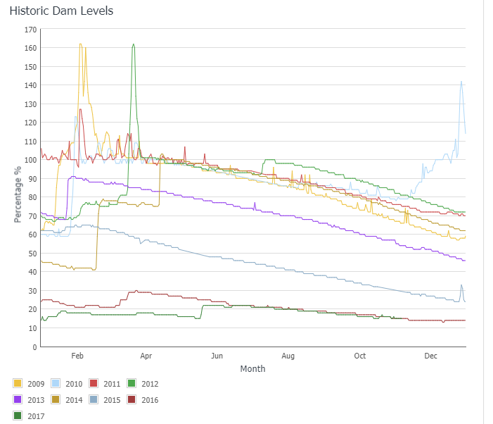

NOTE: Ignore the small peaks that look like this: . These are incorrect sensor readings.

There’s a lot of information in that graph! We need to ask ourselves some questions to understand what this graph is saying.

3. Answer the following questions to connect the graph with what you already know about North Queensland.
a) What do the numbers represent on the vertical axis? __________________________________________________
b) What happens to each line at the end of each year? Where does it continue? ______________________________
_______________________________________________________________________________________________
c) Does the Ross River dam level tend to increase in the first or the second half of each year? ___________________
Why is that? (HINT: think about weather in North Qld) ________________________________________________
_______________________________________________________________________________________________
d) Why do you think it is that the increases in the line graphs are much steeper than the decreasing sections of the line graphs? (HINT: Think about what would happen to make the lines increase and what would happen to make the lines decrease) __________________________________________________________________________________
_______________________________________________________________________________________________
e) Find the line that represents the 2014 data. What might have happened in that year to explain the sudden changes in the line? ______________________________________________________________________________
_______________________________________________________________________________________________
f) Cyclone Olga crossed the North Queensland Coast sometime in 2013 and North Queensland had a great deal of rain as a result. Circle the corresponding change on your graph. Write here how you knew which part of the 2013 graph to circle: __________________________________________________________________________________
_______________________________________________________________________________________________
g) In the December period, one line (the pale blue line) is quite different to the others. Why might that be? ________
_______________________________________________________________________________________________
h) Look at the parts of the graph when the line decreases (so the water level in the dam is dropping). Some decreasing lines are quite steep while others are less steep. What do you think the steepness of the lines tells us about what’s happening to the water in the dam? ______________________________________________________
_______________________________________________________________________________________________
i) Late in 2016 (look at the December region of the 2016 line), the Townsville City Council began to pump water from the Burdekin Dam into the Townsville water supply. How did that affect the water level in the Dam? Refer to the steepness of the line graph in your answer. _______________________________________________________________________________________________
_______________________________________________________________________________________________

- You can be more specific about what happens to the water levels of the Ross River dam by doing some calculations. Complete the table below and describe what happens to the water levels in three different years. You will need to work out the difference between percentage amounts (so you’ll need to subtract) for different parts of the lines. Suggest reasons for any changes that occur in the year. An example is provided to help you get started.
Solve

Changes in water levels of the Ross River Dam

Year | How full was the dam at the start of the year? | What happened over the year? What might have caused those changes? | How full was the dam at the end of the year? | Overall, did the water level increase or decrease from the start of the year to the end? By what percentage?
2013 | 72% full | Slight decrease of 4% down to 68% full over the first month - regular water use  A big increase of 23% in a short amount of time in February (dam up to 91%) – perhaps a cyclone?  Slow decrease after that of 44% over the rest of the year (that’s almost half of what the dam can hold in less than a year!) | 47% full | Overall, a decrease of about 25% (72-47) despite the big rains early in the year.
2011
2012
2017

- Which parts of the graph (be specific) support your initial thoughts (in Question 1) about what you’ve heard about water usage and the dam levels in Townsville? Which parts of the graph look different to what you thought might be happening?
Evaluate & verify

________________________________________________________________________________________________________________________________________________________________________________________________________________________________________________________________________
- Look at the results in your table in Q5 and use your calculations to revise your answer to Q2 earlier.
- If you used the 2013 data, roughly how long do you think it would take for Townsville to empty a full dam? _________________________
- What if you used the 2017 data? Approximately how long would it take then? ____________________
- Why do you think your answers to parts a) and b) are so different (HINT: think about what happens with water usage in a city or town when the dam water levels drop)? _________________________________
_____________________________________________________________________________________

Communicate

- What if someone wanted to know what had happened to the Ross River dam levels over the past five years but they could not understand the information presented in the graph? Sometimes it helps to present the same information in a different way.
Percentage
Using the information in the Council graph, sketch what happened to the dam levels over the past five years with one line graph on the axes below. In mathematics, sketching means that you are not plotting lots and lots of points but you are showing what is happening in general (like an approximation) so you need to choose a few points that will help you get the correct shape.

2013 2014 2015 2016 2017
Years
- If a Townsville resident told you that the Council is just making a big fuss about the Ross River Dam levels and that there is plenty of water, how would you respond? ________________________________________
________________________________________________________________________________________
________________________________________________________________________________________

Sources for local information: https://www.townsville.qld.gov.au/water-waste-and-environment/water-supply-and-dams/dam-levels ; https://www.townsville.qld.gov.au/__data/assets/pdf_file/0012/3270/Water-Restrictions_FAQs.pdf

