A problem-solving and modelling task suitable for students working with volume, surface area (Focus: Cylinders)
Modelling Northern Qld

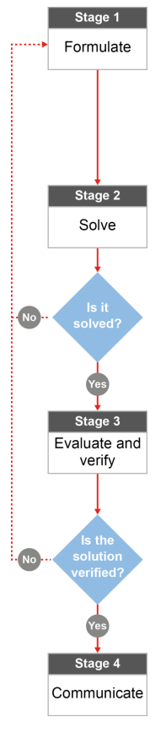

QCAA approach to problem solving and mathematical modelling
(https://www.qcaa.qld.edu.au/downloads/portal/syllabuses/snr_maths_methods_19_syll.pdf)

What kind of crab pot can you buy to get you the biggest feed?

Australian curriculum content descriptors:
Year 9
Calculate the surface area and volume of cylinders and solve related problems (ACMMG217)

L
What kind of crab pot can you buy to get you the biggest feed?
Modelling Northern Qld

- Have you ever used a crab pot to go crabbing? If you have, what makes a good crab pot, in your opinion:

________________________________________________________________________________________________________________________________________________________________________________

Research & Formulate

Let’s gather some information about crab pots that can be used to catch a feed of mud crabs. Imagine that David decides to take his son Daley out crabbing to Casement Grove. David’s old crab pots are too old and torn to use so he and Daley head to a local fishing shop to buy a new one. They see the two crab pots below and they also notice an old roll of crab pot wire on sale. They want the chance to catch the most crabs possible for their family to have a big feed.
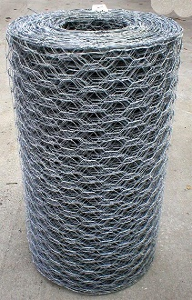
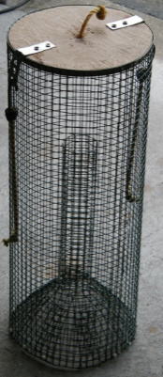
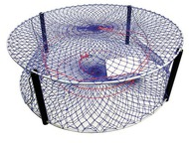
50cm
1.3m
1m

1.5m
Unrolls to 2m
80cm

Crab pot 1 Crab pot 2 Option 3: Crab pot wire

- What 3D shapes could you use to “model” or represent the general shape of each crab pot? Sketch out at least two possibilities for making crab pot number 3 before you answer this question. _________________________________________________________________________________

- What kind of measurement would tell you about the amount of room inside each crab pot: surface area or volume? _________________________________________________

- What formulae will be useful in your calculations? ________________________________________

- What information do you need to be able to use the formulae? Do you have it already or could you figure it out? _____________________________________________________________________

- After you do some calculations, how will you know which pot is the best one to use? What are you looking for? _______________________________________________________________________
Now that you have a plan…
Solve

- Calculate the volume of all of the crab pot options. HINT: Make sure that all of the lengths for each pot are in the same unit (all in cm or all in m) before you do any calculations. Make sure that you can cut out all of the sides needed for your third option from the sheet of crab pot wire.

- Compare the volume for your crab pots. HINT: The volumes must all be in the same unit (cm³ or m³) so that you can make a good comparison. Based on your calculations, which pot do you think is capable of holding the most crabs and why? ___________________________________________________________________________________________________________________________________________________________________________________________________________________________________________________
Evaluate & verify

- Check back at what you wrote for question 1. Based on what you wrote and what you may have researched about catching mud crabs, do you think that choosing a crab pot using volume calculations is a good way to go? What other factors might also be important when choosing a good crab pot?

________________________________________________________________________________________________________________________________________________________________________________________________________________________________________________________________________
Communicate

- If someone who didn’t live in Queensland bumped into you at the local fishing shop and asked you to help them choose a good crab pot that would “catch me a big feed of mud crabs”, describe the maths they could use to help them decide.

________________________________________________________________________________________________________________________________________________________________________________________________________________________________________________________________________
References:
Images for crab pot options
http://www.nbssportfishing.com/vBforum/attachment.php?attachmentid=15432&d=1318635305 http://media.supercheapauto.com.au/bcf/images/thumbs/120362-thumb.jpg
https://cdn.shopify.com/s/files/1/0888/6842/products/galvanized-wire.jpg?v=1447359667

