A problem-solving and modelling task suitable for students working with area (Focus: composite shapes)
Modelling Northern Qld

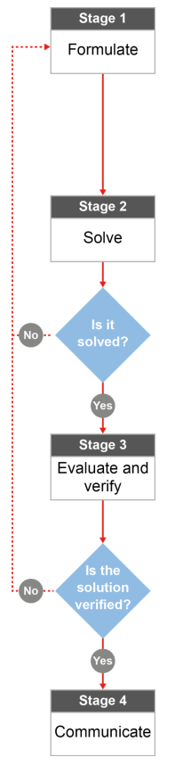

QCAA approach to problem solving and mathematical modelling
(https://www.qcaa.qld.edu.au/downloads/portal/syllabuses/snr_maths_methods_19_syll.pdf)

How big is the Burdekin?

Australian curriculum content descriptors:
Year 9
Calculate areas of composite shapes (ACMMG216)
L
How big is the Burdekin?
Modelling Northern Qld

1. Which of the following towns/regions do you think is smaller than the Burdekin Shire?

- Townsville
- Mackay
- Cairns
- Brisbane
- Atherton Tablelands
- Rockhampton
- Charters Towers Region
- Whitsundays Region
- Canberra

Research & Formulate

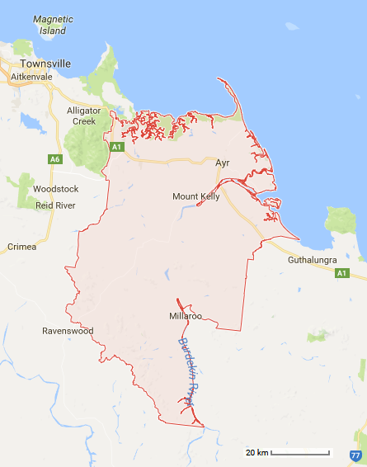
Brittany goes to the Burdekin every year for Christmas with her family. Her friend Jessie thought that the Burdekin was a single town. However, the Burdekin Shire consists of 49 smaller regions such as Fredericksfield, Ayr, and Dalbeg. Because Jessie has never been to the Burdekin Shire, Brittany is trying to explain how big it really is.
2. What combinations of 2D shapes could you use to ‘model’ or represent the general shape of the Burdekin? Choose shapes that cover the Burdekin as accurately as you can.
Reference:
Region Map - https://www.google.com.au/maps/place/Burdekin,+QLD/@-19.7665909,146.9071502,9z/data=!4m5!3m4!1s0x6bd81f210958bc6b:0x8201f8aac328ae68!8m2!3d-19.5227151!4d147.4627259
_______________________________________________________________________________________
- What type of measurement would be the best to describe how big the Burdekin is?
Perimeter Area Volume

- What formula will be useful in your calculations?
_______________________________________________________________________________________
_______________________________________________________________________________________________
_______________________________________________________________________________________________
- What information do you need to be able to use the formula? Do you have it already or could you figure it out?
_______________________________________________________________________________________
_______________________________________________________________________________________________
- The picture is a scaled diagram. How will you get the real size of the Burdekin? [Hint” It is usually easier to do your conversions before using any measurement formula.]
_______________________________________________________________________________________
_______________________________________________________________________________________________
- Looking at the shapes you are using to calculate the size of the Burdekin Shire, would you say that your calculations will be too big or too small? How can you tell? ____________________________________________________________________________________
____________________________________________________________________________________________

Now that you have a plan…
Solve

- Using your answers from Q2-6, calculate the area of the Burdekin (approximately).

Evaluate & Verify

- The actual area for the Burdekin is 5,025 km². Compare this with your approximation of the area. How could you improve your approximation?
_______________________________________________________________________________________________
______________________________________________________________________________________________
______________________________________________________________________________________________
______________________________________________________________________________________________
______________________________________________________________________________________________
- Google some of the areas of the towns and regions from question 1. Compare these areas to the area of the Burdekin – are there any that you weren’t expecting? If so, what key factors influenced your decision making?

- Townsville _______
- Mackay _______
- Cairns _______
- Charters Towers Region ______
- Atherton Tablelands ______
- Rockhampton ______
- Brisbane ______
- Whitsundays Region ______
- Canberra ______
______________________________________________________________________________________________
______________________________________________________________________________________________
______________________________________________________________________________________________
______________________________________________________________________________________________
______________________________________________________________________________________________
Communicate

- If someone else was like Jessie and didn’t realise how big the Burdekin is, how would you explain it to them. Justify your answer using your calculations and your research of other areas in Australia.
_______________________________________________________________________________________________
_______________________________________________________________________________________________
_______________________________________________________________________________________________
_______________________________________________________________________________________________
_______________________________________________________________________________________________
_______________________________________________________________________________________________

