A problem-solving and modelling task suitable for students working with linear relationships (Focus: Equations)
Modelling Northern Qld

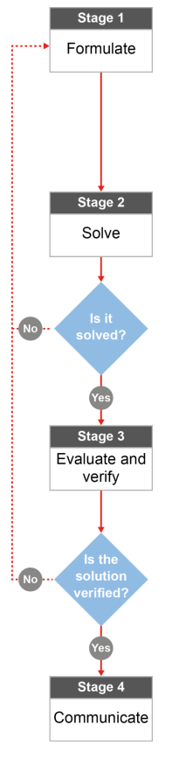

QCAA approach to problem solving and mathematical modelling
(https://www.qcaa.qld.edu.au/downloads/portal/syllabuses/snr_maths_methods_19_syll.pdf)

Could Townsville ever run out of water?

Australian curriculum content descriptors:

Year 10
Solve problems involving linear equations, including those derived from formulas (ACMNA235)

L

Could Townsville ever run out of water?

Modelling Northern Qld

- Would you say that Townsville residents change their water usage when different water level restrictions are imposed by the Townsville City Council? State your opinion based on what you’ve heard in the local media or from family and friends.

________________________________________________________________________________________________________________________________________________________________________________

Research & Formulate

Let’s gather some information by researching more about water restrictions and use our knowledge of linear equations to find out if what you’ve heard is accurate.
Here’s what we know about water restrictions from the Townsville City council website:

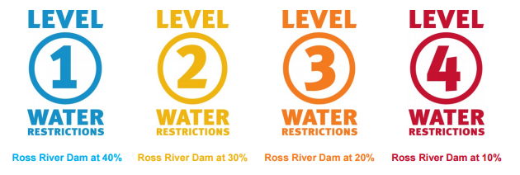

Hmmm… Looks like water restrictions are related to the level of the Ross River dam. That means we’ll need more information.

On the next page is some information about the Ross River Dam levels in Townsville over the past eight years.
NOTE: Ignore the small peaks that look like this: . These are incorrect sensor readings.

2. Answer the following questions to connect the graph with what you already know about North Queensland.
a) What do the numbers represent on the vertical axis? __________________________________________________
b) What happens to each line at the end of each year? Where does it continue? ______________________________
c) Does the Ross River dam level tend to increase in the first or the second half of each year? ___________________
Why is that? (HINT: think about weather in North Qld) ________________________________________________
d) Cyclone Olga crossed the North Queensland Coast early in 2013 and North Queensland had a great deal of rain as a result. Circle the corresponding change on your graph.
e) Water restrictions are enforced according to the dam levels. Take a ruler and rule four horizontal lines to indicate where level 1, 2, 3 and 4 water restrictions should occur. Use the graphic up the top of this page to help you find the percentage that matches each water restriction level.
f) The capacity of the Ross River dam is 233 187 ML (mega litres). Add this value to the vertical axis next to 100% and then use that information to add the capacity of the dam at 75%, 50%, 25%, 20% to the vertical axis.
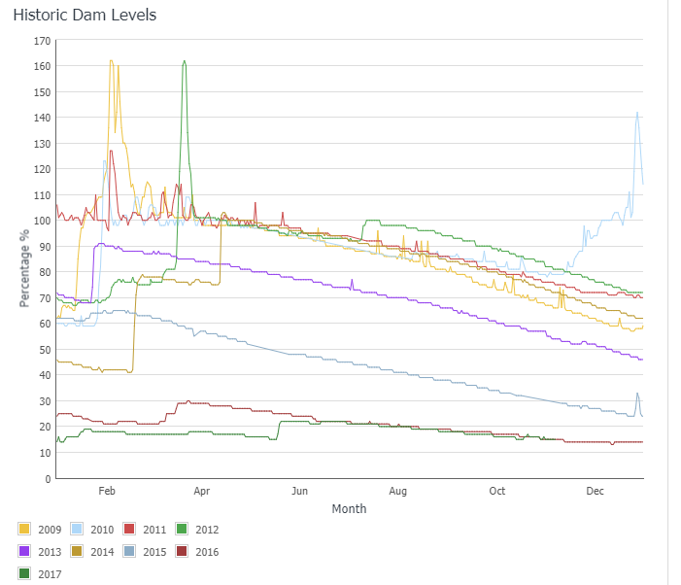

- Identify the 2013 Dam levels on the graph. You can model (represent) the Dam levels from February 2013 to December 2013 using a linear equation. To do this, use a ruler to rule in a line of best fit on your graph. Number the horizontal axis as “Months after the year begins” so that you have numbers to work with on that axis. Now calculate the gradient and y intercept of your line. Use the capacity measurements from the vertical axis (in ML) and not the percentages in your calculations.
Solve

________________________________________________________________________________________________________________________________________________________________________________________________________________________________________________________________________________________________________________________________________________________________________________________________________________________________________________________
- What does the value of the gradient represent in this situation? You’ll need to think carefully about what the vertical and horizontal axis represent. (HINT: Think about the unit of measure that you are using to measure gradient)

________________________________________________________________________________________________________________________________________________________________________________

- What does the value of the y intercept represent in this situation? ________________________________________________________________________________________________________________________________________________________________________________

- Would gradient or y intercept calculations be more helpful in finding out about Townsville residents’ water usage? Why? ________________________________________________________________________________________________________________________________________________________________________________

- Model the dam levels from April to December 2016 using a linear equation. Rule in a line of best fit, calculate the gradient and y-intercept and write your equation in y = mx + c form below.

________________________________________________________________________________________________________________________________________________________________________________________________________________________________________________________________________________________________________________________________________________________________

- Late in 2016, the Townsville City Council began to pump water from the Burdekin Dam into the Townsville water supply. How did the rate of water usage (i.e., the gradient) change at that time? Compare the gradient in early 2017 with previous years/months. Don’t complete any calculations but instead just use a ruler placed above the graph lines to compare.

________________________________________________________________________________________________________________________________________________________________________________________________________________________________________________________________________
- What if the option of pumping water from the Burdekin Dam was not possible and Townsville residents continued to use water at the same rate (with no major rain in sight)? How long would it take for the Ross River dam to run completely dry? Use the equation that you developed in Question 6 to make some calculations and to find the month and year when the Dam levels would be 0%.
________________________________________________________________________________________________________________________________________________________________________________________________________________________________________________________________________________________________________________________________________________________________
________________________________________________________________________________________________________________________________________________________________________________

Evaluate & verify

- Do your findings support your initial thoughts (in Question 1) about what you’ve heard about water restrictions and water usage in Townsville?

________________________________________________________________________________________________________________________________________________________________________________________________________________________________________________________________________

- What are the strengths and weaknesses of your approach in answering Question 8? What do you know about the weather and the people in North Queensland that might affect the accuracy of your calculations?
________________________________________________________________________________________________________________________________________________________________________________________________________________________________________________________________________
Communicate

- If someone who didn’t live in Queensland asked you if it is possible that Townsville could run out of water, what would you say? Include an example using an equation that you developed.

________________________________________________________________________________________________________________________________________________________________________________________________________________________________________________________________________

Sources for local information: https://www.townsville.qld.gov.au/water-waste-and-environment/water-supply-and-dams/dam-levels ; https://www.townsville.qld.gov.au/__data/assets/pdf_file/0012/3270/Water-Restrictions_FAQs.pdf

