TRIM/HPRM – Searching
TRIM is so powerful and has so many search options that you only need to know one piece of information about the record to find it.
Hence there are numerous categories you can ‘Search By’ and listed below.
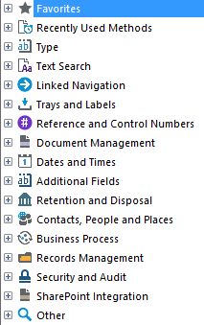
Under each of these categories are more specific search options.

The most commonly used ones are located under ‘Text Search’. These are:
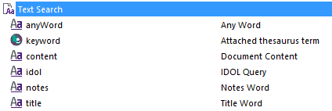
- Any Word – this option searches titles of Containers/Files/Boxes/Folders/Documents etc, as well as any ‘Notes’ that may be applied to those records created. For example, boxes of HR and Student files received by the Records team are created in TRIM with a full list of who is in the box, typed in the notes. So if you use ‘Anyword’ as a search when looking for a student’s file, you may come across a box in your results, which indicates a physical file exists in a box in Records storage.
- Document Content – TRIM has the ability to search for typed words on a page, using Optical Character Recognition (OCR).

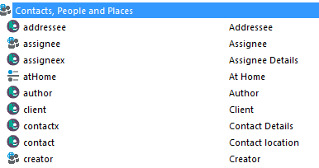
- Author – This option allows you to search for records using authors such as email senders.
- Creator – Everyone who saves documents to TRIM is known as a ‘Creator’. A good search tool to use if you have saved a record to TRIM and cannot find the folder you put it in. For management, it is a good way of monitoring how much a person is putting in to TRIM. Particularly when the search is used with the ‘Date Registered’ search type.

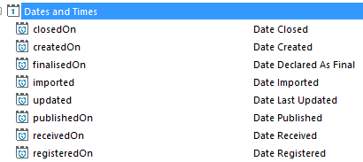
- Date Registered – Used to search for documents saved to TRIM between certain dates, on specific dates or years etc. The options under ‘Date Registered’ are:
- 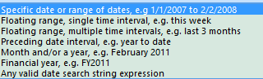

Now that you know what the most common search types are, lets look at how to search in TRIM.

There are four different types of searching covered in this guide:
- Simple Searching
- Sorting and filtering searches
- Wildcard searching
- Advanced searching
Instructions | Picture demonstration
There are four main ways to start the search.  - Click on Global menu;  - Click on the ‘Find Records’ icon;  - Use the ‘Quick Search’ window; or  - Ctrl and F | 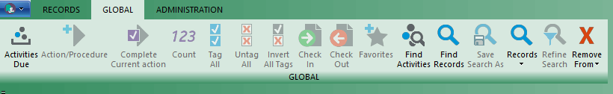
If using the ‘Find Records’ option on the menu bar, the following ‘Search for Records’ dialogue box will appear, which is the same as pressing the ‘Ctrl and F’ keys on your keyboard.  Hence the quickest way to bring the search window up is via ‘Ctrl and F’  Each time you access this window, TRIM will remember each different types of ‘Search By’ methods you have performed.  Such as those covered above:  - Anyword  - Document content  - Date registered  - creator | 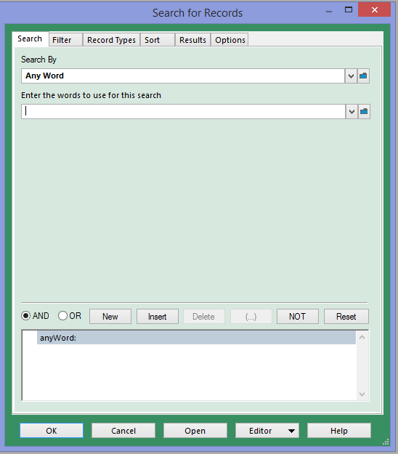
Quick search is the only one that does not give you the ability to build a search or choose options such as filtering record types.
The ‘Equal To’ field is the next step for TRIM. It knows you want ‘Any word’ within a Title of a record or the notes within the record.  Whatever word of number is typed in this field will be the one TRIM uses to search every record in TRIM for a match.  In Student administration teams, your ‘Equal To’ field is where you type the student ID number.  In Human Resources, your ‘Equal To’ field is where you type the employee number or position number etc.  Press ‘OK’ and your records will appear. | 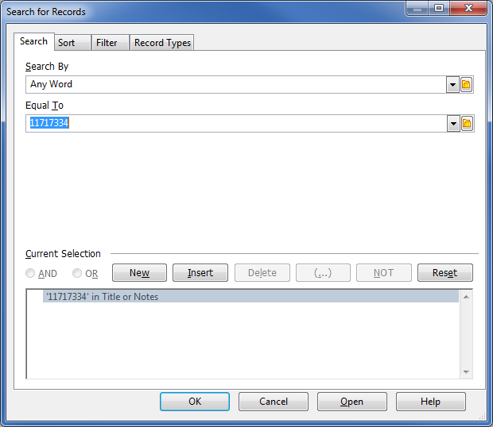
Your records will appear.  In this example I have used the word ‘Geology’  If too many records appear in your search results, or you would like to put them in a particular order, you can refine your search.  To find out how many records you have the in search results window, press the 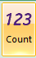  On the Global Ribbon. | 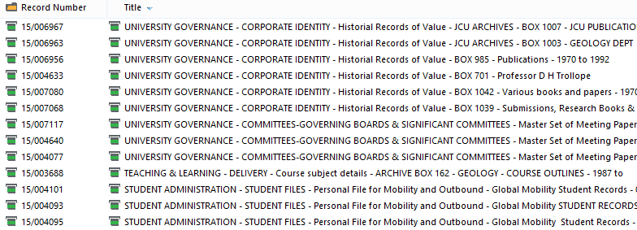
To ‘Refine Search’ press ‘F7’ and your original search window will appear so that you can click on each folder and set the search criteria you wish. | 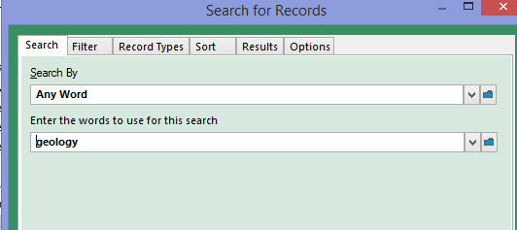
Select the ‘Record Types’ tab to only show the record types you want to see.  In this example I’m looking for photographs related to the Geology department.  Note. It is easier to right click and Untag all first,  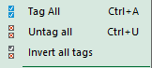  then go back and place a tick next to the ones you do want. | 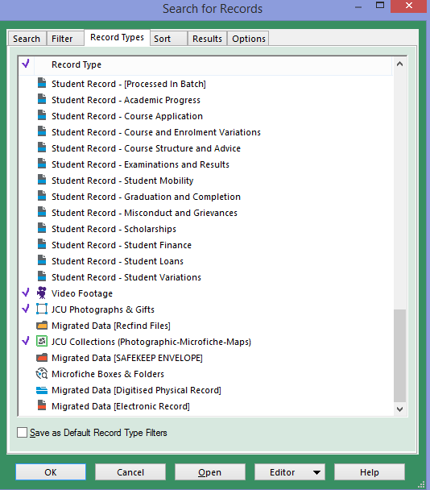

Wildcard searching
A wildcard search is one where you only have part of a word or unsure of the spelling etc. Rather than type the entire word you use the wildcard icon ‘*’ at the end of the word. For example, rather than type the full word ‘Administration’, you can use the wildcard search character ‘*’ and type ‘Admin*’ instead.
Process Steps | Instructions | Picture demonstration
1 | Bring up your search window.  Click on the field ‘Equal To’ | 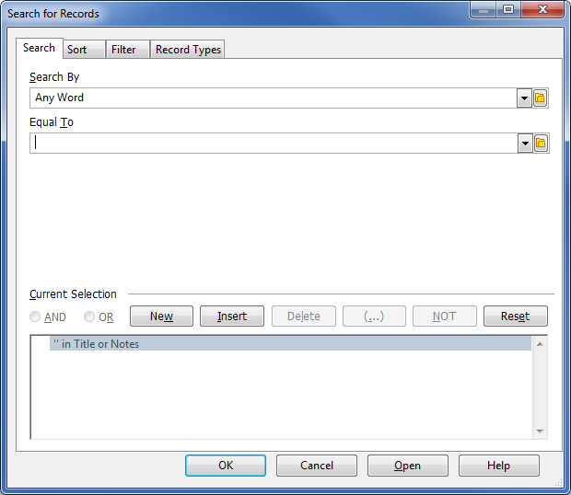
2 | Type a partial Student surname and * In the example we have used ‘Dev*’  Then Click ‘OK’ | 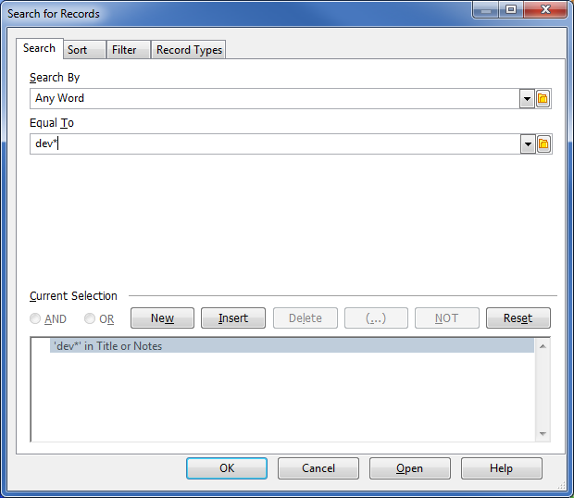
3 | Your record search result has listed all records containing the partial word. | 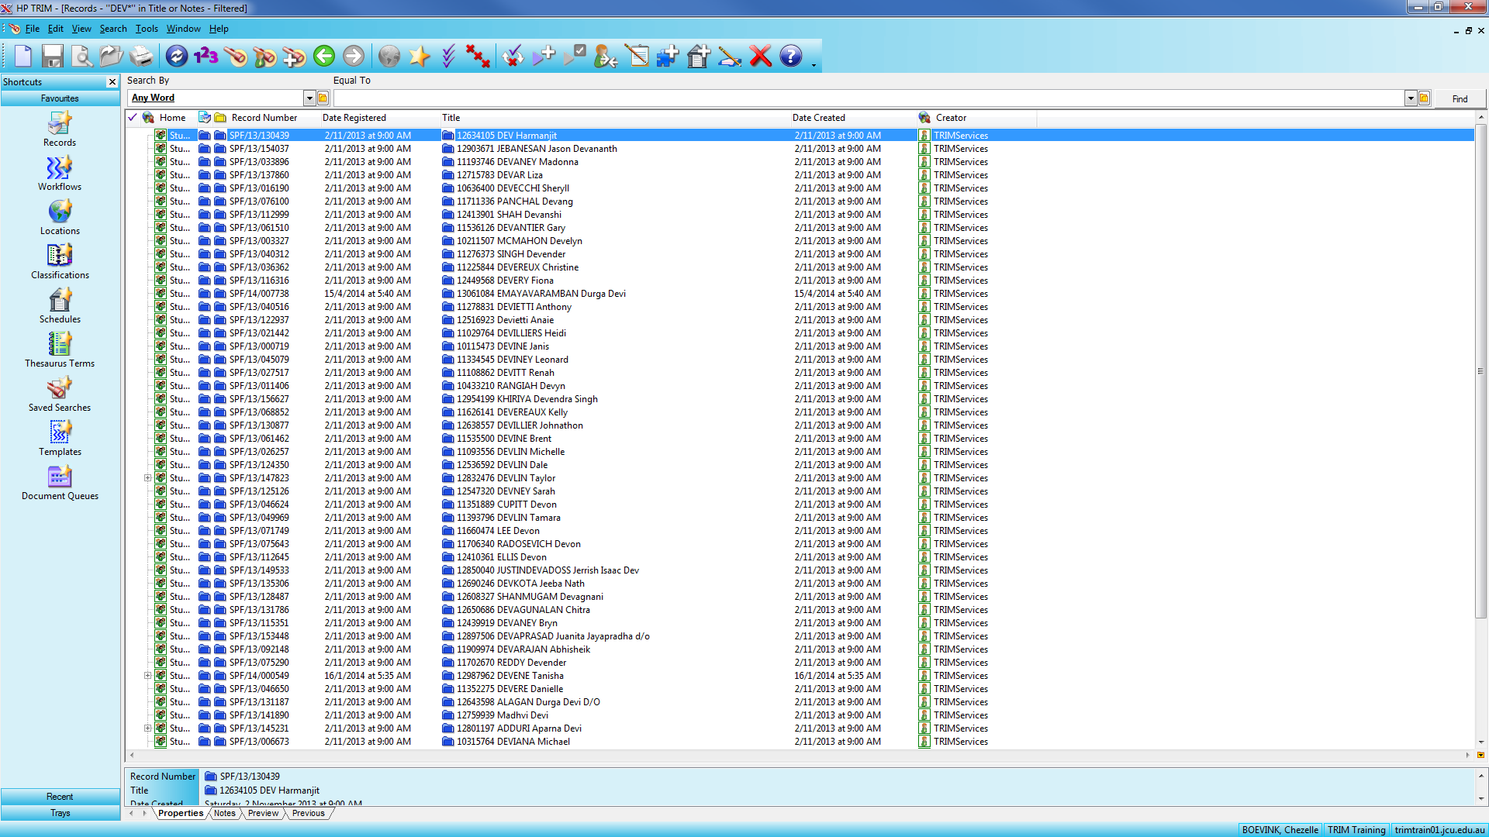
4 | To find out how many records you have, ‘123’ icon will calculate this for you. If there are too many, you can elect to refine your search by pressing ‘F7’ | 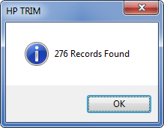

Advanced searching
Advanced searching is doing so using multiple pieces of information. For example, you are searching for a record and you know the date it was created in TRIM and part of the title. In this case you use 2 layers of ‘Search By’ functions.
Process Steps | Instructions | Picture demonstration
1 | Click on ‘Search’ menu, or ‘Find Records’ icon or ‘Ctrl F’ to bring up the search window  This is where we build the layers to your search using the ‘Search By’ and ‘Equal To’ fields as any other search.  The search build will show in the bottom pane ‘Current Selection’ | 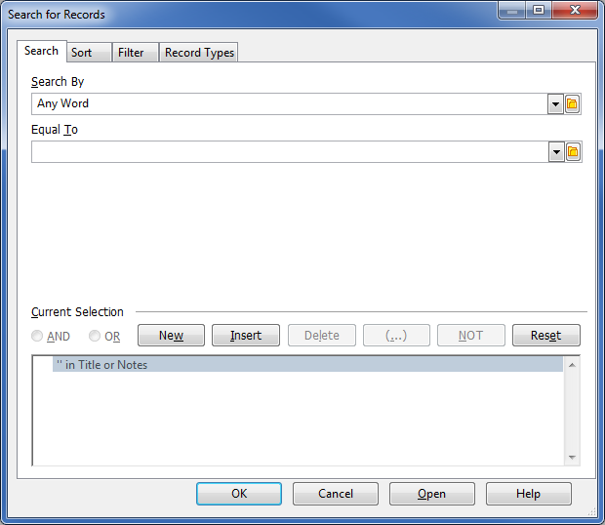
2 | Now that you have chosen your ‘Search By’ method, click on ‘Equal To’ box  We will use the ‘Smith’  Knowing there will be a lot of students with the surname Smith, we will add another search layer to reduce our results.  To do this:  - Any word Equal To ‘Smith’  - Press ‘New’ button  - Leave ‘Any Word’ and type Michael  - OK | 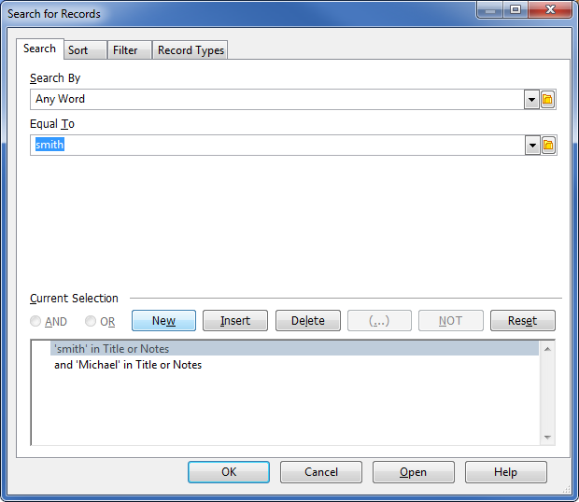
3 | The bottom of the ‘Search for Records’ window shows that you have asked TRIM is search for “‘smith’ in Title or Notes and ‘Michael’ in Title or Notes”
4 | We will also choose the record types we want to see via the ‘Record Types’ tab in the Search window as shown. | 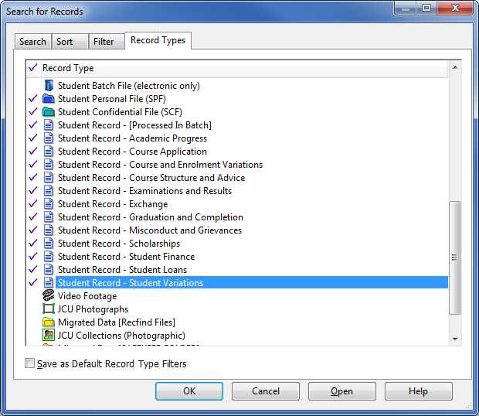
5 | TRIM has produced a list of Student files in the name of Michael Smith as requested in the layered search

