TRIM Setup Options

TRIM has been setup using standard options and a generic colour. These can be easily changed and as often as you like.
This package will show you how to change the:
- Colour – known as ‘Appearance’
- Options when putting records in from the Shared drive
- Integration options so that Outlook is connected; and
- Microsoft options, acknowledging that not all documents in the shared drive will be saved to TRIM

Colour - Appearance
Step 1 –  In TRIM, go to the ‘File’ drop down and choose  ‘Options’ | 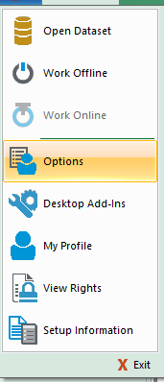
Step 2  The ‘HPE Records Manager Options’ will appear. | 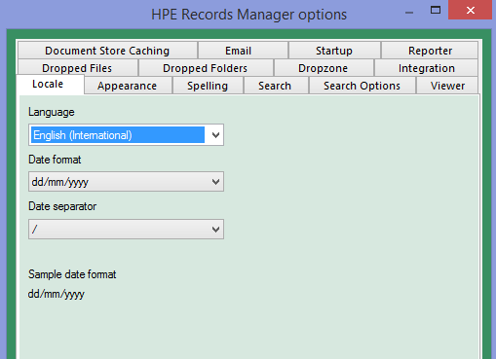
Step 3  Choose the ‘Appearance’ folder | 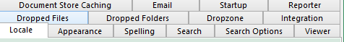
Step 4  Ensure the ‘Use a custom Skin’ is ticked, the click on ‘Set Skin Colour’ | 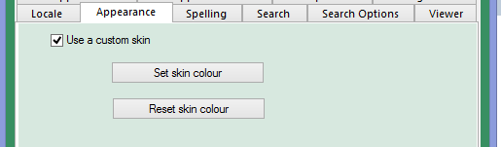
Step 5  Once the colour pallet is displayed, choose a colour and press OK. | 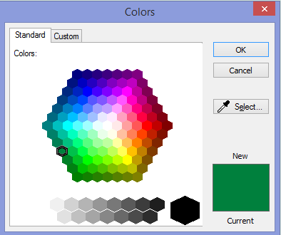

Options when putting records in from the Shared drive
TRIM is set up to ask three questions when documents are moved in to folders.
- What document icon (Record Type) is the document you are putting in going to look like in TRIM? (Dark blue is for student services, Red is for corporate users and light blue indicates it is a scanned document from the Ezescanner)
- What will the title be?
- What container/folder/file is it going to be saved in? This is the Record number of the Container.

In the ‘HPE Records manager Options’ dialogue box, go to the folder labeled ‘Dropped Files’.  The setup on the right indicates that all my records I place in TRIM are:  - Electronic Records  - Going to be saved in to TRIM with the heading it currently has; and  - Automatically deleted from it’s original saved location once it is in TRIM | 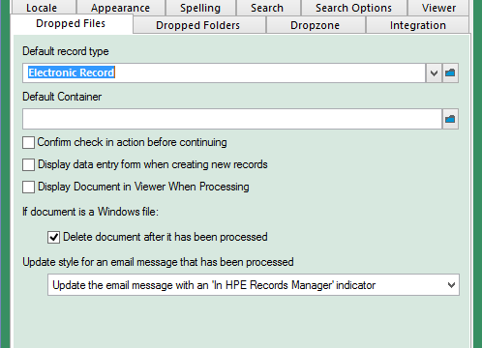
Changing the Default Record Type  Select the blue folder  Choose the ‘Record Type’ and press Ok | 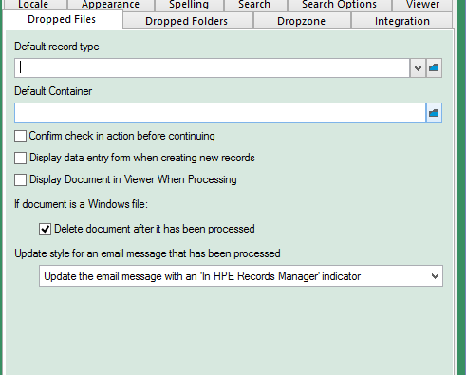  A number of Record Type options will appear  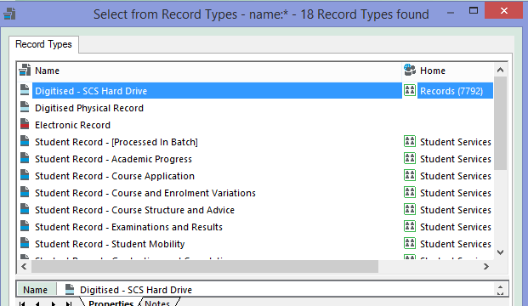
The ‘Default Record Type’ is new populated with your selection | 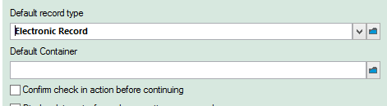
Removing the Data entry form
If you are happy to leave original titles, then the Data entry form is not required.

To turn this option off, ensure the ‘Display data entry form when creating new records’ is not ticked, as shown.
Auto deletion of records from the shared drive once in TRIM  Rather than have to go back to the shared drive and manually delete the records, this function will have TRIM automatically do this for you as each on is ‘checked in’. | 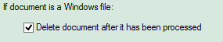
Integration Options to ensure Outlook & TRIM are connected
TRIM and Outlook are integrated so that:
- Linked folders between TRIM and Outlook mean that emails placed in linked folders will automatically go to the relevant Container/Folder/File in TRIM
- Records in TRIM can be emailed out; and
- Emails received can be saved to TRIM.
Step 1

Go to the TRIM Menu File

Step 2  Choose ‘Desktop Add-Ins’ | 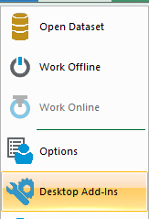
Step 3  Ensure the following are ticked:  - ‘Integrate HPE Records Manager with ODMA-compliant applications’  - Microsoft Outlook  Press OK | 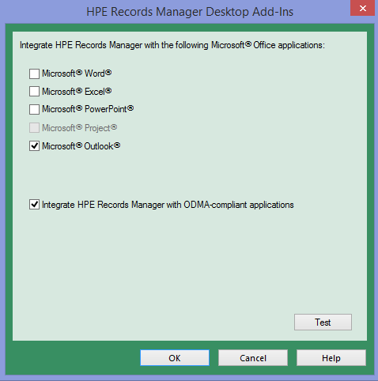
Step 4
Check the integration has worked.
Outlook should now have the following folder at the top banner with the other folders
Microsoft options
TRIM has been designed to assume that all documents you save on the shared drives will be saved to TRIM.
Because certain documents such as personal, working papers and drafts are not considered to be records, the following will show you how to turn that automatic function off. If left on, every microsoft record you try save to the shared drive will do so to a TRIM holding folder.

Step 1
Go to the TRIM Menu File

Step 2

Choose desktop Add-Ins
Step 3
Remove the ‘Tick’ from each box as shown.

Note. The grey shaded file type will remove automatically once the others are de-selected.
Step 4  Press OK | End of process

