A problem-solving and modelling task suitable for students working with volume (Focus: Composite solids)
Modelling Northern Qld

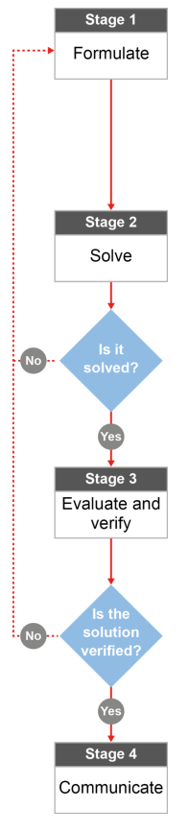

QCAA approach to problem solving and mathematical modelling
(https://www.qcaa.qld.edu.au/downloads/portal/syllabuses/snr_maths_methods_19_syll.pdf)

What kind of crab pot gets you the biggest feed?

Australian curriculum content descriptors:
Year 10
Solve problems involving surface area and volume for a range of prisms, cylinders and composite solids (ACMMG242)
Solve problems involving surface area and volume of right pyramids, right cones, spheres and related composite solids (ACMMG271)

L
What kind of crab pot gets you the biggest feed?
Modelling Northern Qld

- Have you ever used a crab pot to go crabbing? If you have, what makes a good crab pot, in your opinion:

________________________________________________________________________________________________________________________________________________________________________________

Research & Formulate

Let’s gather some information about crab pots that can be used to catch a feed of mud crabs. Imagine that David decided to take his son Daley out crabbing one day. David took his boat up to Casement Grove and pulled out the three crab pots below. Only then does David also discover that he hasn’t packed enough bait! He only has enough bait for one pot but wants the chance to catch the most crabs possible for his family to have a big feed. Which is the best crab pot for David and Daley to use?

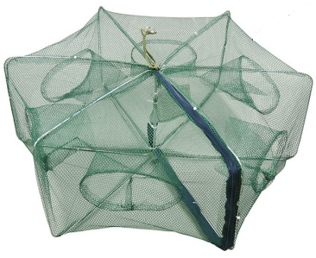
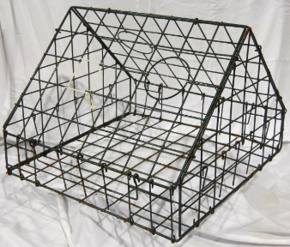
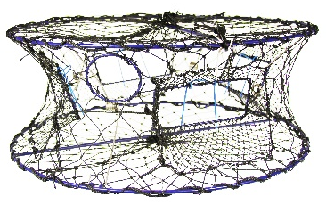
60cmm
80cm
20cmm
20cm
50cm
60cm

1.3 m
50cm
1.3 m
1.5m

Crab pot 1 Crab pot 2 Crab pot 3

- What 3D shape combinations could you use to “model” or represent the general shape of each crab pot? Break up the shapes into parts before you answer this question. _________________________________________________________________________________

- What kind of measurement would tell you about the amount of room inside each crab pot: surface area or volume? _________________________________________________

- What formulae will be useful in your calculations? ________________________________________

- What information do you need to be able to use the formulae? Do you have it already or could you figure it out? _____________________________________________________________________

- After you do some calculations, how will you know which pot is the best one to use? What are you looking for? _______________________________________________________________________

Now that you have a plan…
Solve

- Calculate the volume of all of the crab pot options. HINT: Make sure that all of the lengths for each pot are in the same unit (all in cm or all in m) before you do any calculations.

- Compare the volume for your crab pots. HINT: The volumes must all be in the same unit (cm³ or m³) so that you can make a good comparison. Based on your calculations, which pot do you think is capable of holding the most crabs and why? ___________________________________________________________________________________________________________________________________________________________________________________________________________________________________________________
Evaluate & verify

- Check back at what you wrote for question 1. Based on what you wrote and what you may have researched about catching mud crabs, do you think that choosing a crab pot using volume calculations is a good way to go? What other factors might also be important when choosing a good crab pot?

________________________________________________________________________________________________________________________________________________________________________________________________________________________________________________________________________
Communicate

- If someone who didn’t live in Queensland bumped into you at the local fishing shop and asked you to help them choose a good crab pot that would “catch me a big feed of mud crabs”, describe the maths they could use to help them decide.

________________________________________________________________________________________________________________________________________________________________________________________________________________________________________________________________________
References:
Images for crab pot options
http://media.supercheapauto.com.au/bcf/images/thumbs/120362-thumb.jpg http://wdfw.wa.gov/enforcement/lost_gear/graphics/doghouse_crab_pot.jpg https://ae01.alicdn.com/kf/HTB19DK3SXXXXXbZXFXXxh4dFXXXp/High-Quality-Nylon-Foldable-font-b-Fishing-b-font-font-b-Pot-b-font-Net-Crab.jpeg

