A problem-solving and modelling task suitable for students working with area (Focus: rectangles, triangles & parallelograms)
Modelling Northern Qld

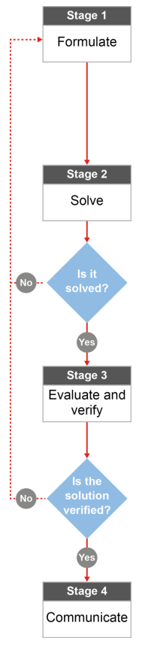

QCAA approach to problem solving and mathematical modelling
(https://www.qcaa.qld.edu.au/downloads/portal/syllabuses/snr_maths_methods_19_syll.pdf)

How big is the Burdekin?

Australian curriculum content descriptors:
Year 7
Establish the formulas for areas of rectangles, triangles and parallelograms, and use these in problem-solving (ACMMG159)
L
How big is the Burdekin?
Modelling Northern Qld

1. Which of the following towns do you think is smaller than the Burdekin Shire?

- Townsville
- Mackay
- Cairns
- Brisbane
- Atherton Tablelands
- Rockhampton
- Charters Towers Region
- Whitsundays Region
- Canberra

Research & Formulate

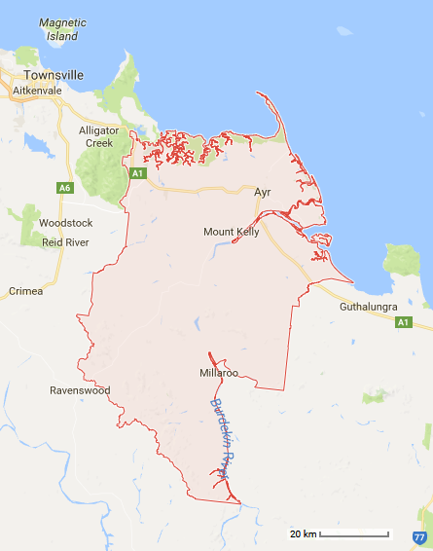
Brittany goes to the Burdekin every year for Christmas with her family. Her friend Jessie thought that the Burdekin was a single town. However, the Burdekin Shire consists of 49 smaller regions such as Fredericksfield, Ayr, and Dalbeg! Because Jessie has never been to the Burdekin Shire, Brittany is trying to explain how big it really is.
Reference:
Region Map - https://www.google.com.au/maps/place/Burdekin,+QLD/@-19.7665909,146.9071502,9z/data=!4m5!3m4!1s0x6bd81f210958bc6b:0x8201f8aac328ae68!8m2!3d-19.5227151!4d147.4627259

2. If you could choose only one shape, what single 2D shape could you use to ‘model’ or represent the general shape of the Burdekin? It won’t be a perfect fit but which shape would be your best option?
_______________________________________________________________________________________
- Circle below the best measurement attribute to describe how big the Burdekin is.
Perimeter Area Volume

- What formula will be useful in your calculations?
_______________________________________________________________________________________
_______________________________________________________________________________________________
_______________________________________________________________________________________________
- What information do you need to be able to use the formula? Do you have it already or could you figure it out?
________________________________________________________________________________________
_______________________________________________________________________________________________
- How would a scale be helpful in these calculations?
_______________________________________________________________________________________
_______________________________________________________________________________________________

Now that you have a plan…
Solve

- Using your shape from question 2, calculate the approximate area of the Burdekin. HINT: draw and measure your shape first, and then apply the scale at the bottom of the map before you complete any area calculations.

Evaluate & Verify

- The actual area for the Burdekin is 5,025 km². Compare this with your approximation of the area. Why was your calculation different to the real area? How could you improve your model and your area approximation?
_______________________________________________________________________________________________
______________________________________________________________________________________________
______________________________________________________________________________________________
______________________________________________________________________________________________
______________________________________________________________________________________________

- Google the areas of the towns and regions from question 1 (Wikipedia is a good place to start). Compare these areas to the area of the Burdekin – are there any that you weren’t expecting? If so, what key factors influenced your decision making?

- Townsville _______
- Mackay _______
- Cairns _______
- Charters Towers Region ______
- Atherton Tablelands ______
- Rockhampton ______
- Brisbane ______
- Whitsundays Region ______
- Canberra ______
______________________________________________________________________________________________
______________________________________________________________________________________________
______________________________________________________________________________________________
______________________________________________________________________________________________
______________________________________________________________________________________________
Communicate

- If someone else was like Jessie and didn’t realise how big the Burdekin is, how would you explain it to them? Use your own area calculations (Q7) and your research into other areas (Q9) to provide a convincing argument about just how big the Burdekin really is.
_______________________________________________________________________________________________
_______________________________________________________________________________________________
_______________________________________________________________________________________________
_______________________________________________________________________________________________
_______________________________________________________________________________________________
_______________________________________________________________________________________________

