A problem-solving and modelling task suitable for students working with linear relationships (Focus: Limitations of linear models)
Modelling Northern Qld

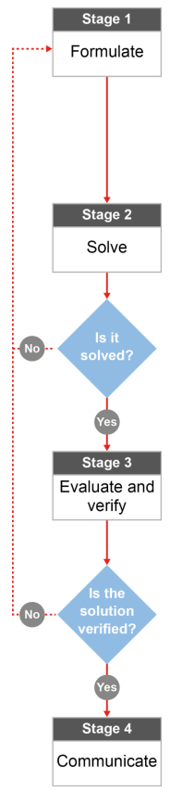

QCAA approach to problem solving and mathematical modelling
(https://www.qcaa.qld.edu.au/downloads/portal/syllabuses/snr_maths_methods_19_syll.pdf)

Will Townsville or Cairns ever have one million residents?

Australian curriculum content descriptors:

Year 9
Sketch linear graphs using the coordinates of two points and solve linear equations (ACMNA215)

Find the midpoint and gradient of a line segment (interval) on the Cartesian plane using a range of strategies, including graphing software (ACMNA294)
NOTE FOR THE TEACHER
The intent of this worksheet is partly to show the limitations of using a linear model to represent real life situations. A discussion of functions with increasing gradients over time (quadratics, exponentials) would be a valuable extension of this task.

L
Will Townsville or Cairns ever have one million residents?

Modelling Northern Qld

- Would you expect the population of Townsville or Cairns to reach one million people in your lifetime? Why/why not? State your opinion.

________________________________________________________________________________________________________________________________________________________________________________

Research & Formulate

The Australian Bureau of Statistics conducts a census of the population of Australia every 5 years.

The table below shows the data collected by the Australian Bureau of Statistics in the last 4 censuses for the populations of the cities of Cairns and Townsville.

Year | Years after 2001 | Population of Cairns | Population of Townsville
2001 | 0 | 122 057 | 133 003
2006 | 5 | 127 438 | 143 328
2011 |  | 133 911 | 157 748
2016 |  | 144 787 | 168 729

- Looking at the data provided in the table, which population would you say is increasing more rapidly, the population of Cairns, or the population of Townsville? Explain your reasoning.

________________________________________________________________________________________________________________________________________________________________________________________________________________________________________________________________________________________________________________________________________________________________________________________________________________________________________________________

- a) Use the data provided in the table to plot four points about the population of Townsville below. Make your horizontal x axis “years after 2001” and work out the rest of the x-values you will need by completing the information in your table. Label the y-axis “Population”.
b) Sketch a line of best fit through your four points. Find the gradient of that line.
________________________________________________________________________________________________________________________________________________________________________________
________________________________________________________________________________________

c) What does the gradient of the line represent? ________________________________________________________________________________________________________________________________________________________________________________
d) What is the y-intercept of that line? ________________________________________________________
e) What does the y-intercept of the line represent? ________________________________________________________________________________________________________________________________________________________________________________
f) Create a linear equation in the form y = mx + c to represent the growth of the Townsville population.
________________________________________________________________________________________________________________________________________________________________________________
________________________________________________________________________________________
- Use the data provided in the table, repeat the process for the Cairns population.
a) Plot the points on the same plane as you did for the Townsville data.
b) Sketch in a line of best fit and label it clearly as “Cairns population”. Find the gradient of that line.
________________________________________________________________________________________________________________________________________________________________________________
c) What does the gradient represent this time? _________________________________________________
d) What is the y-intercept? __________________________________________________________________
e) What does the y-intercept represent this time? _______________________________________________
f) Write the linear equation in the form y = mx + c to show the growth of the Cairns population.
________________________________________________________________________________________________________________________________________________________________________________
________________________________________________________________________________________

- Using the two linear equations you’ve created, estimate the populations of both Townsville and Cairns in each of the following years and compare them:
a) 2020
Solve

________________________________________________________________________________________________________________________________________________________________________________
b) 2050

________________________________________________________________________________________________________________________________________________________________________________
d) 2500

________________________________________________________________________________________________________________________________________________________________________________

- Looking at the results you’ve calculated in Question 5. Do the populations of Cairns and Townsville over the years specified get closer, or further away to each other? Is one city growing faster than the other?

________________________________________________________________________________________________________________________________________________________________________________________________________________________________________________________________________

- Using your linear equation, in what year do you estimate that the population of Townsville will reach one million people? ________________________________________________________________________________________________________________________________________________________________________________

- Using your linear equation, in what year do you estimate that the population of Cairns will reach one million people? ________________________________________________________________________________________________________________________________________________________________________________

Evaluate & verify

- Does the information you’ve found above support your initial idea you answered in Question 1?
________________________________________________________________________________________________________________________________________________________________________________________________________________________________________________________________________

- Linear equations are not traditionally used to represent population growth over time. Think about how a population of a city grows over time. What does a linear model fail to take into account?
________________________________________________________________________________________________________________________________________________________________________________________________________________________________________________________________________

Communicate

- Do your results obtained in Question 5 and 6 seem reasonable? If so, why do you believe these are reasonable? If not, what causes you to believe these values are unreasonable?
________________________________________________________________________________________________________________________________________________________________________________________________________________________________________________________________________________________________________________________________________________________________________________________________________________________________________________________________________________________________________________________________________________

Sources:
All census data obtained via http://www.censusdata.abs.gov.au/

