A problem-solving and modelling task suitable for students working with Bivariate data (Focus: Scatterplots)
Modelling Northern Qld

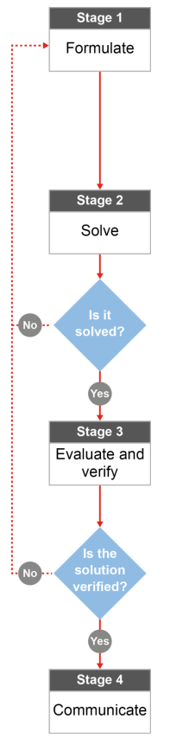

QCAA approach to problem solving and mathematical modelling
(https://www.qcaa.qld.edu.au/downloads/portal/syllabuses/snr_maths_methods_19_syll.pdf)

How much does it cost to be a North Queensland thrill seeker?
This task forms part of a set of tasks that link to an excursion to your local show.
Our thanks to the Cairns State High School maths staff for sharing these ideas.

Australian curriculum content descriptors:
Year 10
Use scatter plots to investigate and comment on relationships between two numerical variables (ACMSP251)

L
How much does it cost to be a North Queensland thrill seeker?

Modelling Northern Qld

- Is there a connection between the cost of thrill rides and ride time? Would you expect ride time to increase with increasing ride cost? Or are these two factors entirely unrelated? State your opinion based on what you’ve heard in the local media or from family and friends.

________________________________________________________________________________________________________________________________________________________________________________

Research & Formulate

Let’s gather some information by (1) researching more about the cost of local show rides and the time a ride takes and (2) using our knowledge of statistics to find out if your prediction in Question 1 is accurate.

Research the situation: Costs of rides

Ride operators have a lot to consider when they determine an appropriate ticket price for their rides. Too much and they won’t have many participants; too little and they won’t make much profit. Decisions about such matters fall under the mathematical concept termed ‘optimisation’. But firstly, you need to determine if there is a relationship between these two aspects of rides.
Research the Maths needed to investigate: Scatterplots
Background Maths
Mathematicians use a scatterplot drawn on a Cartesian plane to graph two (bivariate) variables against each other. This allows them to investigate if a trend (relationship) exists between the two variables. There are three aspects to bivariate data:
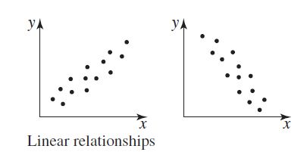
Two main types of relationships are observed:
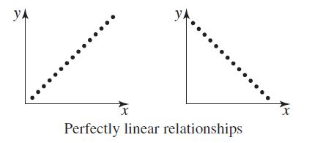

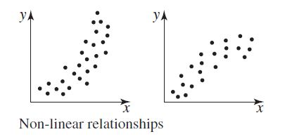
OR

Three outcomes are possible:
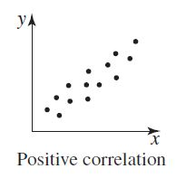
As one variable increases, so does the second

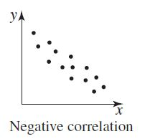

As one variable increases, the second decreases

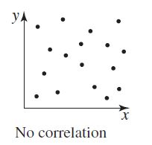
As one variable increases, there is no obvious trend with the second variable

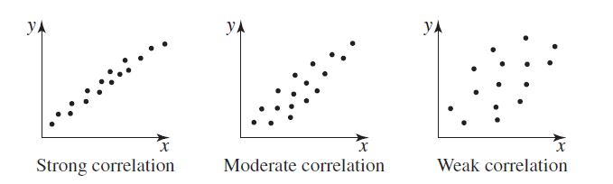
Furthermore, the strength of the relationship can be described as:

- If you want to find out if longer rides cost more, what could you use as your two variables (because we are looking at bivariate data)? ___________________________ and __________________________________
Solve

- Collect some data on ride time and ticket price as you move around the show.
  - Record the cost of a ride before the ride starts in the Table on the next page
  - Record the ride time (time from the start of the ride to the finish) in the table
  - Collect data on at least 10 different rides. Decide if you want to stick with as many thrill seeker rides as you can find or if you would prefer to choose different types of rides (include rides for little kids, “family” type rides like the dodgems and thrill seeker rides).

Ride | Cost ($) | Time (seconds)
(e.g. The Claw) | (4) | (115)
1
2
3
4
5
6
7
8
9
10

- Use an appropriate scale on the grid on next page to construct a ‘scatterplot’ by graphing cost on the x axis (horizontal) and time on the y axis (vertical). Don’t forget to label and title your graph correctly.

Evaluate & verify

- Do you notice a trend? ___________________________________________
- If so, describe the relationship between ride cost and ride time. If you found a linear trend, what is an equation that could represent that trend?
_________________________________________________________________________________________________________________________________________________________________________________________________________________________________________________________________________________

- Can you think of two other variables you might collect data on that would show a definite relationship with Ride Cost? ___________________________________________________

Communicate

- What if someone you knew decided to join the show and to run a thrill seeker ride. What advice would you give to that person about ticket prices and ride time? Justify your advice with specific examples in your data.
____________________________________________________________________________________________________________________________________________________________________________________________________________________________________________________________________________________________________________________________________________________________________________________________________________________________________________________________________________

