A problem-solving and modelling task suitable for students working with Measurement (Focus: Pythagoras)
Modelling Northern Qld

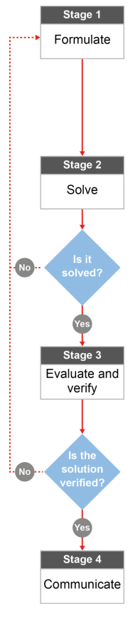

QCAA approach to problem solving and mathematical modelling
(https://www.qcaa.qld.edu.au/downloads/portal/syllabuses/snr_maths_methods_19_syll.pdf)

Who is the furthest
from home?

Australian curriculum content descriptors:
Year 9
Investigate Pythagoras’ Theorem and its application to solving
simple problems involving right angled triangles (ACMMG222)
L
Who is the furthest
from home?
Modelling Northern Qld

- Have you ever been to boarding school or do you know someone who has? How far do some people travel to get to school? How long does it take to travel there? Write what you know below:
_______________________________________________________________________________________
_______________________________________________________________________________________
_______________________________________________________________________________________
Research & Formulate

India, Camille and Stephen are three friends, all in year 6 on Palm Island. Next year they will be going to three different boarding schools (Abergowrie, St Patrick’s and Columba) and they want to know who will be the furthest away from home, geographically (not in travel time).
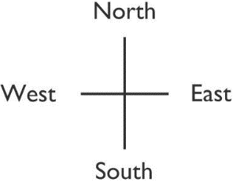
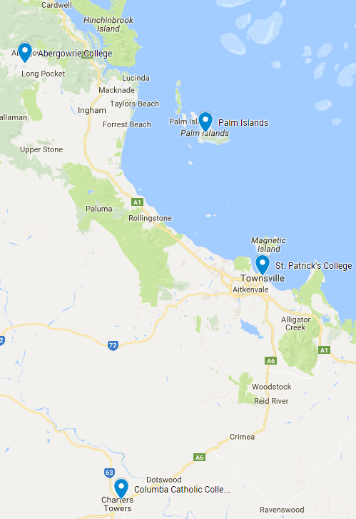
Below is a table with each student, their school, and how far the school is from Palm Island using the directions.
Student | School | Distance from Palm Island
India | Columba Catholic College, Charters Towers | 33.7 km West  147.46 km South
Camille | St Patrick’s College, Townsville | 57.82 km South  25.2 km East
Stephen | St Teresa’s College, Abergowrie | 71.53 km West  28.11 km North

- On your diagram, rule in a straight line from Palm Island to Columba College. Now rule a line that travels west from Palm Island (until you are directly above Columba) and then south to the school. What shape do you have that you could use to find the distance between each school and Palm Island?
_____________________________________________
_____________________________________________
- What formula will be useful in your calculations?
_____________________________________________
_____________________________________________
- What information do you need to be able to use the formula? Do you have it already or could you figure it out?
_______________________________________________________________________________________
_______________________________________________________________________________________
_______________________________________________________________________________________
_______________________________________________________________________________________
- After you do some calculations, how will you know who lives the furthest away? What are you looking for?
_______________________________________________________________________________________
_______________________________________________________________________________________
_______________________________________________________________________________________
_______________________________________________________________________________________
Now that you have a plan…
Solve

- Create three right-angled triangles using the information you identified in question 4. Calculate the unknown distance between each school and Palm Island.

- Compare the distances. Based on your calculations, who goes to school the furthest away from Palm Island and why?
_______________________________________________________________________________________
_______________________________________________________________________________________
______________________________________________________________________________________________________________________________________________________________________________
_______________________________________________________________________________________
Evaluate & Verify

- How reasonable are your three distances? If you were to do this investigation again, what would you change to improve the accuracy of your answers?
_______________________________________________________________________________________
_______________________________________________________________________________________
______________________________________________________________________________________________________________________________________________________________________________
_______________________________________________________________________________________
Communicate

- Imagine all the technology in the world stopped working, and we were in some sort of apocalypse. You need to travel south west for the summer, so you don’t die in the heat. As all the digital technology is useless, you only have a map and compass to guide you. Your family insist that travelling in a southerly direction first and then turning west is the quickest way to get to your new location. Using the above maths as a guide, how would you explain to your family that their suggestion is not the best way to go?
_______________________________________________________________________________________
_______________________________________________________________________________________
_______________________________________________________________________________________
_______________________________________________________________________________________
_______________________________________________________________________________________
_______________________________________________________________________________________

