

**RESEARCH DATA & INFORMATION MANAGEMENT**

**Singapore’s TRIM archiving process - for signed consent forms**

For research projects that involve human participants and require consent.

Signed consent forms must be kept for 15 years.

## Important information

* The processes below are for research projects that have signed ethics consent documents, for:
  + **Digital** – complete the template (pg. 2), copy/paste into an email and attach the signed consent forms. Send the email to the Records Team.
  + **Physical** – complete the template below and email it to the Records Team and copy (CC) Research Support. Store the signed consent documents in a manila folder, write the TRIM container / file number (you will receive this from the Records Team) and pass to Research Support to be filed in E3-01 - Block E Level 3 Room 1

NB. Physical documents with wet signatures (handwritten signatures) must be retained and archived for verification i.e. should a legal situation occur. Documents can still be scanned, even with a mix of signature methods, but the physical documents with wet signatures must not be destroyed.

* The room (location) has been specifically assigned for signed consent forms.
* The relevant email addresses are: Records Team - [corporateinformation@jcu.edu.au](mailto:corporateinformation@jcu.edu.au) and Research Support - [researchsupport-singapore@jcu.edu.au](mailto:researchsupport-singapore@jcu.edu.au) (CC required for physical documents only)
* The email template (pg. 2) is designed so that you can copy and paste it to your e-mail and customise the red text to your research project’s details. It is important you complete all fields with required details and you **must** include all participant names.
* As per [Step 3 – Archive](https://www.jcu.edu.au/rdim/step-3-archive) (of the Research (Data and Information) Asset Lifecycle) ensure you complete a Data Record in Research Data JCUfor your project/research data (including consent forms), and that under the “Where” tab you add:

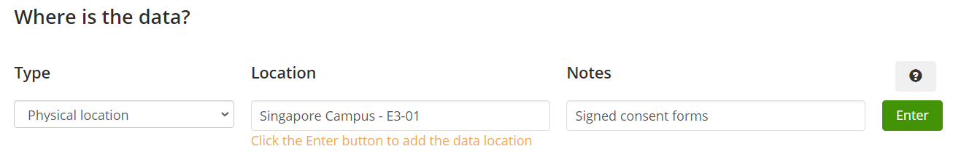

|  |
| --- |
| Please email the Research Data Services team at [researchdata@jcu.edu.au](mailto:researchdata@jcu.edu.au) if you need help archiving your research data and/or to organize storage for large datasets (>100 MB) or sensitive data. |



**RESEARCH DATA & INFORMATION MANAGEMENT**

**Singapore’s TRIM archiving process – for signed consent forms**

## E-mail Template

Hi Records Team

Please create a TRIM Container/File as follows:-

* RESEARCH -
* Ethical Clearances -
* Consent

## Enter: Title of the Project, **HREC Approval Number, L**ead Investigator Name, content of the box/envelope (i.e. signed consent forms), year start – year end

**Add to notes:**

Project name: Enter project name (in full)

Start Year: 2018

End Year: 2022

College: Enter College / Institute / Centre

Lead Investigator: Enter Name

Researcher: Enter Name *(Remove if not applicable)*

Primary Advisor: Enter Name *(Remove if not applicable)*

Contents: signed consent forms

Room: Enter **physical** location i.e. Singapore Campus, filing cupboard in E3-01 *(remove if signed consent forms are digital and attach them to this e-mail)*

**No of Participants: 10**

1. Name SURNAME *(e.g. Joe BLOGGS)*
2. Name SURNAME
3. Name SURNAME
4. Name SURNAME
5. Name SURNAME
6. Name SURNAME
7. Name SURNAME
8. Name SURNAME
9. Name SURNAME
10. Name SURNAME