|  |  |
| --- | --- |
| BOATING AND DIVING Fatigue Guideline  **WHS-PRO-GUI-016c** |  |

In a work context, fatigue is a state of mental and/or physical exhaustion which reduces a person’s ability to perform work safely and effectively.

It can occur because of prolonged mental or physical activity, sleep loss and/or disruption of the internal body clock.

Fatigue can be caused by factors which may be work related, non-work related or a combination of both and can accumulate over time.

Fatigue can be extremely dangerous during diving operations as it is a predisposing factor for decompression illness.

**Fatigue risk management is a shared responsibility between the participants on the trip and the organisation.**

**How does JCU manage the risk of fatigue for Boating and Diving Operations?**

|  |  |
| --- | --- |
|  | Fatigue awareness training |
|  | Fatigue risks are included when planning and budgeting for a trip |
|  | Ensuring a healthy shipboard environment, where relevant |
|  | Instilling a culture that promotes open communication with regards to fatigue risks |
|  | Managing workloads, including hours of work and rest requirements |
|  | Encouraging participants to monitor self-fatigue and peer-fatigue ensuring ‘fit for duty’ |

# Fatigue awareness and training

JCU includes fatigue awareness training in the B&D Induction training programs.

Fatigue training includes:

* Factors contributing to fatigue
* Minimising risk of fatigue
* Identifying signs and symptoms
* Managing fatigue/possible control measures

# planning & BUDGETING

JCU controls:

* The Field Trip Leader is responsible for considering fatigue risks when planning the trip and ensuring that adequate resources (both human and material) are included.
* As part of reviewing trips, the B&D Officers consider resources required to manage fatigue when deciding whether to verify the trip.
* As part of approving trips, the Field Trip Leaders’ Supervisor is also responsible for reviewing resources in relation to managing fatigue when deciding whether to approve the trip.
* Grant applications must include redundancy to manage fatigue risks in the costs of the project. Funding constraint/s does not alleviate the need for fatigue management and periods of rest. The B&D Officers can be invited to view the application prior to submission to review resources and provide feedback.
* Field trip leaders are required to include fatigue controls in the risk assessment (riskware) including resources (human, vessel, and diving) in the B&D register trip.

***Example risk assessment:***

|  |  |
| --- | --- |
| Risk Factor | Possible Controls |
| Fatigue due to inadequate resources, including crewing levels | This is an example of the kind of controls that could be included:   * Grant applications to involve consultation with B&D Officers to ensure that crewing and vessel resources are suitable for the work being conducted. Including redundancy for unforeseen circumstances - weather, technical problems, illness.   **EXAMPLE CONTROLS ONLY**   * Travel times taken into account when reviewing staffing hours |
| Fatigue - due to poor reporting culture - fear of reprisal if person discloses fatigue | * Fatigue training completed * All participants on the trip are aware of fatigue symptoms * Open communication between the field trip leader and participants * Ensure that there are well-defined rules regarding the confidentiality of reported information. |

# Healthy shipboard environment

JCU minimises fatigue causing ship environment by:

* When purchasing new vessels – JCU considers fatigue risks including but not limited to heat/cold (shade, wind breaks), manual tasks (loading, unloading vessel, storage of equipment), adequate space to sit in a comfortable environment (for rest)
* When hiring or chartering vessels – The Field Trip Leader considers vessel features that increase fatigue when choosing hire vessels.

# Managing workloads, including hours of work and rest requirements

## Hours of work and rest requirements

Planning trips based on fatigue science and operational requirements allows for **predictive** identification of fatigue hazards. **DO NOT** use this tool in isolation or allow it to be the main driver in final decisions; it does not provide sufficient information to determine the full extent of fatigue-related risk. The main purpose of the tool is to **identify potentially fatigue-inducing hot spots**, allowing for better decision making in planning resourcing requirements for trips.

**‘Rest’ periods mean just that— rest, not substituting a different form of work (e.g., data entry).**

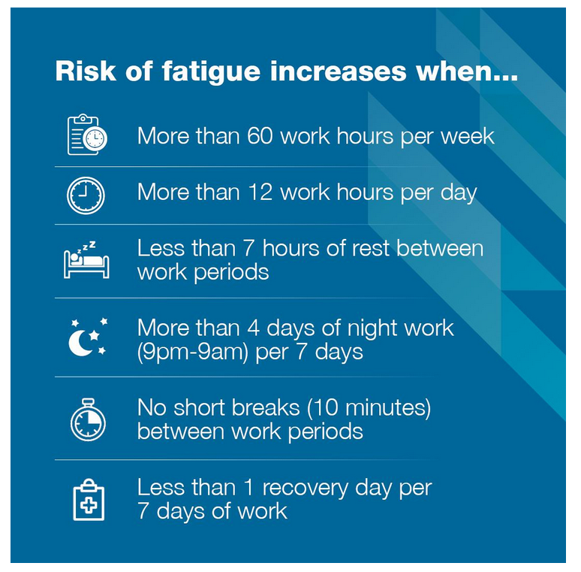

Figure 1: AMSA Recommendations for Domestic Commercial Vessels

## Workload management

* Carefully considering task design according to the workload and the available resources, including crewing.
* Reducing the time participants need to spend doing sustained physically and mentally demanding work (for example navigation through congested waters).
* Managing workload and work-pace change caused by machinery breakdowns, planned and unplanned staff absence (e.g. illness, annual leave).
* Minimising routine and administrative tasks, or redesigning them to ensure participants can focus on core duties in their working time.
* Minimising repetitive or monotonous tasks by rotating tasks.
* Deferring non-urgent work to allow appropriate rest and recovery if necessary.
* Conducting the ‘Pre & Post Work Sheet’

# Self and peer-fatigue monitoring ensuring ‘fit for duty’

Participants can use the fatigue signs and symptoms as a self and peer monitoring tool to assess if any fatigue signs and symptoms are observed in themselves and their peers.

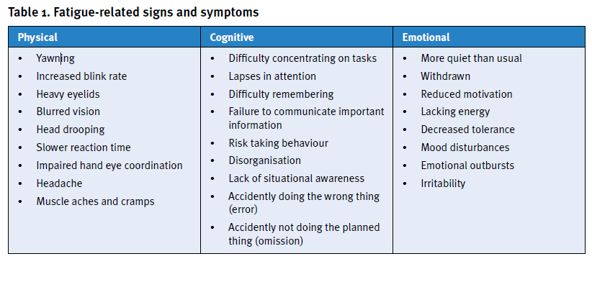

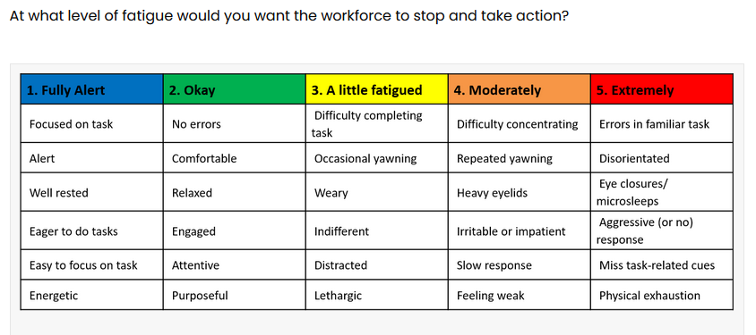

## Field Trip Leader fatigue evaluation at the end of each day:

At the end of each day, the Field Trip Leader should consider the following questions?

* How many errors occurred today?
* What is the mood of the crew?
* Observation of body language – are participants weary?
* Attitude to work?
* Work standard?

Refer to Appendix A – Pre & Post Work Sheet

# ResponsibilitIES FOR MANAGING FATIGUE

|  |  |
| --- | --- |
|  | RESPONSIBILITIES |
| FIELD TRIP LEADER | * Ensuring minimum hours of rest and/or maximum hours of work are considered during the planning and execution of the trip in relation to fatigue management (refer to section 4a of this document). Additionally, the JCU Enterprise Agreement 2022 should be considered when determining hours of work / rest (section 16 Hours of Work Professional and Technical Staff). * Managing the amount of time participants need to spend performing physically and mentally demanding work (e.g. diving and navigation through congested waters). * Ensuring provisions for nutritious food and continuous access to drinking water. * Maintaining interaction between shore and vessel management about fatigue awareness and preventive measures on board the vessel. * Creating an open communication environment, by making it clear to participants that it is important to inform the field trip leader when fatigue is impairing or likely to impair their performance, or that of others, and ensuring that there are no recriminations for such reports. * Ensuring that selected participants can do the job for which they are assigned, to prevent the potential for fatigue in other crew members. * Where possible, assign work by mixing up tasks to break monotony and to combine work requiring high physical or mental demand with low-demand tasks (job rotation). * Providing support for participants to recognise and deal with the effects of fatigue * Emphasising the participant’s responsibility to sleep during rest periods and ensure they get adequate sleep. * Ensuring that accommodation provided is conducive to quality rest. * Promoting supportive relationships on board (good morale) and dealing with interpersonal conflict between participants. * Establishing practices for dealing with fatigue incidents and learning from them, e.g. as part of the pre-start meeting. |
| PARTICIPANTS | * The Trip Leader is responsible for communicating the tasks to be completed at the start of each day including timelines with all participants, during these discussions, participants are responsible for disclosing whether they are capable and comfortable with planned activities. * Doing their best to begin duty in a fit state to work the expected duty length and perform assigned boating and diving work safely. * Monitoring and effectively managing hours of rest. * Reporting fatigue-related hazards that affect safety to the Field Trip Leader and other participants. * Identifying potential fatigue symptoms with others and alerting them. * Communicating honestly about fatigue. * Being aware of fatigue and how to counter its effects. * Using available rest periods appropriately, as well as using personal fatigue mitigation strategies.   Participants are responsible for monitoring and seeking appropriate treatments for any health concerns that may influence their fitness for duty. |

**Appendix A Pre & Post Work Sheet**

PRE & POST WORK SHEET

Trip Leader: _______________________________­­­­­­­­­­­­­­­­­______________________ Date: __________

TAKE 5 – PRE START

|  |  |  |
| --- | --- | --- |
| **Pre-work briefing:** | Is this activity in accordance with your trip plan, if not, have notes been added to both registers | **Y / N** |
| Are all staff / volunteers FIT for work and well rested? | Y / N |
| Staff / Volunteers have been properly briefed about: | Expected time on the water. | Y / N |
| Today’s activities | Y / N |
| Opportunities for toilet breaks | Y / N |
| Their willingness to speak up if they are uncomfortable or struggling in any way. | Y / N |
| Safety: | The tasks being performed, and risk control measures being applied. | Y / N |
| Do the current environmental conditions elevate risk? | Y / N |
| Can anyone see risks that haven’t been identified and controlled? | Y / N |
| Equipment: | Is all equipment onboard? | Y / N |
| Is all equipment checked and functional? | Y / N |
| Everyone knows how to use the equipment (where required)? |  |
| Is everyone happy to proceed? | Y / N |
| **Notes:** |  | |

END OF DAY

|  |  |
| --- | --- |
| 1. How many errors occurred today? |  |
| 1. What is the mood of the crew? |  |
| 1. Observation of body language – are participants weary? |  |
| 1. Attitude to work? |  |
| 1. Work standard? |  |
| 1. From the above responses, what changes need to be made for tomorrow? |  |